OSPF Configuration and Troubleshooting Guide

Abstract

The main purpose of this guide is to illustrate various issues encountered while configuring OSPF on HP routers. This troubleshooting guide discusses ways of analyzing a problem and the corrective measures to resolve the issue. This guide assumes that readers are familiar with the OSI layer and IP routing protocols.

|  |  |
| --- | --- |
| Part number: 5998-4041 | HP_S_K_1C_SM |
|  |

© Copyright 2012 Hewlett-Packard Development Company, L.P.

No part of this documentation may be reproduced or transmitted in any form or by any means without prior written consent of Hewlett-Packard Development Company, L.P.

The information contained herein is subject to change without notice.

HEWLETT-PACKARD COMPANY MAKES NO WARRANTY OF ANY KIND WITH REGARD TO THIS MATERIAL, INCLUDING, BUT NOT LIMITED TO, THE IMPLIED WARRANTIES OF MERCHANTABILITY AND FITNESS FOR A PARTICULAR PURPOSE. Hewlett-Packard shall not be liable for errors contained herein or for incidental or consequential damages in connection with the furnishing, performance, or use of this material.

The only warranties for HP products and services are set forth in the express warranty statements accompanying such products and services. Nothing herein should be construed as constituting an additional warranty. HP shall not be liable for technical or editorial errors or omissions contained herein.

Contents

[1 Common problems in OSPF Neighbor relationship 5](#_Toc342565205)

[Basic concept 5](#_Toc342565206)

[OSPF neighbor relation establishment 6](#_Toc342565207)

[OSPF packet types 8](#_Toc342565208)

[OSPF neighbor table does not display adjoining router 10](#_Toc342565209)

[Problem 1: Flowchart OSPF is not enabled on the Router 11](#_Toc342565210)

[Problem 1: OSPF is not enabled on the Router 12](#_Toc342565211)

[Problem 2: OSPF is not enabled on the interface 13](#_Toc342565212)

[Problem 3: OSPF interface is down (Layer 1/2 problem) 16](#_Toc342565213)

[Problem 4: Subnet mask mismatch between the interfaces 18](#_Toc342565214)

[Problem 5: Area ID mismatch between the interfaces 19](#_Toc342565215)

[Problem 6: Hello/Dead timer configured on the routers do not match 21](#_Toc342565216)

[Problem 7: OSPF Authentication is enabled on one router and disabled on another 23](#_Toc342565217)

[Problem 8: OSPF Authentication-mode configured on both routers do not match 25](#_Toc342565218)

[Problem 9: OSPF authentication-key configured on both routers do not match 28](#_Toc342565219)

[Problem 10: OSPF interface configured as silent-interface 31](#_Toc342565220)

[Problem 11: ACL is blocking OSPF traffic 32](#_Toc342565221)

[Problem 12: OSPF area configured as stub on one router and normal on another router 35](#_Toc342565222)

[Problem 13: OSPF area configured as stub on one router and NSSA on adjoining router 37](#_Toc342565223)

[Problem 14: OSPF area configured as NSSA on one router and normal on the adjoining router 38](#_Toc342565224)

[Problem 15: Duplicate Router ID configured 40](#_Toc342565225)

[Problem 16: Network-type mismatch 42](#_Toc342565226)

[OSPF Neighbor relation is stuck in INIT state 45](#_Toc342565227)

[Problem 1: Access-list on one end is blocking the OSPF traffic 45](#_Toc342565228)

[OSPF Neighbor relation is stuck in 2-WAY state 48](#_Toc342565229)

[Problem 1: Routers not participating in DR/BDR election on broadcast network: dr-priority set to 0 48](#_Toc342565230)

[OSPF Neighbor relation stuck in EXSTART/EXCHANGE state 51](#_Toc342565231)

[Problem 1: ACL blocking unicast traffic 51](#_Toc342565232)

[Problem 2: MTU Mismatch between the two routers 53](#_Toc342565233)

[2 Common problems in OSPF routing 57](#_Toc342565234)

[Basic concepts 57](#_Toc342565235)

[OSPF Area design concept 57](#_Toc342565236)

[OSPF router types 58](#_Toc342565237)

[LSA types 59](#_Toc342565238)

[STUB Area 63](#_Toc342565239)

[NSSA Area 63](#_Toc342565240)

[Common problems faced in OSPF routing 64](#_Toc342565241)

[Router is not advertising OSPF routes 65](#_Toc342565242)

[Problem 1: Layer 1/2 is down 65](#_Toc342565243)

[Problem 2: Network command missing 65](#_Toc342565244)

[Problem 3: ASBR is not advertising External routes 66](#_Toc342565245)

[Router is not receiving the advertised external routes 68](#_Toc342565246)

[Problem 1: OSPF Area configured as stub 68](#_Toc342565247)

[3 Common problems in OSPF route summarization 72](#_Toc342565248)

[Basic concepts 72](#_Toc342565249)

[Problem 1: ASBR is not summarizing routes: ASBR-summary command missing 73](#_Toc342565250)

[Problem 2: ABR not summarizing the routes 74](#_Toc342565251)

[Problem 3: Mistake in the configuration of summary command 78](#_Toc342565252)

[Problem 4: ACL/IP-Prefix blocking the summary routes 79](#_Toc342565253)

[4 Common problems in OSPF virtual-link configuration 83](#_Toc342565254)

[Basic concept 83](#_Toc342565255)

[Discontiguous area 0 83](#_Toc342565256)

[Newly configured area is disconnected from area 0 84](#_Toc342565257)

[Redundancy for area 0 routers 84](#_Toc342565258)

[Problem 1: Incorrect virtual-link command 86](#_Toc342565259)

[Problem 2: Wrong Router ID chosen by the router 87](#_Toc342565260)

[Problem 3: Authentication enabled on Area 0 91](#_Toc342565261)

[Problem 4: Vlink peer status stuck at INIT state 93](#_Toc342565262)

# 1 Common problems in OSPF Neighbor relationship

This chapter covers the common issues encountered while establishing neighbor relationships between OSPF peers. It describes various issues that hinder the OSPF Neighbor relation formation. This chapter assists you in diagnosing the problems met with neighbor relations and helps you resolve the problems efficiently.

The common problems found in an OSPF Neighbor relationship are:

* OSPF Neighbor table does not display adjoining router.
* OSPF Neighbor status is stuck in INIT state.
* OSPF Neighbor status is stuck in 2-way state.
* OSPF Neighbor status is stuck in EXSTART/EXCHANGE state.

## Basic concept

The basic requirement for the successful operation of OSPF in a network is the establishment of adjacency, that is, a full neighbor relation between the peers within an area. The adjacency among the routers is required for the synchronization of their LSDB (Link-state database). LSDB is also referred to as a topology table. All the routers in an OSPF domain maintain three databases as follows:

* Neighbor table or adjacency table
* Routing table or forwarding database
* Topology table or LSDB

In these three databases, the LSDB or topology table contains the information of all the routers within an area and their connected routes. In brief, LSDB is analogous to a map of an area. Every router in an area contains identical LSDB with them as the center point.

The Routing table accumulates the best paths to each destination network. It is computed using Dijkstra’s SPF algorithm, whereas the neighbor table accumulates the information of all the routers with which it has formed successful peering.

If the neighbor relation does not establish between two routers, then these routers cannot install the OSPF routes known by the other router into their routing table, resulting in a “destination route unreachable” condition.

Every router goes through various states before establishing a full neighbor relation with its peer.

In a broadcast environment, routers do not establish adjacency with every other neighboring router. Instead they form a full neighbor relation only with DR and BDR of the segment. The neighbor status with other routers (DROTHER) would be 2-way, which means routing updates are exchanged only between DR and BDR and not with DROTHER routers.

## OSPF neighbor relation establishment

Every router must go through eight states to attain a FULL neighbor relation status as follows.

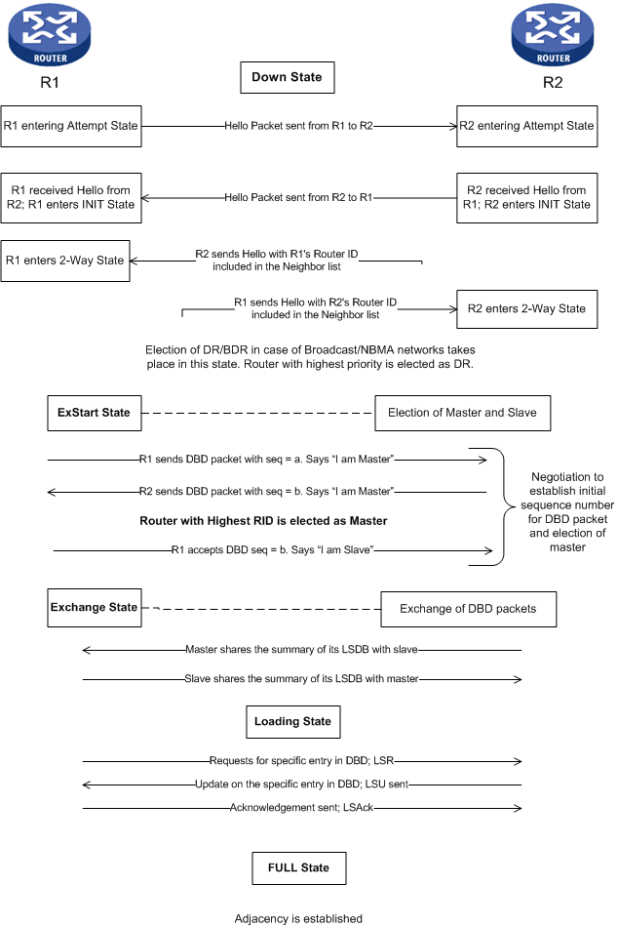

These states are described in more detail as follows:

* Down state—Initial state wherein no initiative has been taken to form a neighbor relationship, that is, the interface participating in OSPF has neither sent nor received any Hello packet.
* Attempt state—In this state the router sends a Hello packet out of its OSPF-enabled interface in an attempt to begin the neighbor relation.
* INIT state—In this state the router receives a Hello packet from the neighboring router. Upon receiving the Hello packet, this router checks the neighbor list inside the Hello packet to verify the presence of its RID. Since this router’s RID is not listed in the Hello packet, it changes its state to INIT. Once this router enters the INIT state, the router waits to receive a Hello packet with its RID listed in the neighbor list of Hello packet.
* 2-way state—In this state a router receives a Hello packet from its neighboring router with its RID listed in the neighbor list of Hello packet. As a result, the router changes its state to 2-way. Thus, a bi-directional communication is established in this state.

In a Broadcast environment, DR and BDR election takes place in this state. The ultimate state between two DROTHER routers is 2-way. The relation between DROTHER and DR or BDR proceeds further to reach a FULL state.

* ExStart state—Master/slave election and the decision on the initial sequence number for DD packets takes place in this state.
* Exchange state—In this state Master exchanges its Database with the slave first. Slave updates its LSDB and sends back its database to master.
* Loading—In this state exchange of LSRs and LSUs take place between the two routers to populate the LSDB. Both routers examine the received DD packets and compare it with their LSDB. If they find any entry missing or any sequence number for a specific entry is older in their database, an LSR (Link-state-request) is sent to the neighboring router requesting detailed data on the specific entry. The neighboring router responds by sending LSU (link-state-update), which contains the detailed info on the specific entry requested. On receiving the LSU, the first router sends an LSAck packet to acknowledge the receipt of LSU.
* Full—When the exchange of LSUs and LSAcks are completed, routers enter into FULL state. In this state Neighbors become fully adjacent.

|  |  |
| --- | --- |
|  | NOTE:  The problem occurs when the neighbor relation is stuck in any of these states and is not proceeding to form FULL Neighbor relation. |

Following is a description of the various OSPF packets and their role in the establishment of neighbor relationship.

## OSPF packet types

OSPF has 5 packet types as follows:

* OSPF packet type 1: Hello packet
* OSPF Packet type 2: Database description (DD) packet
* OSPF Packet type 3: Link-state-request (LSR)
* OSPF packet type 4: Link-state-update (LSU)
* OSPF packet type 5: Link-state-acknowledge (LSAck)

Every OSPF Packet is preceded by an OSPF Header of 20 bytes. This OSPF protocol header is the same for all the OSPF packet types.

The following diagram shows the OSPF Packet Header format.

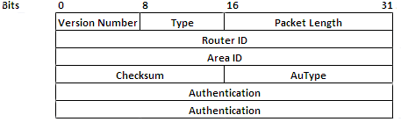

These packets are further described as follows:

#### Hello packet

Hello packets are used to discover neighbor routers and maintain the neighbor relation between the two routers. The figure below illustrates a Hello packet format.

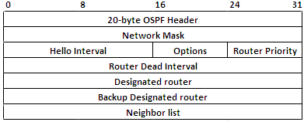

For a neighbor relation to initiate, routers must exchange a Hello packet. There are five main fields in a Hello packet, the values of which must be the same on both routers. If there is any mismatch in the values of these fields, two routers never establish adjacency between them.

The five main fields in a Hello packet are:

* + Area ID
  + Subnet Mask
  + Hello/Dead timer
  + Stub flag (included under options field)
  + Authentication

#### Database Description Packet (DD)

M

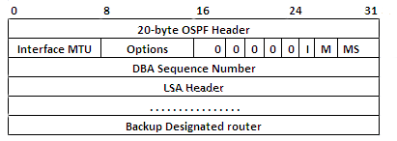

A DD packet contains the summary of the LSDB (Link-state-database) of a router. As discussed earlier, LSDB contains the detailed information about the entire area routers and their connected routes.

The LSDB of all the routers within an area must be the same. DD packets are exchanged between routers to synchronize their LSDB.

#### Link-State-Request Packet (LSR)

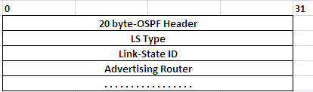

If a DD packet received from the neighboring router contains a new route entry, which is not present in the LSDB of the receiving router, or if the receiving router finds the sequence number for a specific route entry as outdated in its LSDB on comparison with the entry found in the DD packet, it sends an LSR requesting the details of that specific entry.

#### Link-State-Update Packet (LSU)

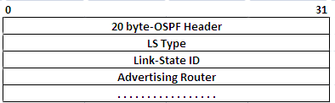

On receiving an LSR from its neighbor, an OSPF peer sends across an LSU packet to its neighbor. This packet contains the detailed information of the requested route entry.

#### Link-State-Acknowledgement Packet (LSAck)

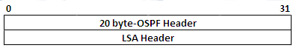

LSAck packets are sent as an acknowledgment on the receipt of LSU.

## OSPF neighbor table does not display adjoining router

This is a major problem in OSPF network. If the neighbor table does not display the adjoining router, it means either Hello packets are not being exchanged or it is being blocked or dropped between the two routers. There could be various reasons behind this behavior. It could be a layer 1 / 2 problem or a configuration mistake.

Some reasons why an OSPF neighbor table does not display the adjoining router as its neighbor are:

OSPF is not enabled on the router

OSPF is not enabled on the interface

OSPF interface is down. Layer 1 /2 problem

Area ID mismatch between the interfaces

Subnet mask mismatch between the interfaces

Hello and Dead timer configured on the routers do not match

OSPF authentication is enabled on one router and disabled on another

OSPF authentication-mode configured on both routers do not match

OSPF authentication-key configured on both routers do not match

OSPF interface is configured as silent-interface

ACL is blocking OSPF traffic

Stub/NSSA flag is set on one router and not set on another router

Same Router ID configured on both routers

Different network-type configured under interfaces

The following flowchart demonstrates a step-by-step troubleshooting method to diagnose the problem.

Sections following the flowchart discuss each problem in detail.

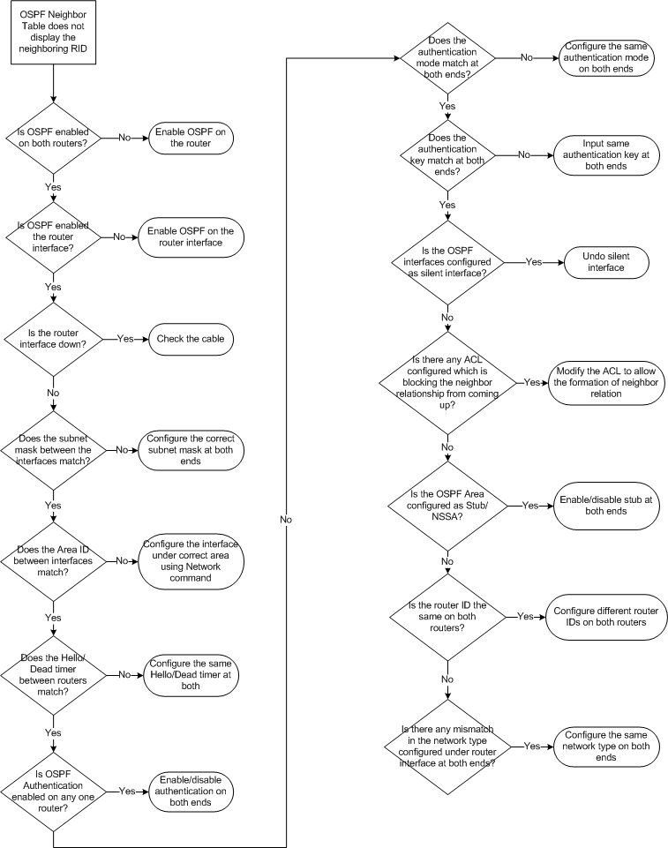

### Problem 1: Flowchart OSPF is not enabled on the Router

### Problem 1: OSPF is not enabled on the Router

OSPF is not enabled on R2. As a result, Router R1 is not able to form a neighbor relation with R2, as shown in .

In a large network containing 300-400 routers, configuring OSPF on all these routers is a big task. If any one of the routers is not configured, this can lead to various routing issues.

OSPF not enabled

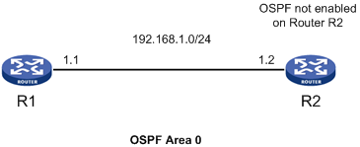

In a large network containing 300-400 routers, configuring OSPF on all these routers is a big task. If any one of the routers is not configured, this can lead to various routing issues.

#### Problem

The Neighbor table of R1 does not display R2

The following neighbor table of R1 is empty:

[R1]disp ospf peer

OSPF Process 1 with Router ID 1.1.1.1

Neighbor Brief Information

|  |  |
| --- | --- |
|  | NOTE:  When the router at one end shows empty neighbor table, it is advised to check the neighbor table of the router at the other end as well because, sometimes the router at the other end would be stuck at INIT state. If that is the case, then the reason could vary as well as the troubleshooting method. |

#### Diagnosis

Check the OSPF peer table of Router R2. Use the command **display ospf peer** to check the output of neighbor table

[R2]disp ospf peer

Info: OSPF routing process is not enabled

R2 shows that OSPF routing process is disabled on the router

#### Resolution

Enable OSPF on Router R2.

To enable OSPF on a router, input the command **ospf** followed by **process id.** The process id is local to the router and can vary on both routers. Create areas under OSPF configuration mode and include the interface under correct area. The interfaces on both ends must be included under the same area or else neighbor relation never comes up. In the example, both R1 and R2 are included under area 0.

The commands configured on R2 are as follows:

[R2] router id 2.2.2.2

[R2]ospf 1

[R2-ospf-1]area 0

[R2-ospf-1-area-0.0.0.0]network 192.168.1.0 0.0.0.255

#### Result

Now check the neighbor table of R2.

[R2]disp ospf peer

OSPF Process 1 with Router ID 2.2.2.2

Neighbor Brief Information

Area: 0.0.0.0

Router ID Address Pri Dead-Time Interface State

1.1.1.1 192.168.1.1 1 33 GE0/0 Full/DR

The neighbor table of R2 shows that it has successfully established adjacency with Router R1.

### Problem 2: OSPF is not enabled on the interface

#### Case (i): Network command missing

shows two routers with OSPF running between them. R1 is trying to establish neighbor relation with R2.

OSPF not enabled on int Gi0/0

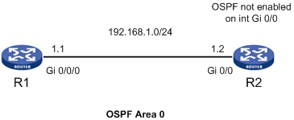

#### Problem

The neighbor table of R1 does not display the RID of R2

Below is the output of ospf peer table of R1:

[R1]disp ospf peer

OSPF Process 1 with Router ID 1.1.1.1

Neighbor Brief Information

#### Diagnosis

Check whether OSPF is enabled on the interfaces.

Use the command **display ospf interface <interface-type><interface-number**> to display the OSPF status on the interface.

[R1]disp ospf interface gi 0/0/0

OSPF Process 1 with Router ID 1.1.1.1

Interfaces

Interface: 192.168.1.1 (GigabitEthernet0/0/0)

Cost: 1 State: DR Type: Broadcast MTU: 1500

Priority: 1

Designated Router: 192.168.1.1

Backup Designated Router: 0.0.0.0

Timers: Hello 10, Dead 40, Poll 40, Retransmit 5, Transmit Delay 1

OSPF is enabled on the interface of R1. Now check the ospf status on the interface of R2.

[R2]disp ospf int gi 0/0

Info: OSPF is not enabled on such interface

The output of display ospf interface command on R2 shows that OSPF is not enabled on the interface Gi0/0

Check the ospf configuration on R2

[R2]disp current-configuration | begin ospf

ospf 1

area 0.0.0.0

Network command is missing under OSPF view. Therefore, OSPF is not enabled on the interface.

#### Resolution

Enable OSPF on the interface Gi 0/0.

To enable OSPF on an interface, include the **network** command followed by the correct network address and wildcard maskunder ospf view. The wildcard mask must cover the subnet configured under Gi 0/0.

Below are the commands configured on R2.

[R2]ospf 1

[R2-ospf-1]area 0

[R2-ospf-1-area-0.0.0.0]network 192.168.1.0 0.0.0.255

#### Result

Check the Neighbor table of R2.

[R2]disp ospf peer

OSPF Process 1 with Router ID 2.2.2.2

Neighbor Brief Information

Area: 0.0.0.0

Router ID Address Pri Dead-Time Interface State

1.1.1.1 192.168.1.1 1 33 GE0/0 Full/DR

The Neighbor table of R2 shows that it has successfully formed full neighbor relation with R1.

#### Case (ii): Wildcard mask under network command does not cover the interface subnet mask

If two interfaces on a router having the following ip addresses 192.168.1.1/24 and 192.168.2.1/24 are participating in OSPF routing, then it is a general practice to enable OSPF on both interface using a single network command. In the example stated above, the network command would be:

Network 192.168.0.0 0.0.255.255

This command enables OSPF on both interfaces. If wildcard mask calculated is incorrect, it results in not enabling OSPF on the interfaces.

Network command carries incorrect subnet mask

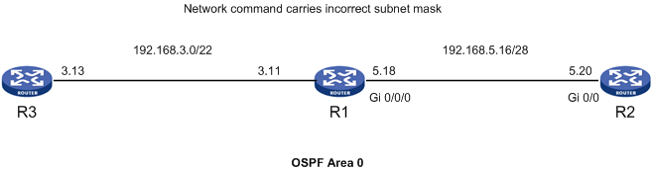

In , Router R1 is connected to R2 and R3. The ip address of interface connecting R1 to R3 is 192.168.3.11/22 and interface connecting R1 to R2 is 192.168.5.18/28.

The ip address 192.168.3.11 belongs to a /22 subnet which will range from 192.168.0.0-192.168.3.255 and the ip address 192.168.5.18 belongs to a /28 subnet which will range from 192.168.5.16-192.168.5.31.

#### Problem

The neighbor table of R1 does not display R2 as its neighbor

The Neighbor table of R1 is as follows:

[R1]disp ospf peer

OSPF Process 1 with Router ID 1.1.1.1

Neighbor Brief Information

Area: 0.0.0.0

Router ID Address Pri Dead-Time Interface State

3.3.3.3 192.168.3.13 1 31 GE0/0/1 Full/BDR

Router R1 shows successful peering with R3 but it does not display Router R2 as its peer.

#### Diagnosis

Check the OSPF configuration on R1.

[R1]disp current-configuration | begin ospf

ospf 1

area 0.0.0.0

network 192.168.0.0 0.0.3.255

The **display current-configuration** command shows that the network command contains the network 192.168.0.0 with a wildcard mask of 0.0.3.255. This wild card mask includes only the subnet 192.168.0.0/22. That is, it ranges from 192.168.0.0-192.168.3.255 and does not include 192.168.5.0 subnet.

#### Resolution

Modify the network command to include the left-out interface. Below are the configurations done on R1.

[R1]ospf 1

[R1-ospf-1]area 0

[R1-ospf-1-area-0.0.0.0]undo network 192.168.0.0 0.0.3.255

[R1-ospf-1-area-0.0.0.0]network 192.168.0.0 0.0.255.255

#### Result

Check the OSPF peer status.

[R1]disp ospf peer

OSPF Process 1 with Router ID 1.1.1.1

Neighbor Brief Information

Area: 0.0.0.0

Router ID Address Pri Dead-Time Interface State

2.2.2.2 192.168.5.20 1 38 GE0/0/0 Full/DR

3.3.3.3 192.168.3.13 1 39 GE0/0/1 Full/DR

The peer table of R1 shows the successful inclusion of R2 as its peer.

### Problem 3: OSPF interface is down (Layer 1/2 problem)

OSPF interface down

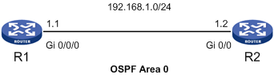

#### Problem

Neighbor Table of R1 does not reflect the RID of R2

The following peer table of R1 is empty:

[R1]disp ospf peer

OSPF Process 1 with Router ID 1.1.1.1

Neighbor Brief Information

#### Diagnosis

Check the interface status of both R1 and R2.

Use the command **display ip interface <interface-type><interface-number**>to get the status of the particular interface.

Listed below is the status of Gi 0/0/0 on Router R1.

[R1]disp ip int gi 0/0/0

GigabitEthernet0/0/0 current state :UP

Line protocol current state :DOWN

Internet Address is 192.168.1.1/24 Primary

Broadcast address : 192.168.1.255

The Maximum Transmit Unit : 1500 bytes

The line protocol on interface gi 0/0/0 is showing to be down.

#### Resolution

The above problem is not directly connected with OSPF protocol. But if the interface Ethernet status is down or line protocol is down, this hampers the working of OSPF as no packets can flow through a broken interface.

The reasons for the failure of layer 1 and layer 2 connectivity could vary. Listed below are some of the common reasons.

* Cable unplugged
* Loose cable
* Poor cable
* Bad crimping on cable
* Bad port
* Bad transceiver
* Broken interface module

Find and correct the apparent cause of the problem.

Listed below is the interface status after correcting the layer 2 problem.

[R1]disp ip int gi 0/0/0

GigabitEthernet0/0/0 current state :UP

Line protocol current state :UP

Internet Address is 192.168.1.1/24 Primary

Broadcast address : 192.168.1.255

The Maximum Transmit Unit : 1500 bytes

#### Result

R1 has formed FULL Neighbor relation with R2.

[R1]disp ospf peer

OSPF Process 1 with Router ID 1.1.1.1

Neighbor Brief Information

Area: 0.0.0.0

Router ID Address Pri Dead-Time Interface State

2.2.2.2 192.168.1.2 1 36 GE0/0/0 Full/DR

### Problem 4: Subnet mask mismatch between the interfaces

R1-interface is configured with /16 subnet mask and R2-interface is configured with /24 subnet mask. The subnet masks configured under these interfaces are different, which results in an unsuccessful attempt of forming neighbor relation with each other, as shown in .

Subnet mask is incorrectly defined at the interface

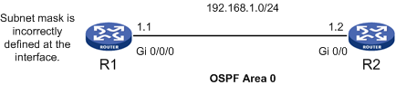

#### Problem:

Neighbor table of R1 does not display R2

The following peer table of R1 is empty:

[R1]disp ospf peer

OSPF Process 1 with Router ID 1.1.1.1

Neighbor Brief Information

#### Diagnosis

Check the interface configuration of both R1 and R2 interfaces. Use the command **display ip interface <interface-type><interface-number>.**

Router R1

[R1]disp ip int gi 0/0/0

GigabitEthernet0/0/0 current state :UP

Line protocol current state :UP

Internet Address is 192.168.1.1/16 Primary

Broadcast address : 192.168.255.255

The Maximum Transmit Unit : 1500 bytes

Router R2

[R2]disp ip int gi 0/0

GigabitEthernet0/0 current state :UP

Line protocol current state :UP

Internet Address is 192.168.1.2/24 Primary

Broadcast address : 192.168.1.255

The Maximum Transmit Unit : 1500 bytes

The above diagnosis shows that there is a subnet mask mismatch between the two interfaces.

#### Resolution

Configure the same subnet mask on both ends. In the example, configure R1-interface under /24 subnet.

[R1]int gi 0/0/0

[R1-GigabitEthernet0/0/0]ip address 192.168.1.1 24

#### Result

R1 forms successful neighbor relation with R2

[R1]disp ospf peer

OSPF Process 1 with Router ID 1.1.1.1

Neighbor Brief Information

Area: 0.0.0.0

Router ID Address Pri Dead-Time Interface State

2.2.2.2 192.168.1.2 1 36 GE0/0/0 Full/DR

### Problem 5: Area ID mismatch between the interfaces

OSPF works on the concept of Area design. The area design concept was introduced to reduce the CPU cycle and the memory load on routers.

A neighbor relation is established only between interfaces configured under same area. If the interface of Router A is configured under area 0 and Router B is configured under Area 1, Neighbor relation will never come up between these two routers.

OSPF area mismatch

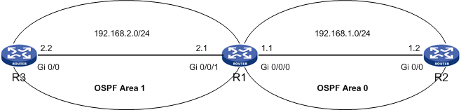

#### Problem

Neighbor table of R1 does not display R2 as its neighbor

Below listed is the neighbor table of R1

[R1]disp ospf peer

OSPF Process 1 with Router ID 1.1.1.1

Neighbor Brief Information

Area: 0.0.0.1

Router ID Address Pri Dead-Time Interface State

3.3.3.3 192.168.2.2 1 39 GE0/0/1 Full/BDR

R1 has formed successful peering with R3 but R2 is missing from the list.

#### Diagnosis

Use the debug command.

<R2>debug ospf event

<R2>terminal debugging

OSPF 1 :OSPF received packet with mismatch area ID :0.0.0.1 from interface GigabitEthernet0/0.

The debug command shows that a Hello packet has been received at interface Gi 0/0, but the area ID carried in the Hello packet is 0.0.0.1 which does not match with the area ID on interface Gi 0/0.

Check the OSPF configurations on both the routers.

Router R2

[R2]disp current-configuration | begin ospf

ospf 1

area 0.0.0.0

network 192.168.1.0 0.0.0.255

R2-interface is included under area 0. Now let us check the OSPF configuration on R1.

Router R1

[R1]disp current-configuration | begin ospf

ospf 1

area 0.0.0.0

area 0.0.0.1

network 192.168.0.0 0.0.255.255

The network command configured under area 1include both the interfaces of R1 under area 1.

#### Resolution

Modify the network command to include only interface Gi 0/0/1 under area 1 and include Gi 0/0/0 under area 0. Below listed are the configurations done on R1.

[R1]ospf 1

[R1-ospf-1]area 1

[R1-ospf-1-area-0.0.0.1]undo network 192.168.0.0 0.0.255.255

[R1-ospf-1-area-0.0.0.1]network 192.168.2.0 0.0.0.255

[R1-ospf-1-area-0.0.0.1]quit

[R1-ospf-1]area 0

[R1-ospf-1-area-0.0.0.0]network 192.168.1.0 0.0.0.255

#### Result

Check the OSPF peer status

[R1]disp ospf peer

OSPF Process 1 with Router ID 1.1.1.1

Neighbor Brief Information

Area: 0.0.0.0

Router ID Address Pri Dead-Time Interface State

2.2.2.2 192.168.1.2 1 34 GE0/0/0 Full/DR

Area: 0.0.0.1

Router ID Address Pri Dead-Time Interface State

3.3.3.3 192.168.2.2 1 37 GE0/0/1 Full/DR

### Problem 6: Hello/Dead timer configured on the routers do not match

OSPF advertises Hello and dead timer in its Hello packet, as shown in .

OSPF advertises Hello and dead timer in its Hello packet. These timer values must match on both ends to proceed with the establishment of neighbor relation. If any mismatch is found in the timer values configured for two routers, these routers will never initiate the neighbor relation between them.

Hello/dead timer mismatch

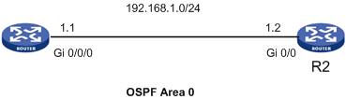

#### Problem

Neighbor table of R2 does not display R1 as its neighbor

Listed below is the ospf peer table of R2, which is empty.

[R2]disp ospf peer

OSPF Process 1 with Router ID 2.2.2.2

Neighbor Brief Information

#### Diagnosis

Run the debug command.

<R1>debugging ospf packet

<R1>terminal debugging

<R1>terminal monitor

\*Apr 26 15:24:46:867 2000 R1 RM/6/RMDEBUG: OSPF 1: RECV Packet.

\*Apr 26 15:24:46:867 2000 R1 RM/6/RMDEBUG: Source Address: 192.168.1.2

\*Apr 26 15:24:46:867 2000 R1 RM/6/RMDEBUG: Destination Address: 224.0.0.5

\*Apr 26 15:24:46:867 2000 R1 RM/6/RMDEBUG: Ver# 2, Type: 1, Length:44.

\*Apr 26 15:24:46:867 2000 R1 RM/6/RMDEBUG: Router: 2.2.2.2, Area: 0.0.0.0, Checksum: 14064.

\*Apr 26 15:24:46:867 2000 R1 RM/6/RMDEBUG: AuType: 00, Key(ascii): 0 0 0 0 0 0 00.

\*Apr 26 15:24:46:867 2000 R1 RM/6/RMDEBUG: Hello: hello timer mismatch.

The **debug ospf packet** command on R1 displays that the Hello packet received from R2 carries the value of Hello timer, which is different from the value configured on R1.

To verify the same, use the command **display ospf interface <interface-type><interface-number>.** This command displays the Hello and dead timer configured for that interface.

[R2]disp ospf int gi 0/0

OSPF Process 1 with Router ID 2.2.2.2

Interfaces

Interface: 192.168.1.2 (GigabitEthernet0/0)

Cost: 1 State: DR Type: Broadcast MTU: 1500

Priority: 1

Designated Router: 192.168.1.2

Backup Designated Router: 0.0.0.0

Timers: Hello 10, Dead 40, Poll 40, Retransmit 5, Transmit Delay 1

The Hello timer is 10 seconds and Dead timer is 40 seconds on Gi 0/0 of Router R2.

Now check the interface configuration for R1.

[R1]disp ospf int gi 0/0/0

OSPF Process 1 with Router ID 1.1.1.1

Interfaces

Interface: 192.168.1.1 (GigabitEthernet0/0/0)

Cost: 1 State: DR Type: Broadcast MTU: 1500

Priority: 1

Designated Router: 192.168.1.1

Backup Designated Router: 0.0.0.0

Timers: Hello 30, Dead 120, Poll 120, Retransmit 5, Transmit Delay 1

The Hello timer for R1 interface is 30 seconds and dead timer is 120 seconds.

Because the Hello and Dead timer configured under the interfaces of both R1 and R2 do not match, they are not able to form neighbor relationship.

#### Resolution

Configure the same Hello and dead timer on both the routers. The example modifies the hello/dead timer of R1 to match with R2.

[R1]int gi 0/0/0

[R1-GigabitEthernet0/0/0]ospf timer hello 10

Verify the interface configuration after making changes.

[R1]disp ospf int gi 0/0/0

OSPF Process 1 with Router ID 1.1.1.1

Interfaces

Interface: 192.168.1.1 (GigabitEthernet0/0/0)

Cost: 1 State: BDR Type: Broadcast MTU: 1500

Priority: 1

Designated Router: 192.168.1.2

Backup Designated Router: 192.168.1.1

Timers: Hello 10, Dead 40, Poll 40, Retransmit 5, Transmit Delay 1

#### Result

R1 forms successful peering with R2.

[R1]disp ospf peer

OSPF Process 1 with Router ID 1.1.1.1

Neighbor Brief Information

Area: 0.0.0.0

Router ID Address Pri Dead-Time Interface State

2.2.2.2 192.168.1.2 1 34 GE0/0/0 Full/DR

### Problem 7: OSPF Authentication is enabled on one router and disabled on another

OSPF authentication is enabled on R1, whereas it is disabled on R2, as shown in .

Authentication mismatch



Authentication is enabled to secure a network. To proceed with the OSPF neighbor relation establishment, the authentication must match on both ends. Any mismatch in the authentication mode or authentication key leads to the non-establishment of neighbor relation between the two.

#### Problem

The Neighbor table of R1 does not display R2 as its neighbor

The neighbor table of R1 is as follows:

<R1>disp ospf peer

OSPF Process 1 with Router ID 1.1.1.1

Neighbor Brief Information

#### Diagnosis

Debug command is very useful to determine the problem. Run a debug command on R1 and R2.

<R2>debug ospf event

<R2>terminal debugging

OSPF 1 :OSPF received packet with mismatch authentication type :1 from interface GigabitEthernet0/0.

The **debug ospf event** command shows that R2 has received a packet on its Gi 0/0 interface with a mismatch authentication type 1.

Since authentication type is 1, that means a simple authentication mode is enabled on R1.

Also verify using the command **debug ospf packet**.

<R2>debug ospf packet

<R2>terminal debugging

<R2>terminal monitor

\*Jun 7 17:19:45:940 2012 R2 RM/6/RMDEBUG: OSPF 1: SEND Packet.

\*Jun 7 17:19:45:940 2012 R2 RM/6/RMDEBUG: Source Address: 192.168.1.2

\*Jun 7 17:19:45:940 2012 R2 RM/6/RMDEBUG: Destination Address:224.0.0.5

\*Jun 7 17:19:45:940 2012 R2 RM/6/RMDEBUG: Ver# 2, Type: 1, Length:44.

\*Jun 7 17:19:45:940 2012 R2 RM/6/RMDEBUG: Router: 2.2.2.2, Area: 0.0.0.0, Checksum: 14064.

\*Jun 7 17:19:45:940 2012 R2 RM/6/RMDEBUG: AuType: 00, Key(ascii): 0 0 0 0 0 0 00.

\*Jun 7 17:19:45:940 2012 R2 RM/6/RMDEBUG: Net Mask: 255.255.255.0, Hello Int: 10, Option: \_E\_.

\*Jun 7 17:19:45:940 2012 R2 RM/6/RMDEBUG: Rtr Priority: 1, Dead Int: 40, DR: 192.168.1.2, BDR: 0.0.0.0.

The **debug** command shows that R2 is sending a Hello packet with Authentication type 0, which means No authentication has been enabled on R2.

Debug command for R1

<R1>debug ospf packet

<R1>terminal debugging

<R1>terminal monitor

\*Apr 26 15:53:00:380 2000 R1 RM/6/RMDEBUG: OSPF 1: SEND Packet.

\*Apr 26 15:53:00:380 2000 R1 RM/6/RMDEBUG: Source Address: 192.168.1.1

\*Apr 26 15:53:00:380 2000 R1 RM/6/RMDEBUG: Destination Address:224.0.0.5

\*Apr 26 15:53:00:380 2000 R1 RM/6/RMDEBUG: Ver# 2, Type: 1, Length:44.

\*Apr 26 15:53:00:380 2000 R1 RM/6/RMDEBUG: Router: 1.1.1.1, Area: 0.0.0.0, Checksum: 14578.

\*Apr 26 15:53:00:380 2000 R1 RM/6/RMDEBUG: AuType: 01, Key(ascii): 6c 69 66 65 69 73 6f 6b.

\*Apr 26 15:53:00:380 2000 R1 RM/6/RMDEBUG: Net Mask: 255.255.255.0, Hello Int: 10, Option: \_E\_.

\*Apr 26 15:53:00:380 2000 R1 RM/6/RMDEBUG: Rtr Priority: 1, Dead Int: 40, DR: 192.168.1.1, BDR: 0.0.0.0.

The debug command on R1 verifies that Authentication is enabled on R1 and the authentication-mode is simple.

Check the OSPF configurations on R1.

<R1>display current-configuration | begin ospf

ospf 1

area 0.0.0.0

authentication-mode simple

network 192.168.1.0 0.0.0.255

Check the OSPF configuration on R2.

<R2>display current-configuration | begin ospf

ospf 1

area 0.0.0.0

network 192.168.1.0 0.0.0.255

#### Resolution

Either enable authentication on R2 or disable authentication on R1. In the example, enable authentication on R2 with the same authentication-mode and key configured on R1

The configurations done on R2 are as follows:

[R2]ospf 1

[R2-ospf-1]area 0

[R2-ospf-1-area-0.0.0.0]authentication-mode simple

[R2-ospf-1-area-0.0.0.0]quit

[R2-ospf-1]quit

[R2]int gi 0/0

[R2-GigabitEthernet0/0]ospf authentication-mode simple lifeisok

#### Result

Verify the peer status using the command display ospf peer.

[R2]disp ospf peer

OSPF Process 1 with Router ID 2.2.2.2

Neighbor Brief Information

Area: 0.0.0.0

Router ID Address Pri Dead-Time Interface State

1.1.1.1 192.168.1.1 1 30 GE0/0 Full/DR

R2 has formed successful peering with R1.

### Problem 8: OSPF Authentication-mode configured on both routers do not match

As discussed in r problem 7, authentication-mode must match at both ends; otherwise neighbor relation is dropped. , as shown in .

Authentication-mode mismatch



#### Problem

Neighbor table of R1 does not display R2 as its neighbor

Listed below is the neighbor table of R1.

<R1>disp ospf peer

OSPF Process 1 with Router ID 1.1.1.1

Neighbor Brief Information

#### Diagnosis

Use debug ospf eventcommand for debugging.

<R1>debug ospf event

OSPF 1 :OSPF received packet with mismatch authentication type :2 from interface GigabitEthernet0/0/0.

The debug command shows that R1 has received a Hello packet on its interface with a mismatch authentication type 2. This means that MD5 authentication-mode is enabled on the adjoining router, that is, on Router R2.

You can debug ospf packets on R1 using the command debug ospf packet.

<R1>debug ospf packet

<R1>terminal monitor

<R1>terminal debugging

\*Apr 26 16:25:06:380 2000 R1 RM/6/RMDEBUG: OSPF 1: SEND Packet.

\*Apr 26 16:25:06:380 2000 R1 RM/6/RMDEBUG: Source Address: 192.168.1.1

\*Apr 26 16:25:06:380 2000 R1 RM/6/RMDEBUG: Destination Address: 224.0.0.5

\*Apr 26 16:25:06:380 2000 R1 RM/6/RMDEBUG: Ver# 2, Type: 1, Length:44.

\*Apr 26 16:25:06:380 2000 R1 RM/6/RMDEBUG: Router: 1.1.1.1, Area: 0.0.0.0, Checksum: 14578.

\*Apr 26 16:25:06:380 2000 R1 RM/6/RMDEBUG: AuType: 01, Key(ascii): 6c 69 66 65 69 73 6f 6b.

\*Apr 26 16:25:06:380 2000 R1 RM/6/RMDEBUG: Net Mask: 255.255.255.0, Hello Int: 10, Option: \_E\_.

\*Apr 26 16:25:06:380 2000 R1 RM/6/RMDEBUG: Rtr Priority: 1, Dead Int: 40, DR: 192.168.1.1, BDR: 0.0.0.0.

R1 is sending the Hello packet with Authentication type 1, that is, simple authentication is enabled on R1.

Debug the OSPF packet on R2.

<R2>debug ospf packet

<R2>terminal monitor

<R2>terminal debugging

\*Jun 7 17:55:31:940 2012 R2 RM/6/RMDEBUG: OSPF 1: SEND Packet.

\*Jun 7 17:55:31:940 2012 R2 RM/6/RMDEBUG: Source Address: 192.168.1.2

\*Jun 7 17:55:31:940 2012 R2 RM/6/RMDEBUG: Destination Address: 224.0.0.5

\*Jun 7 17:55:31:940 2012 R2 RM/6/RMDEBUG: Ver# 2, Type: 1, Length:44.

\*Jun 7 17:55:31:941 2012 R2 RM/6/RMDEBUG: Router: 2.2.2.2, Area: 0.0.0.0, Checksum: 0.

\*Jun 7 17:55:31:941 2012 R2 RM/6/RMDEBUG: AuType: 02, Key(ascii): 0 0 1 10 0 0 7 b9.

\*Jun 7 17:55:31:941 2012 R2 RM/6/RMDEBUG: Net Mask: 255.255.255.0, Hello Int: 10, Option: \_E\_.

\*Jun 7 17:55:31:941 2012 R2 RM/6/RMDEBUG: Rtr Priority: 1, Dead Int: 40, DR: 192.168.1.2, BDR: 0.0.0.0.

R2 is ending a packet with AuType 02, that is, MD5 authentication is enabled on R2.

Check the OSPF and interface configurations at both routers:

<R2>display current-configuration

#

:

:

#

interface GigabitEthernet0/0

port link-mode route

ip address 192.168.1.2 255.255.255.0

ospf authentication-mode md5 1 cipher $c$3$ZYxcYrw0r5En2cehASKA1xmBX58E5GU2wqaN

#

:

:

#

ospf 1

area 0.0.0.0

authentication-mode md5

network 192.168.1.0 0.0.0.255

Similarly verify the OSPF and interface configuration on R1:

<R1>display current-configuration

#

:

:

#

interface GigabitEthernet0/0/0

ip address 192.168.1.1 255.255.255.0

ospf authentication-mode simple cipher $c$3$3G+dxWmSHwhfAUCBd0t4qW/XIDCre9VkjUO

#

:

:

#

ospf 1

area 0.0.0.0

authentication-mode simple

network 192.168.1.0 0.0.0.255

#### Resolution

Configure the same authentication-mode on both routers. In the example, configure MD5 authentication mode on R1.

Listed below are the commands configured on R1.

[R1]ospf 1

[R1-ospf-1]area 0

[R1-ospf-1-area-0.0.0.0]authentication-mode md5

[R1-ospf-1-area-0.0.0.0]quit

[R1-ospf-1]quit

[R1]int gi 0/0/0

[R1-GigabitEthernet0/0/0]undo ospf authentication-mode simple

[R1-GigabitEthernet0/0/0]ospf authentication-mode md5 1 plain lifeisok

#### Result

Verify the peer status.

<R1>disp ospf peer

OSPF Process 1 with Router ID 1.1.1.1

Neighbor Brief Information

Area: 0.0.0.0

Router ID Address Pri Dead-Time Interface State

2.2.2.2 192.168.1.2 1 31 GE0/0/0 Full/DR

R1 has formed FULL neighbor relation with R2.

### Problem 9: OSPF authentication-key configured on both routers do not match

MD5 authentication mode is enabled on R1 and R2, as shown in .

Authentication-key mismatch



But the authentication key configured on R1 is different from R2. This is hindering the establishment of neighbor relation between R1 and R2.

#### Problem

Neighbor table of R2 does not display R1 as its neighbor

The neighbor table of R2 is as follows:

<R2>disp ospf peer

OSPF Process 1 with Router ID 2.2.2.2

Neighbor Brief Information

The **display ospf peer** command at R2 shows an empty peer table.

#### Diagnosis

Check the debug at R1.

<R1>debug ospf event

OSPF 1 :OSPF received packet with mismatch authentication key from interface GigabitEthernet0/0/0.

From the debug command you can determine that the authentication key configured on R2 is different from R1.

To verify this, you can also use the command **display ospf error.** This command displays the number of error packets received.

<R2>disp ospf error

OSPF Process 1 with Router ID 2.2.2.2

OSPF Packet Error Statistics

0 : OSPF Router ID confusion 0 : OSPF bad packet

0 : OSPF bad version 0 : OSPF bad checksum

0 : OSPF bad area ID 0 : OSPF drop on unnumbered interface

0 : OSPF bad virtual link 0 : OSPF bad authentication type

16 : OSPF bad authentication key 0 : OSPF packet too small

0 : OSPF Neighbor state low 0 : OSPF transmit error

0 : OSPF interface down 0 : OSPF unknown neighbor

0 : HELLO: Netmask mismatch 0 : HELLO: Hello timer mismatch

0 : HELLO: Dead timer mismatch 0 : HELLO: Extern option mismatch

0 : HELLO: Neighbor unknown 0 : DD: MTU option mismatch

0 : DD: Unknown LSA type 0 : DD: Extern option mismatch

0 : LS ACK: Bad ack 0 : LS ACK: Unknown LSA type

0 : LS REQ: Empty request 0 : LS REQ: Bad request

0 : LS UPD: LSA checksum bad 0 : LS UPD: Received less recent LSA

0 : LS UPD: Unknown LSA type

Now, check the OSPF and interface configuration on both R1 and R2 to verify the authentication mode configured.

<R1>display current-configuration

#

:

:

#

interface GigabitEthernet0/0/0

ip address 192.168.1.1 255.255.255.0

ospf timer hello 10

ospf authentication-mode md5 1 cipher $c$3$1dieAInq4Fe6nABDX3NDGo96d+4tzLLlbIkVGo=

#

:

:

#

ospf 1

area 0.0.0.0

authentication-mode md5

network 192.168.1.0 0.0.0.255

Similarly, check the configuration on R2:

<R1>display current-configuration

#

:

:

#

interface GigabitEthernet0/0

port link-mode route

ip address 192.168.1.2 255.255.255.0

ospf authentication-mode md5 1 cipher $c$3$tv66/d9bLGFLNw/bw3S/6V3jsYN0JEm2dafH

#

:

:

#

ospf 1

area 0.0.0.0

authentication-mode md5

network 192.168.1.0 0.0.0.255

The configuration at both the ends shows that md5 authentication is enabled.

#### Resolution

Configure the same authentication key at both ends. The example configures a new key on R1 and R2.

The commands configured on R2 are:

[R2]int gi 0/0

[R2-GigabitEthernet0/0]ospf authentication-mode md5 1 hello

Below listed are the commands configured on R1:

[R1]int gi 0/0/0

[R1-GigabitEthernet0/0/0]ospf authentication-mode md5 1 hello

#### Result

Verify the peer status:

[R1]disp ospf peer

OSPF Process 1 with Router ID 1.1.1.1

Neighbor Brief Information

Area: 0.0.0.0

Router ID Address Pri Dead-Time Interface State

2.2.2.2 192.168.1.2 1 35 GE0/0/0 Full/DR

### Problem 10: OSPF interface configured as silent-interface

Two routers R1 and R3 are running OSPF between them, as shown in .

Interface configured as silent-interface

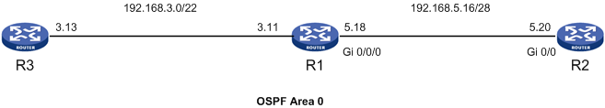

An interface configured as a silent-interface does not participate in the OSPF advertisements, that is, it never sends or receives OSPF hellos. As a result, no adjacency is formed on the interface.

If any of the interfaces are left configured as silent-interface, it never forms a neighbor relation with the adjoining router. All the interfaces on R3 are included under silent-interface. As a result, R1 is not able to establish neighbor relationship with R3.

#### Problem

Neighbor table of R1 does not display R3 as its neighbor

Listed below is the neighbor table of R1.

<R1>disp ospf peer

OSPF Process 1 with Router ID 1.1.1.1

Neighbor Brief Information

Area: 0.0.0.0

Router ID Address Pri Dead-Time Interface State

2.2.2.2 192.168.5.20 1 35 GE0/0/0 Full/DR

The **display ospf peer** commandon R1 shows that it has formed neighbor relation with R2 but has not formed any neighbor relation with R3.

#### Diagnosis

Check the OSPF configuration on both R1 and R3:

For R1:

<R1>disp current-configuration | begin ospf

ospf 1

area 0.0.0.0

network 192.168.0.0 0.0.255.255

For R3:

<R3>disp current-configuration | begin ospf

ospf 1

silent-interface all

area 0.0.0.0

network 192.168.0.0 0.0.3.255

The display current config command shows that the **silent-interface all** command has been configured on R3.

#### Resolution

Remove interface gi 0/0 from silent-interface.

Listed below are the commands configured on R3.

[R3]ospf 1

[R3-ospf-1]undo silent-interface gi 0/0

#### Result

Verify the OSPF peer status.

[R3]disp ospf peer

OSPF Process 1 with Router ID 3.3.3.3

Neighbor Brief Information

Area: 0.0.0.0

Router ID Address Pri Dead-Time Interface State

1.1.1.1 192.168.3.11 1 40 GE0/0 Full/BDR

R3 has formed successful neighbor relation with R1.

### Problem 11: ACL is blocking OSPF traffic

An ACL is configured on both R1 and R3, which denies all the IP packets from flowing between R1and R3, as shown in .

ACL blocking OSPF packets



Incorrect ACL configurations can end up blocking wanted traffic. As a result, R1 and R3 are not able to form a neighbor relationship.

#### Problem

Neighbor table of R3 does not display R1 as its neighbor

Listed below is the neighbor table of R3.

<R3>disp ospf peer

OSPF Process 1 with Router ID 3.3.3.3

Neighbor Brief Information

R3 Shows an empty neighbor table.

Check the configurations on both routers.

For R1:

<R1> display current-configuration

#

:

:

#

acl number 3000

rule 100 deny ip

#

:

:

#

interface GigabitEthernet0/0/1

firewall packet-filter 3000 outbound

ip address 192.168.3.11 255.255.252.0

#

For R3:

<R3> display current-configuration

#

:

:

#

acl number 3000

rule 100 deny ip

#

:

:

#

interface GigabitEthernet0/0

port link-mode route

firewall packet-filter 3000 outbound

ip address 192.168.3.13 255.255.252.0

#

The above configuration shows that an ACL has been configured on both the end routers, which is denying all IP packets. As a result, no neighbor relation is established between R1 and R3.

#### Resolution

Modify the ACL configurations on both Router R1 and R3 to allow the flow of OSPF packets between them.

Listed below are the commands configured on R1.

[R1]acl number 3000

[R1-adv-acl-3000]rule 50 permit ip destination 224.0.0.5 0

[R1-adv-acl-3000]rule 52 permit ospf destination 192.168.0.0 0.0.3.255

Listed below are the commands configured on R3.

[R3]acl number 3000

[R3-adv-acl-3000]rule 50 permit ip destination 224.0.0.5 0

[R3-adv-acl-3000]rule 52 permit ospf destination 192.168.0.0 0.0.3.255

#### Result

Verify the OSPF peer relation between R1 and R3.

[R3]disp ospf peer

OSPF Process 1 with Router ID 3.3.3.3

Neighbor Brief Information

Area: 0.0.0.0

Router ID Address Pri Dead-Time Interface State

1.1.1.1 192.168.3.11 1 31 GE0/0 Full/BDR

R3 has formed successful peering with R1.

The **permit ospf** command configured in the above example permits only the IP packets with protocol id 89 to pass through the interface. If you then check the ping reply between R1 and R3, you get **request timed out** as the output because ICMP packets are blocked between them.

[R1]ping 192.168.3.13

PING 192.168.3.13: 56 data bytes, press CTRL\_C to break

Request time out

Request time out

Request time out

Request time out

Request time out

--- 192.168.3.13 ping statistics ---

5 packet(s) transmitted

0 packet(s) received

100.00% packet loss

If you want to pass all the ip packets between R1 and R3, you must modify the acl as follows**:**

For R1:

[R1] acl number 3000

[R1-adv-acl-3000] rule 50 permit ip destination 224.0.0.5 0

[R1-adv-acl-3000] rule 52 permit ip destination 192.168.3.0 0.0.0.255

[R1-adv-acl-3000] rule 100 deny ip

For R3:

[R3]acl number 3000

[R3-adv-acl-3000] rule 50 permit ip destination 224.0.0.5 0

[R3-adv-acl-3000] rule 52 permit ip destination 192.168.3.0 0.0.0.255

[R3-adv-acl-3000] rule 100 deny ip

This generates the following Ping reply:

<R1>ping 192.168.3.13

PING 192.168.3.13: 56 data bytes, press CTRL\_C to break

Reply from 192.168.3.13: bytes=56 Sequence=0 ttl=255 time=1 ms

Reply from 192.168.3.13: bytes=56 Sequence=1 ttl=255 time=1 ms

Reply from 192.168.3.13: bytes=56 Sequence=2 ttl=255 time=1 ms

Reply from 192.168.3.13: bytes=56 Sequence=3 ttl=255 time=1 ms

Reply from 192.168.3.13: bytes=56 Sequence=4 ttl=255 time=1 ms

--- 192.168.3.13 ping statistics ---

5 packet(s) transmitted

5 packet(s) received

0.00% packet loss

round-trip min/avg/max = 1/1/1 ms

R1 is receiving successful ping reply from R3.

### Problem 12: OSPF area configured as stub on one router and normal on another router

The stub flag is carried in the options field of the Hello packet and the value of stub flag has to match to proceed with the neighbor relation.

STUB area

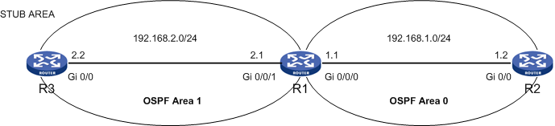

If the stub flag is set on one router, then it has to be set on the adjoining router as well to form a neighbor relation. If the stub flag is not set on the neighboring router, the neighbor relation never comes up.

#### Problem

Neighbor table of R3 does not display R1 as its neighbor

Listed below is the neighbor table of R3.

[R3]disp ospf peer

OSPF Process 1 with Router ID 3.3.3.3

Neighbor Brief Information

R3 shows an empty peer table.

#### Diagnosis

Check the OSPF configuration of both R1 and R2.

R1:

<R1> display current-configuration | begin ospf

ospf 1

area 0.0.0.0

network 192.168.1.0 0.0.0.255

area 0.0.0.1

network 192.168.2.0 0.0.0.255

R3:

<R3> display current-configuration | begin ospf

ospf 1

area 0.0.0.1

network 192.168.2.0 0.0.0.255

stub

From the above outputs, observe that Area 1 is configured as stub on R3, which causes the neighbor relation not to be established between R1 and R3.

This issue can also be determined from the **debug ospf packet** command, as shown below:

<R3>debug ospf packet

<R3>terminal debugging

<R3>terminal monitor

\*Jun 8 14:16:55:344 2012 R3 RM/6/RMDEBUG: OSPF 1: SEND Packet.

\*Jun 8 14:16:55:344 2012 R3 RM/6/RMDEBUG: Source Address: 192.168.2.2

\*Jun 8 14:16:55:344 2012 R3 RM/6/RMDEBUG: Destination Address:224.0.0.5

\*Jun 8 14:16:55:344 2012 R3 RM/6/RMDEBUG: Ver# 2, Type: 1, Length:44.

\*Jun 8 14:16:55:344 2012 R3 RM/6/RMDEBUG: Router: 3.3.3.3, Area: 0.0.0.1, Checksum: 13805.

\*Jun 8 14:16:55:344 2012 R3 RM/6/RMDEBUG: AuType: 00, Key(ascii): 0 0 0 0 0 0 00.

\*Jun 8 14:16:55:345 2012 R3 RM/6/RMDEBUG: Net Mask: 255.255.255.0, Hello Int: 10, Option: \_.

\*Jun 8 14:16:55:345 2012 R3 RM/6/RMDEBUG: Rtr Priority: 1, Dead Int: 40, DR: 192.168.2.2, BDR: 0.0.0.0.

\*Jun 8 14:17:00:789 2012 R3 RM/6/RMDEBUG: OSPF 1: RECV Packet.

\*Jun 8 14:17:00:789 2012 R3 RM/6/RMDEBUG: Source Address: 192.168.2.1

\*Jun 8 14:17:00:789 2012 R3 RM/6/RMDEBUG: Destination Address:224.0.0.5

\*Jun 8 14:17:00:789 2012 R3 RM/6/RMDEBUG: Ver# 2, Type: 1, Length: 44.

\*Jun 8 14:17:00:789 2012 R3 RM/6/RMDEBUG: Router: 1.1.1.1, Area: 0.0.0.1, Checksum: 14322.

\*Jun 8 14:17:00:789 2012 R3 RM/6/RMDEBUG: AuType: 00, Key(ascii): 0 0 0 0 0 0 00.

\*Jun 8 14:17:00:789 2012 R3 RM/6/RMDEBUG: Hello: extern option mismatch.

The debug output shows that R3 is receiving a Hello packet from R1 with a **Hello: extern option mismatch**.

#### Resolution

Either configure both ends at stub or both ends as normal areas. In the example below, the area 1 of Router R1 is configured as stub.

[R1]ospf 1

[R1-ospf-1]area 1

[R1-ospf-1-area-0.0.0.1]stub

#### Result

Verify whether neighbor relation has been established between R1 and R3.

[R1]disp ospf peer

OSPF Process 1 with Router ID 1.1.1.1

Neighbor Brief Information

Area: 0.0.0.0

Router ID Address Pri Dead-Time Interface State

2.2.2.2 192.168.1.2 1 33 GE0/0/0 Full/BDR

Area: 0.0.0.1

Router ID Address Pri Dead-Time Interface State

3.3.3.3 192.168.2.2 1 39 GE0/0/1 Full/DR

### Problem 13: OSPF area configured as stub on one router and NSSA on adjoining router

Neighbor relation is never established if one router is configured as STUB and the other router is configured as NSSA. In , area 1 of R1 is configured as NSSA while area 1 of R3 is configured as STUB.

STUB/NSSA configuration

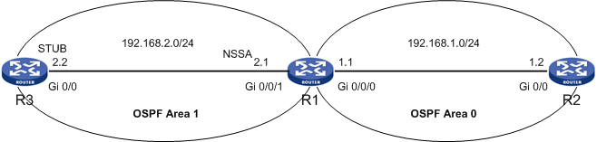

#### Problem

Neighbor table of R3 does not display R1 as its neighbor

Shown below is the Neighbor table of R3 which is empty:

<R3>disp ospf peer

OSPF Process 1 with Router ID 3.3.3.3

Neighbor Brief Information

#### Diagnosis

Check the OSPF configuration on both R1 and R3.

For R3:

<R3> display current-configuration | begin ospf

ospf 1

area 0.0.0.1

network 192.168.2.0 0.0.0.255

stub

For R1:

<R1> display current-configuration | begin ospf

ospf 1

area 0.0.0.0

network 192.168.1.0 0.0.0.255

area 0.0.0.1

network 192.168.2.0 0.0.0.255

nssa

R3 is configured as stub while R1 is configured as nssa.

#### Resolution

Either configure Area 1 of R1 as stub or area 1 of R3 as nssa. The example below configures area 1 of R1 as stub.

[R1]ospf 1

[R1-ospf-1]area 1

[R1-ospf-1-area-0.0.0.1]undo nssa

[R1-ospf-1-area-0.0.0.1]stub

#### Result

R3 has formed FULL neighbor relation with R3.

<R3>disp ospf peer

OSPF Process 1 with Router ID 3.3.3.3

Neighbor Brief Information

Area: 0.0.0.1

Router ID Address Pri Dead-Time Interface State

1.1.1.1 192.168.2.1 1 32 GE0/0 Full/BDR

### Problem 14: OSPF area configured as NSSA on one router and normal on the adjoining router

This scenario is similar to the earlier problem 12. Neighbor relation does not come up if NSSA flag is set only at one end, as shown in .

NSSA flag

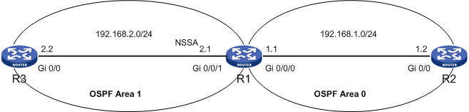

#### Problem

Neighbor table of R3 does not display R1 as its neighbor

Below is the Neighbor table of R3, which is empty.

<R3>disp ospf peer

OSPF Process 1 with Router ID 3.3.3.3

Neighbor Brief Information

#### Diagnosis

Check the OSPF configuration on both R1 and R3.

For R1:

<R1> display current-configuration | begin ospf

ospf 1

area 0.0.0.0

network 192.168.1.0 0.0.0.255

area 0.0.0.1

network 192.168.2.0 0.0.0.255

nssa

For R3:

<R3> display current-configuration | begin ospf

ospf 1

area 0.0.0.1

network 192.168.2.0 0.0.0.255

Listed below is the debug output of R1.

<R1>debug ospf packet

<R1>terminal debugging

<R1>terminal monitor

\*Apr 26 13:15:19:708 2000 R1 RM/6/RMDEBUG: OSPF 1: RECV Packet.

\*Apr 26 13:15:19:708 2000 R1 RM/6/RMDEBUG: Source Address: 192.168.2.2

\*Apr 26 13:15:19:708 2000 R1 RM/6/RMDEBUG: Destination Address: 224.0.0.5

\*Apr 26 13:15:19:708 2000 R1 RM/6/RMDEBUG: Ver# 2, Type: 1, Length:44.

\*Apr 26 13:15:19:708 2000 R1 RM/6/RMDEBUG: Router: 3.3.3.3, Area: 0.0.0.1, Checksum: 13293.

\*Apr 26 13:15:19:708 2000 R1 RM/6/RMDEBUG: AuType: 00, Key(ascii): 0 0 0 0 0 0 00.

\*Apr 26 13:15:19:708 2000 R1 RM/6/RMDEBUG: Hello: extern option mismatch.

The debug output shows that R1 has received an OSPF packet with Hello parameters mismatched.

#### Resolution

Make the following changes on R1:

[R1]ospf 1

[R1-ospf-1]area 1

[R1-ospf-1-area-0.0.0.1]undo nssa

Area 1 of R1 is now a normal area.

#### Result

<R3>disp ospf peer

OSPF Process 1 with Router ID 3.3.3.3

Neighbor Brief Information

Area: 0.0.0.1

Router ID Address Pri Dead-Time Interface State

1.1.1.1 192.168.2.1 1 36 GE0/0 Full/BDR

R3 has established Neighbor relationship with R1.

### Problem 15: Duplicate Router ID configured

One common mistake that recurs in a network is duplicate ip addresses and Router IDs. This results in many routing problems. If the adjoining routers are configured with the same Router ID, as shown in , they are not able to form adjacency between them.

Duplicate Router ID

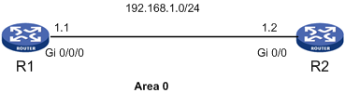

#### Problem

Neighbor table of R1 does not display R2 as its neighbor

The Neighbor table of R1 is as follows:

<R1>disp ospf peer

OSPF Process 1 with Router ID 1.1.1.1

Neighbor Brief Information

R1 shows an empty neighbor table.

#### Diagnosis

Run the debug command on R1.

<R1>debugging ospf event

<R1> terminal debugging

OSPF 1 :OSPF received packet having conflicted Router ID :1.1.1.1 from interface GigabitEthernet0/0/0.

The debug command shows that there is a conflict in router-id configured.

Check the OSPF configuration on both R1 and R2. Use the command **display ospf brief.** This command displays the Router ID configured.

For R1

<R1>disp ospf brief

OSPF Process 1 with Router ID 1.1.1.1

OSPF Protocol Information

RouterID: 1.1.1.1 Router Type:

Route Tag: 0

Multi-VPN-Instance is not enabled

Applications Supported: MPLS Traffic-Engineering

ISPF is not enabled

SPF-schedule-interval: 5

LSA generation interval: 5

LSA arrival interval: 1000

Transmit pacing: Interval: 20 Count: 3

Default ASE parameters: Metric: 1 Tag: 1 Type: 2

Route Preference: 10

ASE Route Preference: 150

SPF Computation Count: 14

RFC 1583 Compatible

Graceful restart interval: 120

Area Count: 1 Nssa Area Count: 0

ExChange/Loading Neighbors: 0

For R2:

<R2>disp ospf brief

OSPF Process 1 with Router ID 1.1.1.1

OSPF Protocol Information

RouterID: 1.1.1.1 Router Type:

Route Tag: 0

Multi-VPN-Instance is not enabled

Applications Supported: MPLS Traffic-Engineering

ISPF is not enabled

SPF-schedule-interval: 5

LSA generation interval: 5

LSA arrival interval: 1000

Transmit pacing: Interval: 20 Count: 3

Default ASE parameters: Metric: 1 Tag: 1 Type: 2

Route Preference: 10

ASE Route Preference: 150

SPF Computation Count: 2

RFC 1583 Compatible

Graceful restart interval: 120

Area Count: 1 Nssa Area Count: 0

ExChange/Loading Neighbors: 0

The **display ospf brief** command shows that the Router ID configured on R1 and R2 are the same.

#### Resolution

Configure different Router IDs on both routers. The following example changes the Router ID configured on R2:

[R2]int lo 0

[R2-LoopBack0]ip add 2.2.2.2 32

[R2-LoopBack0]quit

[R2]router id 2.2.2.2

After the Router ID is changed, reset the ospf process to bring it in effect:

<R2>reset ospf process

Warning : Reset OSPF process? [Y/N]:y

#### Result

Verify the Neighbor relation between R1 and R2.

<R2>disp ospf peer

OSPF Process 1 with Router ID 2.2.2.2

Neighbor Brief Information

Area: 0.0.0.0

Router ID Address Pri Dead-Time Interface State

1.1.1.1 192.168.1.1 1 39 GE0/0 Full/DR

### Problem 16: Network-type mismatch

If the network-type configured under the interface does not match the adjoining router’s interface configuration, as shown in , then the neighbor relation does not establish between them.

Network-type mismatch

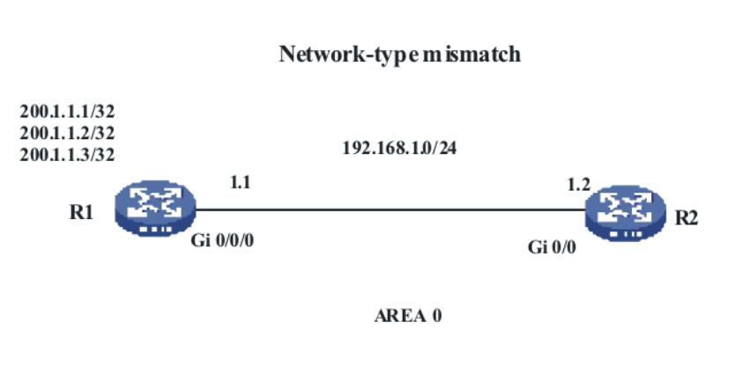

You can modify the network-type of an interface using the command **ospf network-type <network>.**

#### Problem

Neighbor table of R1 does not display R2 as its neighbor

The neighbor table of R1, which is empty, is as follows:

[R1]disp ospf peer

OSPF Process 1 with Router ID 1.1.1.1

Neighbor Brief Information

#### Diagnosis

Check the OSPF and the interface configuration at R1 and R2.

For R1:

<R1>display current-configuration

#

:

:

#

interface GigabitEthernet0/0/0

ip address 192.168.1.1 255.255.255.0

#

:

:

#

ospf 1

area 0.0.0.0

network 192.168.1.0 0.0.0.255

network 200.1.1.0 0.0.0.255

For R2:

<R2>display current-configuration

#

:

:

#

interface GigabitEthernet0/0

port link-mode route

ip address 192.168.1.2 255.255.255.0

ospf network-type p2mp

#

:

:

#

ospf 1

area 0.0.0.0

network 192.168.1.0 0.0.0.255

The interface configuration of R2 shows that it is configured as a p2mp network, whereas no network-type is configured for the R1-interface. Because the R1-interface is an Ethernet interface, OSPF chooses the default network-type for R1-interface as broadcast. Because of the mismatch in the network type between R1 and R2, they are not able to establish adjacency between them.

#### Resolution

Configure same network-type at both ends. The following example configures the interface of R1 as p2mp:

[R1]int gi 0/0/0

[R1-GigabitEthernet0/0/0]ospf network-type p2mp

#### Result

Verify the neighbor relation between R1 and R2.

<R2>disp ospf peer

OSPF Process 1 with Router ID 192.168.1.2

Neighbor Brief Information

Area: 0.0.0.0

Router ID Address Pri Dead-Time Interface State

1.1.1.1 192.168.1.1 1 94 GE0/0 Full/ -

#### Quick reference

These examples cover various issues that result in an empty neighbor table or the neighbor table not displaying its adjoining router.

Troubleshooting the problem of Router not displaying adjoining RID in its neighbor table.

Check the ospf configuration on both routers.

* + Verify whether OSPF is enabled on both the routers:

Commands:

display ospf peer

display current-configuration

* + Verify whether interfaces are included under correct area:

Commands:

display current-configuration | begin ospf

display ospf brief

* + Verify whether the network command configured include the interface:

Commands:

display current-configuration | begin ospf

display ip interface <type><number>

* + Verify whether stub, nssa flag is set:

Commands:

display current-configuration | begin ospf

Check the interface configuration.

* + Verify whether interface is up:

Commands:

display ip interface <type><number>

* + Verify whether both interfaces belong to same subnet:

Commands:

display ip interface <type><number>

* + Verify any ACL is configured on the interface that is blocking ospf packets:

Commands:

display current-configuration

display acl <acl-number>

* + Verify the hello and dead timer configured on the interface:

Commands:

display ospf interface <type><number>

* + Verify the network type configured on the interface:

Commands:

display current-configuration

display ip interface <type><number>

Check the global Router ID configured:

Command: display current-configuration

Other useful commands:

* debug ospf packet
* debug ospf event

## OSPF Neighbor relation is stuck in INIT state

An OSPF router enters into INIT state when it receives a Hello packet from its neighboring router. The Neighbor state of this router remains in INIT until it receives another Hello packet from its neighbor with its Router ID included in the neighbor field of the Hello packet. If no such Hello packet is received from the neighbor, this router gets stuck in INIT state until corrected.

Possible reasons behind this problem are:

* ACL blocking the OSPF traffic at one end
* Hello packet lost in its way to the neighbor at layer 2 due to bad cable

Following is an example:

### Problem 1: Access-list on one end is blocking the OSPF traffic

In this example, ACL is configured on R3 that is blocking all the outbound IP traffic. As a result R1 is not receiving any Hello packets from R3, whereas R3 is able to receive all the IP traffic from R1, as shown in .

Access list configured on R3 which blocks OSPF packets

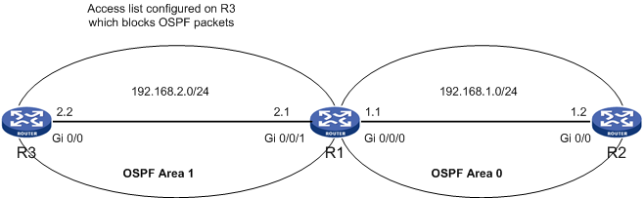

#### Problem

The neighbor relation between R3 and R1 is stuck at INIT state

The neighbor table of R3 is as follows:

<R3>disp ospf peer

OSPF Process 1 with Router ID 3.3.3.3

Neighbor Brief Information

Area: 0.0.0.1

Router ID Address Pri Dead-Time Interface State

1.1.1.1 192.168.2.1 1 36 GE0/0 Init/ -

The neighbor relation between R3 and R1 is stuck at INIT. R3 is waiting for a Hello packet from R1 with its RID listed in the neighbor field. Once it receives the Hello packet, it changes its state to 2-way to establish bi-directional communication.

#### Diagnosis

The neighbor table of R1 is as follows:

<R1>disp ospf peer

OSPF Process 1 with Router ID 1.1.1.1

Neighbor Brief Information

Area: 0.0.0.0

Router ID Address Pri Dead-Time Interface State

2.2.2.2 192.168.1.2 1 38 GE0/0/0 Full/BDR

The **display ospf peer** command on R1 does not show any entry of R3 in its neighbor table. It means R1 has not received any Hello packets from R3 yet.

As seen in section 1, if the Hello packet does not reach a router, its neighbor table never shows the entry of the neighboring router.

From the above observation of Neighbor table at both ends, you can deduce that R3 is able to receive Hello packets from R1, while R1 is not able to receive any Hello packet from R3.

Here is how to check if any ACL is blocking the OSPF traffic:

For R3:

<R3> display current-configuration

#

:

#

acl number 3000

rule 50 deny ip

#

:

#

interface GigabitEthernet0/0

port link-mode route

firewall packet-filter 3000 outbound

ip address 192.168.2.2 255.255.255.0

#

:

#

ospf 1

area 0.0.0.1

network 192.168.2.0 0.0.0.255

From the above configurations, it is clear that IP traffic is being blocked from going out of the interface Gi 0/0 of R3. As a result, no Hello packets are reaching R1.

#### Resolution

Modify the ACL to allow the OSPF traffic to flow out of the interface.

Add a permit rule before the deny-all rule to allow IP traffic to the multicast IP 224.0.0.5. This permit rule allows the exchange of Hello packets. In addition, one more permit statement is necessary to allow ospf packets between R1 and R3 for the LSDB synchronization. Therefore, add another permit rule allowing ospf packets to the destination network 192.168.2.0 as follows:

[R3]acl number 3000

[R3-acl-adv-3000]rule 41 permit ip source 192.168.2.0 0.0.0.255 destination 224.0.0.5 0

[R3-acl-adv-3000]rule 42 permit ospf destination 192.168.2.0 0.0.0.255

Verify the modified ACL:

<R3>disp acl 3000

Advanced ACL 3000, named -none-, 3 rules,

ACL's step is 5

rule 41 permit ip source 192.168.2.0 0.0.0.255 destination 224.0.0.5 0 (36 time(s) matched)

rule 42 permit ospf destination 192.168.2.0 0.0.0.255 (8 time(s) matched)

rule 50 deny ip (493 time(s) matched)

#### Result

Verify the OSPF peer relation between R1 and R3:

[R3]disp ospf peer

OSPF Process 1 with Router ID 3.3.3.3

Neighbor Brief Information

Area: 0.0.0.1

Router ID Address Pri Dead-Time Interface State

1.1.1.1 192.168.2.1 1 38 GE0/0 Full/BDR

R3 has formed FULL Neighbor relation with R1.

## OSPF Neighbor relation is stuck in 2-WAY state

The term 2-way state is also known as bi-directional communication state. In this state, the adjoining routers exchange Hello packets with each other, and a partial neighbor relation is established. However, for the neighbor relationship to proceed to FULL state, both routers must exchange their routing database with each other and synchronize their LSDBs.

As previously noted, the election of DR and BDR takes place in a 2-way state for broadcast/NBMA networks, to proceed to the EXSTART state, an election of DR and BDR is mandatory.

If there is any obstacle in the election of DR and BDR in a broadcast/NBMA environment, Neighbor relation cannot proceed further.

### Problem 1: Routers not participating in DR/BDR election on broadcast network: dr-priority set to 0

If a dr-priority 0 is configured on two routers connected directly on the Ethernet interface, then the neighbor relation does not go to 2-way as no DR and BDR is elected, as shown in .

OSPF neighbor state stuck in 2-WAY

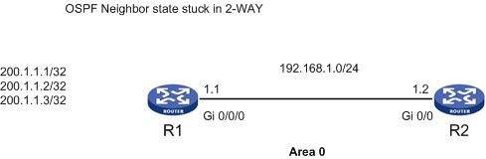

When the dr-priority under the interface is changed to 0, it does not participate in the DR or BDR election process. In a hub and spoke topology, configure the spoke routers on the Frame-relay network with a dr-priority 0 so that they do not participate in the DR/BDR election, and the hub router becomes the DR.

#### Problem

The neighbor relation between R1 and R2 is stuck in 2-way state

The neighbor table of R1 is as follows:

[R1]disp ospf peer

OSPF Process 1 with Router ID 1.1.1.1

Neighbor Brief Information

Area: 0.0.0.0

Router ID Address Pri Dead-Time Interface State

192.168.1.2 192.168.1.2 0 35 GE0/0/0 2-Way/ -

#### Diagnosis

Verify the peer table of R2:

[R2]disp ospf peer

OSPF Process 1 with Router ID 192.168.1.2

Neighbor Brief Information

Area: 0.0.0.0

Router ID Address Pri Dead-Time Interface State

1.1.1.1 192.168.1.1 0 40 GE0/0 2-Way/ -

The neighbor table of R2 shows the neighbor relation stuck in 2-way. As shown in the fields highlighted in yellow, the router priority is set to be 0.

Check the interface and OSPF configurations at R1 and R2 to verify the router priority:

For R2:

<R2>display current-configuration

#

:

#

interface GigabitEthernet0/0

port link-mode route

ip address 192.168.1.2 255.255.255.0

ospf dr-priority 0

#

:

#

ospf 1

area 0.0.0.0

network 192.168.1.0 0.0.0.255

Router R1:

<R1>display current-configuration

#

:

#

interface GigabitEthernet0/0/0

ip address 192.168.1.1 255.255.255.0

ospf dr-priority 0

#

:

#

ospf 1

area 0.0.0.0

network 192.168.1.0 0.0.0.255

network 200.1.1.0 0.0.0.255

The dr-priority value is configured as 0 on both the interfaces.

#### Resolution

There are two solutions for this problem. You can either change the dr-priority under OSPF to anything other than 0 or change the network-type to p2p on both ends. In a p2p network, DR/BDR election does not take place and the neighbors form a FULL adjacency even though the interface dr-priority is configured as 0.

#### Solution1:

Change the dr-priority value for the interface. The following example changes the dr-priority value of R1 to 1:

[R1]int gi 0/0/0

[R1-GigabitEthernet0/0/0]ospf dr-priority 1

#### Result

R1 has formed FULL Neighbor relation with R2:

<R1>disp ospf peer

OSPF Process 1 with Router ID 1.1.1.1

Neighbor Brief Information

Area: 0.0.0.0

Router ID Address Pri Dead-Time Interface State

192.168.1.2 192.168.1.2 0 36 GE0/0/0 Full/DROther

<R2>disp ospf peer

OSPF Process 1 with Router ID 192.168.1.2

Neighbor Brief Information

Area: 0.0.0.0

Router ID Address Pri Dead-Time Interface State

1.1.1.1 192.168.1.1 1 40 GE0/0 Full/DR

In the example, R1 is elected as DR whereas R2 has attained the state of DROTHER. It is because R2’s interface is still configured with a dr-priority value of 0. Consequently, R2 cannot become either a DR or a BDR.

#### Solution 2:

Change the network-type to p2p.

For R1:

[R1] interface GigabitEthernet0/0/0

[R1-GigabitEthernet0/0/0] ospf network-type p2p

For R2:

[R2] interface GigabitEthernet0/0

[R2-GigabitEthernet0/0] ospf network-type p2p

In this example, dr-priority value is still 0 but the network type is changed to p2p.

#### Result

R2 has formed successfully a neighbor relation with R1.

[R2]disp ospf peer

OSPF Process 1 with Router ID 192.168.1.2

Neighbor Brief Information

Area: 0.0.0.0

Router ID Address Pri Dead-Time Interface State

1.1.1.1 192.168.1.1 0 40 GE0/0 Full/ -

## OSPF Neighbor relation stuck in EXSTART/EXCHANGE state

As previously discussed,the election of master and slave and the initial sequence number for DD packet takes place in the EXSTART state. The router with the highest Router ID is elected as the master. The slave accepts the sequence number for DD packets sent by the master. After the master/slave election is completed, both routers enter EXCHANGE state. The exchange of LSDBs occurs in this state. Master sends a DD packet with a specific sequence number to slave. Slave acknowledges the receipt of DD packet by sending its LSDB with the same sequence number. After all the DD packets are exchanged between the routers, they enter into the Loading state.

The problem occurs, when the neighbor status get stuck in ExStart/Exchange. This can happen due to the following reasons:

* ACL blocking unicast traffic
* MTU size mismatch at both ends

### Problem 1: ACL blocking unicast traffic

In this example, an ACL has been configured on Router R3, which is blocking the unicast traffic between the two routers, as shown in .

OSPF neighbor relationship stuck at EXSTART

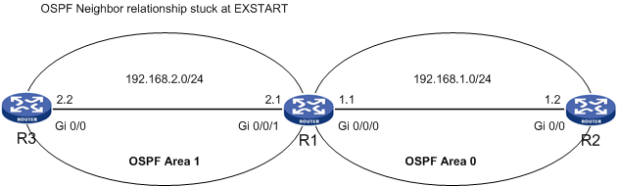

Hello packets are sent on multicast ip address 224.0.0.5. OSPF routers listen to this multicast ip and establish a bi-directional communication with the neighbor router. After the establishment of 2-way state between the routers, unicast packets are sent between them to synchronize their database. When unicast traffic is blocked, then the router gets stuck at EXSTART/EXCHANGE state until corrected.

#### Problem

The Neighbor relationship between R3 and R1 is stuck in EXSTART state

Below listed is the ospf peer table of R3.

[R3-acl-adv-3000]disp ospf peer

OSPF Process 1 with Router ID 3.3.3.3

Neighbor Brief Information

Area: 0.0.0.1

Router ID Address Pri Dead-Time Interface State

1.1.1.1 192.168.2.1 1 39 GE0/0 ExStart/BDR

#### Diagnosis

When the neighbor status is stuck in EXSTART/EXCHANGE state, verify the interface configuration on both ends to check the existence of an ACL or mismatch in the MTU size.

First, verify the interface configuration for Router R3:

<R3> display current-configuration

#

:

#

acl number 3000

rule 40 permit ospf destination 224.0.0.5 0

rule 50 deny ip

#

:

#

interface GigabitEthernet0/0

port link-mode route

firewall packet-filter 3000 outbound

ip address 192.168.2.2 255.255.255.0

#

ospf 1

area 0.0.0.1

network 192.168.2.0 0.0.0.255

The output of display current-configuration command shows that an ACL has been configured at the interface of R3 which is blocking the outbound ip traffic.

Next, verify the router configuration of R1:

<R1> display current-configuration

#

:

#

interface GigabitEthernet0/0/1

ip address 192.168.2.1 255.255.255.0

#

:

#

ospf 1

area 0.0.0.0

network 192.168.1.0 0.0.0.255

area 0.0.0.1

network 192.168.2.0 0.0.0.255

No ACL is configured on R1 interface.

The ACL configured on R3 allows the OSPF hellos to pass through but does not allow the LSA exchange to happen. The ACL would block the exchange of LSAs, thus making the neighbor relation stuck at EXSTART.

#### Resolution

Modify the ACL to allow the unicast IP traffic to flow between R1 and R3.

Below are the commands configured on R3:

[R3-acl-adv-3000]rule 41 permit ospf destination 192.168.2.0 0.0.0.255

Verify the ACL after modifications.

[R3]disp acl 3000

Advanced ACL 3000, named -none-, 3 rules,

ACL's step is 5

rule 40 permit ospf destination 224.0.0.5 0 (15 time(s) matched)

rule 41 permit ospf destination 192.168.2.0 0.0.0.255 (3 time(s) matched)

rule 50 deny ip (510 time(s) matched)

#### Result

Verify the ospf peer status between R1 and R3.

[R3]disp ospf peer

OSPF Process 1 with Router ID 3.3.3.3

Neighbor Brief Information

Area: 0.0.0.1

Router ID Address Pri Dead-Time Interface State

1.1.1.1 192.168.2.1 1 38 GE0/0 Full/BDR

### Problem 2: MTU Mismatch between the two routers

If there is any mismatch in the MTU size, the topology database is not exchanged and the routers get stuck in the EXSTART/EXCHANGE state, as shown in .

MTU Mis-match

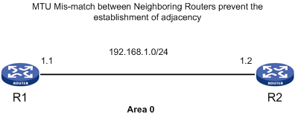

MTU (Maximum transmission unit) decides the maximum bytes that can pass through an interface. If an IP packet exceeds this MTU size, then the packet is either fragmented or discarded.

In HP routers, while exchanging LSDB, MTU is not taken into consideration by default. But if the **mtu-enable** parameter is set in the router’s interface, MTU size is checked while exchanging LSAs.

#### Problem

The neighbor relation status between R1 and R2 is stuck in Exchange state

The neighbor table of R1 is as follows:

<R1>disp ospf peer

OSPF Process 1 with Router ID 1.1.1.1

Neighbor Brief Information

Area: 0.0.0.0

Router ID Address Pri Dead-Time Interface State

2.2.2.2 192.168.1.2 1 36 GE0/0/0 Exchange/DR

#### Diagnosis

Verify the ospf peer table of R2.

[R2]disp ospf peer

OSPF Process 1 with Router ID 2.2.2.2

Neighbor Brief Information

Area: 0.0.0.0

Router ID Address Pri Dead-Time Interface State

1.1.1.1 192.168.1.1 1 31 GE0/0 ExStart/BDR

Check the interface configuration of both R1 and R2:

For R2:

<R2> display current-configuration

#

:

#

interface GigabitEthernet0/0

port link-mode route

mtu 900

ip address 192.168.1.2 255.255.255.0

ospf mtu-enable

#

:

#

ospf 1

area 0.0.0.0

network 192.168.1.0 0.0.0.255

For R1:

<R1> display current-configuration

#

:

#

interface GigabitEthernet0/0/0

mtu 1500

ip address 192.168.1.1 255.255.255.0

ospf mtu-enable

#

:

#

ospf 1

area 0.0.0.0

network 192.168.1.0 0.0.0.255

As shown in the above configuration output, the **ospf mtu-enable** command is configured under the interfaces of both the routers. Because the MTU size differs at both ends, they fail to exchange their LSDB.

#### Resolution

The two solutions for this problem are:

* Disable the MTU checking using the command **undo ospf mtu-enable**.
* Configure the same MTU size at both ends.

The next example configures the R2 with an MTU size of 1500, which is the same value configured for the R1 interface.

The commands configured on R2 are as follows:

[R2]int gi 0/0

[R2-GigabitEthernet0/0]mtu 1500

#### Result

Verify the ospf peer relation between R1 and R2.

[R2]disp ospf peer

OSPF Process 1 with Router ID 2.2.2.2

Neighbor Brief Information

Area: 0.0.0.0

Router ID Address Pri Dead-Time Interface State

1.1.1.1 192.168.1.1 1 33 GE0/0 Full/DR

#### Chapter quick reference

If the OSPF neighbor table is not displaying the adjacent router, it could be for the following reasons:

* OSPF is not enabled on the router
* OSPF is not enabled on the interface
* OSPF interface is down. Layer 1 /2 problem
* Area ID mismatch between the interfaces
* Subnet mask mismatch between the interfaces
* Hello and Dead timer configured on the routers do not match
* OSPF authentication is enabled on one router and disabled on another
* OSPF authentication-mode configured on both routers do not match
* OSPF authentication-key configured on both routers do not match
* OSPF interface is configured as silent-interface
* ACL is blocking OSPF traffic
* Stub/NSSA flag is set on one router and not set on another router
* Same Router ID configured on both routers
* Different network-type configured under interfaces

If the OSPF neighbor status is stuck in INIT, it could be for the following reasons:

* ACL blocking the OSPF traffic at one end
* Hello packets lost in its way to the neighbor at layer 2 due to bad cable

If the OSPF neighbor relation is stuck in 2-Way state, it could be for the following reason:

* Routers not participating in DR/BDR election on broadcast network: dr-priority set to 0

If the OSPF neighbor relation is stuck in ExStart/Exchange state, it could be for the following reasons:

* ACL blocking unicast traffic
* MTU size mismatch at both end

# 2 Common problems in OSPF routing

This chapter covers the common problems in OSPF routing and explains how such problems can cause a huge havoc on a large functional network.

This chapter explores the OSPF area design concept in detail. It is followed by different OSPF router types and their role in exchanging routing updates. The different OSPF LSA types are also explained to describe the concept of OSPF routing. Finally, this chapter covers various issues encountered with routing in real-world OSPF networks and guides you in analyzing and troubleshooting those issues.

## Basic concepts

In an OSPF domain, a routing update is sent only when there is a link-state (interface up/down) change in the network. The local router notifies the change in its link-status by flooding LSAs across the network. The routers receiving the LSAs update their LSDB and forward the LSA to their neighboring routers. This process continues until all the routers update their database. It can be concluded that OSPF routing protocol is called as Link-state routing protocol because a route update is generated and flooded only when there is any change in the link-status.

For better management of network, OSPF domain is divided into multiple areas. The area design concept helps in curbing difficulties met with in the configuration of devices on a large network and makes troubleshooting of routing issues simpler.

### OSPF Area design concept

OSPF works on an Area design concept. As seen in Chapter 1, each router maintains 3 tables in OSPF domain: Neighbor table, topology table, and routing table. In a large network of more than 500 routers, maintaining these three databases would use a huge chunk of memory. Also, a slight change in the interface status would result in flooding of LSAs and recalculation of SPF algorithm, which would cause a huge load on router CPU. In order to minimize the CPU and Memory Load, Area design concept was introduced, as shown in .

Area design concept

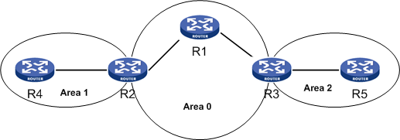

Every OSPF network must have a Backbone area. In an OSPF domain, Area 0 is considered as backbone area. All other areas must connect to Area 0 for communication. That is, if a host in Area 1 wants to communicate with a host in Area 2, all the packets must first pass through Area 0.

Hence, an OSPF domain can be divided into two areas: Backbone area and Non-backbone area. All other areas except Area 0 are called Non-backbone area. The Non-backbone area can further be categorized as stub, nssa, or normal areas. A backbone area can never be configured as stub or nssa.

To understand the stub and nssa area in ospf, you need a thorough knowledge of different LSA types. The following sections cover different OSPF router types, LSA types, and area types of OSPF protocol.

### OSPF router types

The routers in an OSPF domain could be classified based on their location as follows:

* Internal Router—A router that has its entire operational interface in a single area is called as an internal router.
* Backbone Router—A router that has at least one of its operational interfaces in area 0 is called as a backbone router. Also, all the internal routers in a Backbone area are called as Backbone routers.
* Area Border Router (ABR)—A router that interconnects two ospf areas is called as an ABR. As the name suggests this router resides on the boundary of two areas, thqt is, one interface of this router would be in area 0 and the second interface would be in some other area, for example, area 1. A router that resides on the border of two non-backbone areas, for example, area 1 and area 2, is also called an ABR. These ABRs have to form a virtual-link with the backbone ABR to establish communication within the network. A detailed discussion of virtual-link is covered in Chapter 4.
* Autonomous System Boundary Router (ASBR)—As the name suggests, ASBR interconnects two Autonomous systems. ASBR performs the function of importing the routes from one AS to other. For example, an ASBR connecting an OSPF network to a BGP network imports the BGP routes to OSPF and vice-versa. This resolves the interconnectivity issue between two routing protocol.

An OSPF router can don the role of more than one router-type. For example a router connecting area1 to area 0 is called a backbone router as well as ABR.

shows a pictorial representation of different OSPF router types.

Different OSPF router types

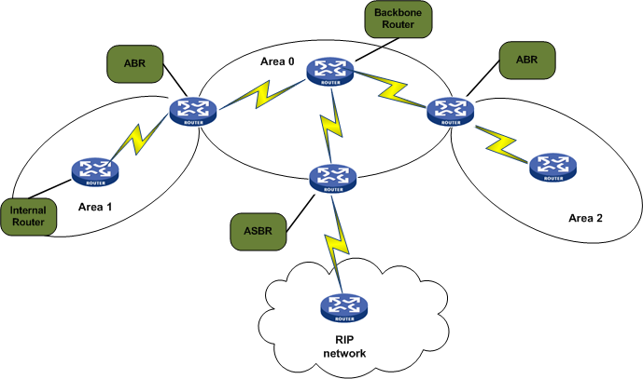

Each OSPF router type has pivotal roles to play in the OSPF routing domain. Though the basic functionality of routing packets and exchanging the routing updates remains the same, the method of advertising these routes differ among different ospf router types. For example, an internal router generates an LSA type 1 to advertise its link status whereas an ABR generates an LSA type 3 to communicate the routing update to other routers in its connected area.

### LSA types

LSA (link-state advertisements) are the routing updates generated by routers to communicate a change occurring in the network. These LSAs are not flooded as a single packet; rather they are encapsulated in LSU packets and sent across the network. Upon receiving the LSU, the LSAs are stripped out and inserted into the LSDB.

The different OSPF LSA types are listed in .

* + - * 1. OSPF LSA types

|  |  |
| --- | --- |
| Type | LSA |
| 1 | Router LSA |
| 2 | Network LSA |
| 3 and 4 | Summary LSA |
| 5 | Autonomous System External LSA |
| 6 | Multicast OSPF LSA or Group Membership LSA |
| 7 | NSSA External LSA |
| 8 | External Attribute LSA for BGP |
| 9, 10 or 11 | Opaque LSA |

These LSA types are explained in detail below.

Router LSA or LSA type 1*:* LSA Type 1 is generated by routers within an area to advertise its local network. A router sends a Type 1 LSA, which contains the status of its connected links to the neighboring routers on multicast ip 224.0.0.5. On receiving this LSA, the neighboring routers update their LSDB and forward the same LSA to their connected neighbors. This process continues until all the routers within the same area receive the LSA originated by the First router. Similarly each and every router within an area generates a Type 1 LSA to communicate their link statuses. The main purpose of this process is to update the Routing table and synchronize the LSDB.

Router LSA or LSA Type 1 is area confined. The LSUs carrying type 1 LSA cannot cross the boundary of one area and get into another area, as shown in .

Router LSA or LSA Type 1

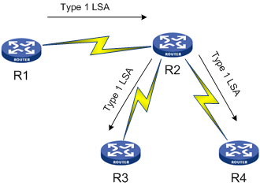

Network LSA or LSA Type 2:Network LSA is generated by a DR on a broadcast/NBMA network. Network LSA or LSA type 2 contains the information of all the routers attached to that segment. The routers on a broadcast segment send the routing updates (LSA Type 1) to the DR of the segment on multicast ip 224.0.0.6. The routing update received in the type 1 LSA is assimilated into the LSDB of DR. The DR then generates the Type 2 LSA and floods it on multicast ip 224.0.0.5 to communicate this update to the remaining routers on the broadcast segment as well as other routers confined to that area, as shown in .

Router LSA or LSA Type 2

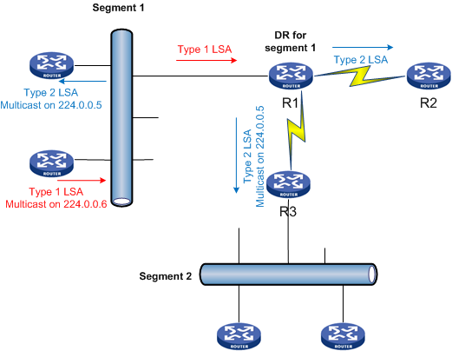

Network Summary LSA or LSA Type 3*:* LSA Type 3 is generated by an ABR of the network. The main purpose of an LSA type 3 is to update the inter-area routes. An ABR accumulates the intra-area routes of one area, for example, area 1in a type 3 LSA, and advertises it to the routers in other area, for example, area 0. The routers in area 0 update their routing table based on the information received in the type 3 LSA. Thus, area 0 routers get acquainted with the area 1 subnets. Similarly, the routes known to area 0 routers (both intra-area and inter-area routes) are accumulated in a type 3 LSA and send to area 1 routers by the same ABR. This way the summary routes are exchanged between two areas, as shown in .

Router LSA or LSA Type 3

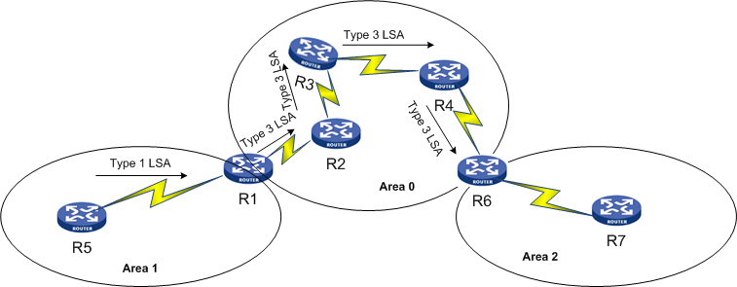

As shown in , Router R1 (ABR) receives type 1 LSA from all the routers in area 1. Router R1then generates a type 3 LSA to advertise the subnets of Area 1 to area 0 routers. Router R2 in area 0 updates its routing table based on the Type 3 LSA received and forwards the same LSA to R3. R3 again updates its routing database and forwards the received type 3 LSA to its neighbor. This process continues until all the routers in area 0 receive the type 3 LSA originated by Router R1. Router R6 also updates its database with the area 1 routes but it does not forward this LSA to routers in area 2. Instead, R6 generates its own type 3 LSA and advertises it to the area 2 routers.

In this way, routers in different areas receive the inter-area routing updates.

ASBR summary LSA or LSA Type 4:LSA type 4 is generated by an ABR belonging to the same area of an ASBR. This Type 4 LSA contains the route to an ASBR and is flooded across all the routers in an Autonomous System. The subsequent ABRs of other areas receiving LSA type 4 regenerates the LSA and flood them into their connected areas.

AS External LSA or LSA Type 5: The LSA Type 5 is generated by an ASBR to import the routes from external network into OSPF domain. This LSA contains the information of subnets in an external network. This information is shared with all the routers in an OSPF routing domain except the routers belonging to stub or nssa area, as shown in .

Router LSA or LSA Type 5

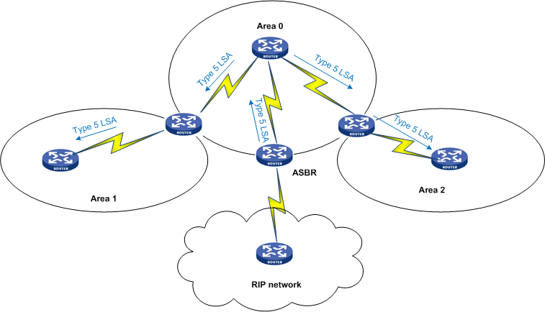

Group Membership LSA or LSA type 6:These LSAs are used in multicast OSPF (MOSPF) application.

NSSA External LSA or LSA Type 7:These LSAs are generated by an NSSA ASBR, that is, an ASBR belonging to an NSSA area. The main purpose of a type 7 LSA is to import the external routes into an NSSA area. ASBR generates a type 7 LSA, which contains the subnets of external network and advertises this packet to the routers in NSSA area. All the NSSA internal routers update their database with the external ospf routes. The NSSA ABR then converts this type 7 LSA into a type 5 LSA and floods them across the entire autonomous system, as shown in .

Router LSA or LSA Type 7

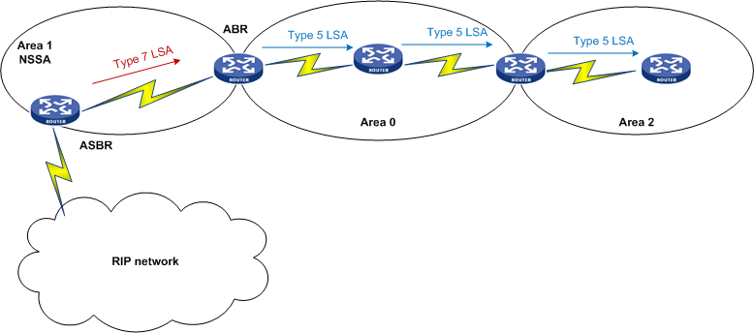

As shown in , an ASBR in NSSA area connecting the ospf domain to RIP network generates a type 7 LSA and forwards it to all the routers in the NSSA area. The ABR of NSSA area converts the type 7 LSA to type 5 LSA before forwarding the routing update to area 0 routers. This type 5 LSA is then flooded across all the areas in the ospf domain.

External Attributes LSA for BGP:These LSAs are used while importing BGP routes into OSPF domain.

Opaque LSA:These LSAs are allotted for future application-specific requirements.

The basic purpose of learning different router types and LSA types is to understand the stub and NSSA area in detail. The next section covers the stub and NSSA area and highlights the difference between them.

### STUB Area

A stub area was designed to reduce the memory consumption of a router by shrinking the OSPF routing table and the CPU load by reducing the computation of SPF algorithm.

The basic functionality of a stub area is to block all the external-AS routes from entering into stub area. The type 5 LSAs generated by an ASBR are curbed at the boundary of a stub area and are not allowed to enter a stubby area. Similarly, an ASBR connecting a stub area to an external network cannot import the external-routes into stubby area. In brief, no LSA type 5 and LSA type 7 are originated in a stub area or transmitted into a stubby area.

### NSSA Area

Similar to a stub area, NSSA was also designed to cut down the memory usage and CPU load. The difference between NSSA and stub area is that NSSA area allows the advertisement of type 7 LSA. These type 7 LSAs are generated by an ASBR belonging to an NSSA area to import the external-as routes into NSSA area. The routers in the entire NSSA area update their database with the external routes received from the ASBR. This type 7 LSA is then converted into type 5 LSA by the NSSA ABR and forwarded to other routers in the autonomous system.

Similar to a stub area, NSSA also does not allow LSA type 5 advertisements, as shown in .

NSSA area in detail

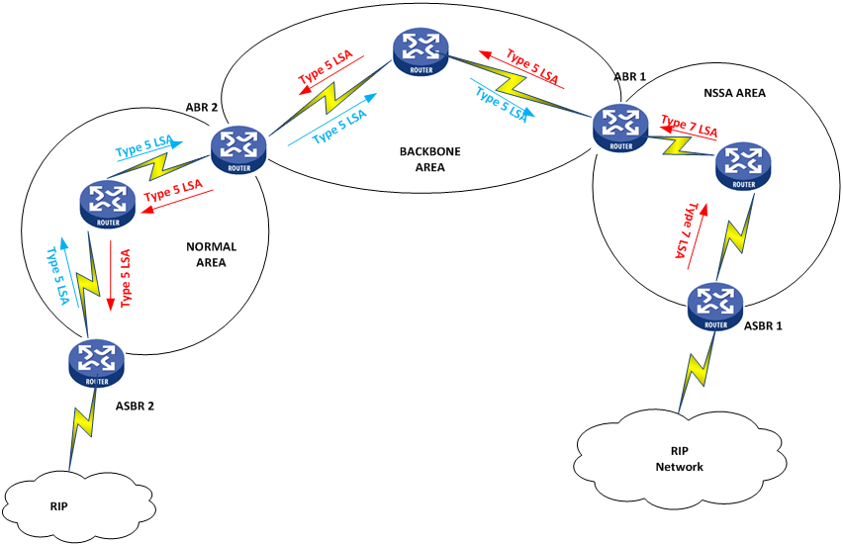

As shown in , ASBR1 generates a Type 7 LSA and injects it into NSSA area. This packet gets traversed across the entire nssa area. The ABR1 then converts this type 7 LSA packet into Type 5 LSA before injecting it into the backbone area. This Type5 LSA packet is advertised across the entire autonomous system. On the other hand, The Type 5 LSA generated by ASBR2 is blocked by ABR1 and does not allow the external-as routes to enter into the nssa area.

### Common problems faced in OSPF routing

The main purpose of having OSPF configured on a network is to implement dynamic routing. Though OSPF is a complex protocol, when properly configured it makes the implementation of dynamic routing simpler in a network. In an ospf domain, the routers form neighbor relationships with the adjacent routers and share their databases with each other in order to synchronize their database and compute the best route to a destination network.

Chapter 1 covers the challenges met in an OSPF neighborship establishment. This chapter covers the routing issues in an ospf domain.

Some basic problems that occur in OSPF routing domain are:

Router is not advertising ospf routes

* + Layer 1 or 2 issues
  + Interface has not been enabled for ospf routing
  + ASBR not advertising external routes

Router is not receiving the advertised ospf routes

* + OSPF area configured as stub

Problems with the OSPF summarized routes and default routes are covered in the next chapters.

## Router is not advertising OSPF routes

OSPF is enabled on an interface if a matching network command is configured under OSPF view. The absence of network command results in non-advertisement of that subnet. As a result, other routers in the ospf domain are deprived of a path to reach the destination. Similarly, even though ospf is enabled on the interface but if the interface is physically down, the associated routes do not get advertised to other routers in the network.

### Problem 1: Layer 1/2 is down

This is a common problem in large networks. A route is never generated for an interface in down status. Also, while the previously Up interface goes down, the former LSAs shared for this destination is removed from the LSDB of the routers when the LSAge timer reaches the max value. As a result, the route to this destination is lost forever until the interface comes up and SPF is computed again.

The layer 1/2 issue could be due to various reasons, such as bad cable, loose cable, unplugged cable, bad crimping on cable, and so on.

#### Resolution

Identify the interface that is down. Find the reason for the layer 1/2 issue and rectify the same.

### Problem 2: Network command missing

In this network diagram, R2 is connected to a series of networks, as shown in .

OSPF is enabled on all three routers

**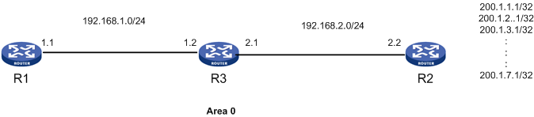**

Requirement: Routers R1 and R3 must receive the connected routes on R2 via ospf.

#### Problem

Router R1 is not receiving the 200.1.x.x networks from R2.

Check the routing table of R1

[R1]disp ip routing-table

Routing Tables: Public

Destinations : 6 Routes : 6

Destination/Mask Proto Pre Cost NextHop Interface

1.1.1.1/32 Direct 0 0 127.0.0.1 InLoop0

127.0.0.0/8 Direct 0 0 127.0.0.1 InLoop0

127.0.0.1/32 Direct 0 0 127.0.0.1 InLoop0

192.168.1.0/24 Direct 0 0 192.168.1.1 GE0/0/0

192.168.1.1/32 Direct 0 0 127.0.0.1 InLoop0

192.168.2.0/24 OSPF 10 2 192.168.1.2 GE0/0/0

From the routing table it is clear that R1 is not receiving any matching routes for 200.1.x.x network.

#### Troubleshooting

#### Verify the lsdb of Router R2 for 200.1.x.x network.

[R2]disp ospf lsdb network 200.1.1.1

OSPF Process 1 with Router ID 2.2.2.2

Area: 0.0.0.0

Link State Database

The LSDB of Router R2 does not contain any information on 200.1.1.1 network.

Check whether OSPF is enabled on that interface.

<R2> display current-configuration | begin ospf

ospf 1

area 0.0.0.0

network 192.168.2.0 0.0.0.255

The OSPF configuration on R2 reveals that OSPF is not enabled for the 200.1.x.x networks on R2.

#### Resolution

Add the network command under ospf view for area 0 to enable OSPF on these subnets.

[R2]ospf 1

[R2-ospf-1]area 0

[R2-ospf-1-area-0.0.0.0]network 200.1.0.0 0.0.255.255

### Problem 3: ASBR is not advertising External routes

Router R2 is an ASBR connected to a static network, as shown in .

ASBR connected to a static network

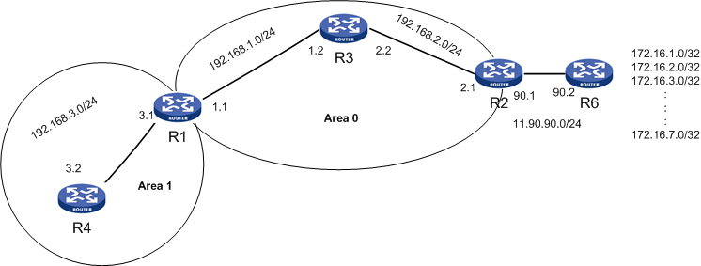

#### Requirement

#### Import the static routes into OSPF domain.

#### Problem

R3 is not receiving the external-as routes

Verify the ospf routing table of Router R3.

<R3>disp ospf routing

OSPF Process 1 with Router ID 3.3.3.3

Routing Tables

Routing for Network

Destination Cost Type NextHop AdvRouter Area

192.168.1.0/24 1 Transit 192.168.1.2 3.3.3.3 0.0.0.0

192.168.2.0/24 1 Transit 192.168.2.2 3.3.3.3 0.0.0.0

Total Nets: 2

Intra Area: 2 Inter Area: 0 ASE: 0 NSSA: 0

R3 is not receiving the routes 172.16.x.x

#### Troubleshooting

Check the OSPF configuration on R2.

<R2> display current-configuration | begin ospf

ospf 1

area 0.0.0.0

network 192.168.2.0 0.0.0.255

R2 is not advertising external routes because the **import-route**command is not configured under R2.

#### Resolution

Configure the command import-route static under the ospf view on R2 to redistribute the external static routes into the ospf domain.

[R2]ospf 1

[R2-ospf-1]import-route static

#### Result

Verify the ospf routing table of R3 to check whether it is receiving the external-as routes.

<R3>disp ospf routing

OSPF Process 1 with Router ID 3.3.3.3

Routing Tables

Routing for Network

Destination Cost Type NextHop AdvRouter Area

192.168.1.0/24 1 Transit 192.168.1.2 3.3.3.3 0.0.0.0

192.168.2.0/24 1 Transit 192.168.2.2 3.3.3.3 0.0.0.0

Routing for ASEs

Destination Cost Type Tag NextHop AdvRouter

172.16.1.0/24 1 Type2 1 192.168.2.1 2.2.2.2

172.16.2.0/24 1 Type2 1 192.168.2.1 2.2.2.2

172.16.3.0/24 1 Type2 1 192.168.2.1 2.2.2.2

172.16.4.0/24 1 Type2 1 192.168.2.1 2.2.2.2

172.16.5.0/24 1 Type2 1 192.168.2.1 2.2.2.2

172.16.6.0/24 1 Type2 1 192.168.2.1 2.2.2.2

172.16.7.0/24 1 Type2 1 192.168.2.1 2.2.2.2

Total Nets: 9

Intra Area: 2 Inter Area: 0 ASE: 7 NSSA: 0

R3 is receiving the external type 2 routes.

## Router is not receiving the advertised external routes

In some scenarios, the router is configured with the appropriate commands under ospf view to redistribute the external routes. Even then the neighboring routers do not receive the external routes. This mainly occurs when the areas are configured as stub. Recalling the section on *stub area,* Stub area does not allow external LSAs from being advertised inside a stub area. These LSA type 5 are curbed at the ABR or ASBR of a stub area. As a result, the internal stub area routers do not receive the external routes.

### Problem 1: OSPF Area configured as stub

Router R4 is an ASBR connecting two different routing domains. In this scenario, R4 is configured to import all the external routes into ospf network. Still, Router R3 is not receiving the external routes, as shown in .

OSPF Area configured as STUB

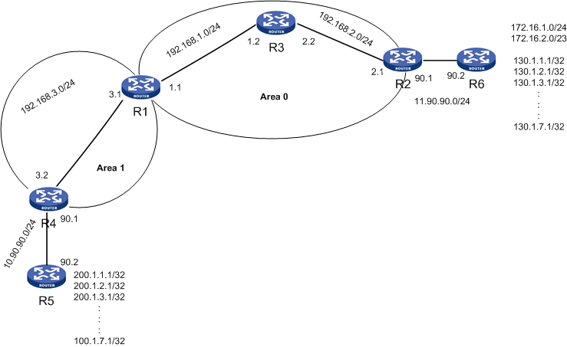

#### Problem

Router R3 in area 0 is not receiving external routes from Router R4 in Area 1

Verify the routing table of R3.

<R3>disp ip routing-table

Routing Tables: Public

Destinations : 8 Routes : 8

Destination/Mask Proto Pre Cost NextHop Interface

3.3.3.3/32 Direct 0 0 127.0.0.1 InLoop0

127.0.0.0/8 Direct 0 0 127.0.0.1 InLoop0

127.0.0.1/32 Direct 0 0 127.0.0.1 InLoop0

192.168.1.0/24 Direct 0 0 192.168.1.2 GE0/0

192.168.1.2/32 Direct 0 0 127.0.0.1 InLoop0

192.168.2.0/24 Direct 0 0 192.168.2.2 GE0/1

192.168.2.2/32 Direct 0 0 127.0.0.1 InLoop0

192.168.3.0/24 OSPF 10 2 192.168.1.1 GE0/0

R3 is not receiving any routes for 200.1.x.x networks.

#### Troubleshooting

Check the routing table of R1 to verify whether Router R1 is receiving the external-as routes.

<R1>disp ospf routing

OSPF Process 1 with Router ID 1.1.1.1

Routing Tables

Routing for Network

Destination Cost Type NextHop AdvRouter Area

192.168.3.0/24 1 Transit 192.168.3.1 1.1.1.1 0.0.0.1

192.168.1.0/24 1 Transit 192.168.1.1 3.3.3.3 0.0.0.0

192.168.2.0/24 2 Transit 192.168.1.2 3.3.3.3 0.0.0.0

Total Nets: 3

Intra Area: 3 Inter Area: 0 ASE: 0 NSSA: 0

The external-as routes are missing from the routing table of R1 as well.

Check the OSPF configuration on R4 to verify whether these external routes are imported into area 1.

<R4>disp current-configuration | begin ospf

ospf 1

import-route static

area 0.0.0.1

network 192.168.3.0 0.0.0.255

stub

The external routes are being imported into ospf at Router R4. But the OSPF area 1 configuration on R4 reveals that area 1 is configured as stub. As a result, these external routes are not getting advertised.

Check the configuration of R1 to verify the stub area configuration.

<R1>disp current-configuration | begin ospf

ospf 1

area 0.0.0.0

network 192.168.1.0 0.0.0.255

area 0.0.0.1

network 192.168.3.0 0.0.0.255

stub

Since both R1 and R4 are configured under stub area, they are able to form successful peering with each other and exchange the routing updates between them.

<R1>disp ospf peer

OSPF Process 1 with Router ID 1.1.1.1

Neighbor Brief Information

Area: 0.0.0.0

Router ID Address Pri Dead-Time Interface State

3.3.3.3 192.168.1.2 1 36 GE0/0/0 Full/DR

Area: 0.0.0.1

Router ID Address Pri Dead-Time Interface State

4.4.4.4 192.168.3.2 1 33 GE0/0/1 Full/BDR

#### Resolution

The requirement of the scenario is to advertise the external routes as well as maintain the stubby nature of Area 1. In the scenario, configure area 1 as nssa. The nssa area is capable of transmitting type 7 LSAs. As a result, Router R4 in area 1 advertises the external routes in a type 7 LSA packet. These type 7 LSA packets are then converted to type 5 and injected to Area 0 by the ABR R1.

The commands configured on R1 and R4 are as follows:

Router R1

[R1]ospf 1

[R1-ospf-1]area 1

[R1-ospf-1-area-0.0.0.1]undo stub

[R1-ospf-1-area-0.0.0.1]nssa

Router R4:

[R4]ospf 1

[R4-ospf-1]area 1

[R4-ospf-1-area-0.0.0.1]undo stub

[R4-ospf-1-area-0.0.0.1]nssa

#### Result

Check the ospf routing table of R3 to verify the external routes.

<R3>disp ospf routing

OSPF Process 1 with Router ID 3.3.3.3

Routing Tables

Routing for Network

Destination Cost Type NextHop AdvRouter Area

192.168.3.0/24 2 Inter 192.168.1.1 1.1.1.1 0.0.0.0

192.168.1.0/24 1 Transit 192.168.1.2 3.3.3.3 0.0.0.0

192.168.2.0/24 1 Transit 192.168.2.2 3.3.3.3 0.0.0.0

Routing for ASEs

Destination Cost Type Tag NextHop AdvRouter

200.1.2.0/24 1 Type2 1 192.168.1.1 1.1.1.1

200.1.3.0/24 1 Type2 1 192.168.1.1 1.1.1.1

200.1.4.0/24 1 Type2 1 192.168.1.1 1.1.1.1

200.1.5.0/24 1 Type2 1 192.168.1.1 1.1.1.1

200.1.6.0/24 1 Type2 1 192.168.1.1 1.1.1.1

200.1.7.0/24 1 Type2 1 192.168.1.1 1.1.1.1

200.1.1.0/24 1 Type2 1 192.168.1.1 1.1.1.1

Total Nets: 10

Intra Area: 2 Inter Area: 1 ASE: 7 NSSA: 0

R3 is now receiving all the external routes.

# 3 Common problems in OSPF route summarization

This chapter covers the common problems in OSPF route summarization. Route summarization is a feature by which a router consolidates multiple routes into a single entry and advertises this single entry to the rest of the routers. The section in Chapter 2 on OSPF router types explains the different types of routers in an OSPF domain and their respective roles. Those concepts are used in this chapter, which familiarizes you with the role of ABR and ASBR in route summarization.

The common problems in OSPF route summarization are:

* ASBR is not summarizing the External routes
* ABR is not summarizing the inter-area routes
* Mistake in the configuration of summary command
* ACL/IP-Prefix blocking the summary routes

## Basic concepts

The classless IP addressing scheme provides the flexibility of subnetting and supernetting a particular network. Subnetting means to divide a network into various smaller networks or subnetworks, whereas supernetting means to consolidate different networks into a single network. In route summarization, the concept of supernetting is applied.

Summarization basically means combining different route entries into a single route entry. When the route entry is reduced to single, the number of LSAs send to update the route also reduces. This helps in reducing the size of the routing table. Unlike the Cisco proprietary EIGRP protocol, OSPF cannot perform the action of route summarization at each and every router. Only an ABR and an ASBR in an OSPF domain has the authority to summarize a particular route.

ABR performs an inter-area route summarization, that is, ABR can summarize the multiple subnets in one area into single route entry before advertising the same to the other area routers whereas an ASBR performs the summarization of external routes. External-as subnets could be summarized into single route entry before advertising in an ospf domain.

The basic advantage of route summarization is the reduction in the size of the routing table. For example, once the multiple route entries of area 1 are summarized at ABR and advertised to area 0, the routers in area 0 receive only a single route entry. This reduces the size of routing table of routers in area 0. Also, if any of the subnet in area 1 goes down, the SPF computation would be limited to only area 1 and no new update is sent to area 0 routers. This curbs the CPU load on area 0 routers.

### Problem 1: ASBR is not summarizing routes: ASBR-summary command missing

Router R2 is an ASBR connected to a static network. It is importing the static routes into ospf domain, as shown in .

ASBR connected to a static network

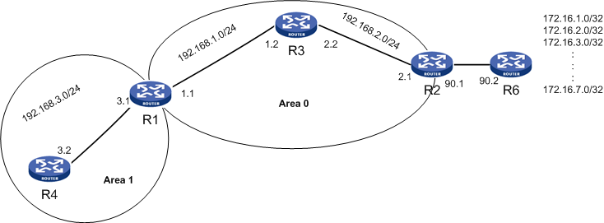

The summarization of multiple subnets into single network at an ASBR is performed only if **asbr-summary** command is configured under ospf view of an ASBR. The missing command or incorrect configuration of command does not summarize the multiple external routes. By summarizing these multiple subnets, the routers in ospf domain receive a single route entry for all the multiple external route entries. This shortens the routing table size thus reducing the memory consumption.

Requirement: All the routers in area 0 and area 1 must receive the summarized external routes.

#### Problem

Router R3 is not receiving the summarized external routes

Verify the routing table of R3.

<R3>disp ospf routing

OSPF Process 1 with Router ID 3.3.3.3

Routing Tables

Routing for Network

Destination Cost Type NextHop AdvRouter Area

192.168.1.0/24 1 Transit 192.168.1.2 3.3.3.3 0.0.0.0

192.168.2.0/24 1 Transit 192.168.2.2 3.3.3.3 0.0.0.0

Routing for ASEs

Destination Cost Type Tag NextHop AdvRouter

172.16.1.0/24 1 Type2 1 192.168.2.1 2.2.2.2

172.16.2.0/24 1 Type2 1 192.168.2.1 2.2.2.2

172.16.3.0/24 1 Type2 1 192.168.2.1 2.2.2.2

172.16.4.0/24 1 Type2 1 192.168.2.1 2.2.2.2

172.16.5.0/24 1 Type2 1 192.168.2.1 2.2.2.2

172.16.6.0/24 1 Type2 1 192.168.2.1 2.2.2.2

172.16.7.0/24 1 Type2 1 192.168.2.1 2.2.2.2

Total Nets: 9

Intra Area: 2 Inter Area: 0 ASE: 7 NSSA: 0

In the above scenario, Router R3 is receiving all the detailed routes and no summary external routes.

#### Troubleshooting

Verify the configuration on Router R2.

[R2]disp current-configuration | begin ospf

ospf 1

import-route static

area 0.0.0.0

network 192.168.2.0 0.0.0.255

Though Router R2 is properly configured for importing static routes, no configuration has been done to summarize those external routes. In brief, the asbr-summary command is missing from Router R2.

#### Resolution

Configure the command **asbr-summary** under the ospf view on R2

[R2]ospf 1

[R2-ospf-1]asbr-summary 172.16.0.0 16

#### Result

Verify the routing table of R3.

<R3>disp ospf routing

OSPF Process 1 with Router ID 3.3.3.3

Routing Tables

Routing for Network

Destination Cost Type NextHop AdvRouter Area

192.168.1.0/24 1 Transit 192.168.1.2 3.3.3.3 0.0.0.0

192.168.2.0/24 1 Transit 192.168.2.2 3.3.3.3 0.0.0.0

Routing for ASEs

Destination Cost Type Tag NextHop AdvRouter

172.16.0.0/16 2 Type2 1 192.168.2.1 2.2.2.2

Total Nets: 3

Intra Area: 2 Inter Area: 0 ASE: 1 NSSA: 0

R3 is now receiving the summary routes.

### Problem 2: ABR not summarizing the routes

The summarization of multiple subnets into single network at an ABR is performed only if abr-summary command is configured under proper area of ospf view of an ABR. The missing command or incorrect configuration of command does not summarize the multiple routes, as shown in .

#### Case (i): abr-summary command missing

ABR not summarizing routes

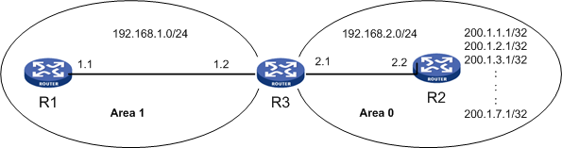

#### Problem

Router R1 is not receiving the summarized route

Verify the ospf routing table of R1.

[R1]disp ospf routing

OSPF Process 1 with Router ID 1.1.1.1

Routing Tables

Routing for Network

Destination Cost Type NextHop AdvRouter Area

200.1.1.1/32 2 Inter 192.168.1.2 3.3.3.3 0.0.0.1

200.1.2.1/32 2 Inter 192.168.1.2 3.3.3.3 0.0.0.1

200.1.3.1/32 2 Inter 192.168.1.2 3.3.3.3 0.0.0.1

200.1.4.1/32 2 Inter 192.168.1.2 3.3.3.3 0.0.0.1

200.1.5.1/32 2 Inter 192.168.1.2 3.3.3.3 0.0.0.1

200.1.6.1/32 2 Inter 192.168.1.2 3.3.3.3 0.0.0.1

200.1.7.1/32 2 Inter 192.168.1.2 3.3.3.3 0.0.0.1

192.168.1.0/24 1 Transit 192.168.1.1 3.3.3.3 0.0.0.1

192.168.2.0/24 2 Inter 192.168.1.2 3.3.3.3 0.0.0.1

Total Nets: 9

Intra Area: 1 Inter Area: 8 ASE: 0 NSSA: 0

R1 is receiving all the detailed external routes.

#### Troubleshooting

Verify the ospf configuration on R3.

<R3> display current-configuration | begin ospf

ospf 1

area 0.0.0.0

network 192.168.2.0 0.0.0.255

area 0.0.0.1

network 192.168.1.0 0.0.0.255

The **abr-summary** command is missing from the ospf configuration. Hence, R3 is not summarizing the area 0 subnets before transmitting them to area 1.

#### Resolution

Add the command abr-summary under area 0 of Router R3’s ospf view to summarize the detailed routes before advertising.

The commands configured on R3 are as follows:

[R3]ospf 1

[R3-ospf-1]area 0

[R3-ospf-1-area-0.0.0.0]abr-summary 200.1.0.0 16

#### Result

Verify the routing table of R1.

[R1]disp ospf routing

OSPF Process 1 with Router ID 1.1.1.1

Routing Tables

Routing for Network

Destination Cost Type NextHop AdvRouter Area

200.1.0.0/16 2 Inter 192.168.1.2 3.3.3.3 0.0.0.1

192.168.1.0/24 1 Transit 192.168.1.1 3.3.3.3 0.0.0.1

192.168.2.0/24 2 Inter 192.168.1.2 3.3.3.3 0.0.0.1

Total Nets: 3

Intra Area: 1 Inter Area: 2 ASE: 0 NSSA: 0

R1 is now receiving only the summary routes from R3

#### Case (ii) abr-summary command configured under wrong area

In this scenario, the networks 200.1.1.1/32, 200.1.2.1/32 and so on are advertised in area 0 by Router R2. If R3 has to summarize these routes, then the abr-summary command has to be configured under area 0 on Router R3 or else summarization of these routes does not take place, as shown in .

Incorrect ABR-summary command configured



The configuration of summary command is area specific for an ABR. An ABR can summarize the routes in an area in which the more detailed routes are advertised.

#### Problem

R1 is not receiving the summary routes

Verify the routing table of R1.

[R1]disp ospf routing

OSPF Process 1 with Router ID 1.1.1.1

Routing Tables

Routing for Network

Destination Cost Type NextHop AdvRouter Area

200.1.1.1/32 2 Inter 192.168.1.2 3.3.3.3 0.0.0.1

200.1.2.1/32 2 Inter 192.168.1.2 3.3.3.3 0.0.0.1

200.1.3.1/32 2 Inter 192.168.1.2 3.3.3.3 0.0.0.1

200.1.4.1/32 2 Inter 192.168.1.2 3.3.3.3 0.0.0.1

200.1.5.1/32 2 Inter 192.168.1.2 3.3.3.3 0.0.0.1

200.1.6.1/32 2 Inter 192.168.1.2 3.3.3.3 0.0.0.1

200.1.7.1/32 2 Inter 192.168.1.2 3.3.3.3 0.0.0.1

192.168.1.0/24 1 Transit 192.168.1.1 3.3.3.3 0.0.0.1

192.168.2.0/24 2 Inter 192.168.1.2 3.3.3.3 0.0.0.1

Total Nets: 9

Intra Area: 1 Inter Area: 8 ASE: 0 NSSA: 0

R1 is receiving all the detailed routes for 200.1.x.x networks.

#### Troubleshooting

Check the configuration at R3.

<R3>display current-configuration | begin ospf

ospf 1

area 0.0.0.0

network 192.168.2.0 0.0.0.255

area 0.0.0.1

abr-summary 200.1.0.0 255.255.0.0

network 192.168.1.0 0.0.0.255

The above display command shows that abr-summary command is configured under area 1 because this command has not plunged into action. The correct configuration would be to summarize the detailed routes under the area in which it is advertised. In the example, area 0 is where these detailed routes are advertised by Router R2. So, configure the abr-summary command under area 0 of the ABR (R3).

#### Resolution

Configure the command abr-summary under area 0.

[R3]ospf 1

[R3-ospf-1]area 1

[R3-ospf-1-area-0.0.0.1]undo abr-summary 200.1.0.0 16

[R3-ospf-1-area-0.0.0.1]quit

[R3-ospf-1]area 0

[R3-ospf-1-area-0.0.0.0]abr-summary 200.1.0.0 16

#### Result

Verify the routing table of R1.

[R1]disp ospf routing

OSPF Process 1 with Router ID 1.1.1.1

Routing Tables

Routing for Network

Destination Cost Type NextHop AdvRouter Area

200.1.0.0/16 2 Inter 192.168.1.2 3.3.3.3 0.0.0.1

192.168.1.0/24 1 Transit 192.168.1.1 3.3.3.3 0.0.0.1

192.168.2.0/24 2 Inter 192.168.1.2 3.3.3.3 0.0.0.1

Total Nets: 3

Intra Area: 1 Inter Area: 2 ASE: 0 NSSA: 0

R1 is now receiving only summary routes.

### Problem 3: Mistake in the configuration of summary command

In this scenario, R2 is advertising the networks 200.1.1.1/32, 200.1.2.1/32, and so on. These networks could be summarized at an ABR (R3) into 200.1.0.0/16 network and advertised to area 1. Hence, the area 1 router, here R1, receives only one route entry instead of 7 different route entries, as shown in .

Incorrect configuration of summary command

****

The summary command is different for an ASBR and ABR. For an ASBR, the summary command is configured directly under ospf view. For an ABR, the summary command is configured under the specific area to which the detailed routes belong.

Any mistake in the configuration of a summary command leads to non-summarization of routes.

#### Problem

Router R1 is not receiving the summarized inter-area routes

Verify the ospf routing table of R1 using the command display ospf routing.

[R1]disp ospf routing

OSPF Process 1 with Router ID 1.1.1.1

Routing Tables

Routing for Network

Destination Cost Type NextHop AdvRouter Area

200.1.1.1/32 2 Inter 192.168.1.2 3.3.3.3 0.0.0.1

200.1.2.1/32 2 Inter 192.168.1.2 3.3.3.3 0.0.0.1

200.1.3.1/32 2 Inter 192.168.1.2 3.3.3.3 0.0.0.1

200.1.4.1/32 2 Inter 192.168.1.2 3.3.3.3 0.0.0.1

200.1.5.1/32 2 Inter 192.168.1.2 3.3.3.3 0.0.0.1

200.1.6.1/32 2 Inter 192.168.1.2 3.3.3.3 0.0.0.1

200.1.7.1/32 2 Inter 192.168.1.2 3.3.3.3 0.0.0.1

192.168.1.0/24 1 Transit 192.168.1.1 3.3.3.3 0.0.0.1

192.168.2.0/24 2 Inter 192.168.1.2 3.3.3.3 0.0.0.1

Total Nets: 9

Intra Area: 1 Inter Area: 8 ASE: 0 NSSA: 0

R1 is receiving all the detailed routes.

#### Troubleshooting

Check the ospf configuration on R3.

<R3> display current-configuration | begin ospf

ospf 1

asbr-summary 200.1.0.0 255.255.0.0

area 0.0.0.0

network 192.168.2.0 0.0.0.255

area 0.0.0.1

network 192.168.1.0 0.0.0.255

R3 is an ABR and not an ASBR. The command "asbr-summary" is the incorrect command for summarization at an ABR.

#### Resolution

Remove the asbr-summary command from the ospf view and configure abr-summary command under area 0 to summarize the detailed routes.

The commands configured on R3 are as follows:

[R3]ospf 1

[R3-ospf-1]undo asbr-summary 200.1.0.0 16

[R3-ospf-1]area 0

[R3-ospf-1-area-0.0.0.0]abr-summary 200.1.0.0 16

#### Result

Verify the routing table of R1.

[R1]disp ospf routing

OSPF Process 1 with Router ID 1.1.1.1

Routing Tables

Routing for Network

Destination Cost Type NextHop AdvRouter Area

200.1.0.0/16 2 Inter 192.168.1.2 3.3.3.3 0.0.0.1

192.168.1.0/24 1 Transit 192.168.1.1 3.3.3.3 0.0.0.1

192.168.2.0/24 2 Inter 192.168.1.2 3.3.3.3 0.0.0.1

Total Nets: 3

Intra Area: 1 Inter Area: 2 ASE: 0 NSSA: 0

R1 is now receiving only the summary routes from R3

### Problem 4: ACL/IP-Prefix blocking the summary routes

Router R3 is an ABR connecting area 0 to area 1. In the scenario, it is required that Router R1 must receive the summary routes of the detailed subnets configured in area 0, as shown in .

ACL/IP-Prefix blocking



#### This is a common problem in network. Configuration of ACL on a network always tends to disrupt the new configurations on the devices. If a network engineer forgets to add or remove ip prefix from the acl, the new configurations may not work properly, creating chaos in the network. Hence, if security is maintained using ACL on a network, then these acls must be checked and updated before configuring any new requirement on the device.

#### Problem

R1 is not receiving the summary routes

Verify the ospf routing table of R1.

<R1>disp ospf routing

OSPF Process 1 with Router ID 1.1.1.1

Routing Tables

Routing for Network

Destination Cost Type NextHop AdvRouter Area

192.168.1.0/24 1 Transit 192.168.1.1 3.3.3.3 0.0.0.1

192.168.2.0/24 2 Inter 192.168.1.2 3.3.3.3 0.0.0.1

Total Nets: 2

Intra Area: 1 Inter Area: 1 ASE: 0 NSSA: 0

R1 is neither receiving the summary routes nor the detailed routes for 200.1.x.x network.

#### Troubleshooting

Check the ospf configuration on R3.

<R3>display current-configuration | begin ospf

ospf 1

area 0.0.0.0

abr-summary 200.1.0.0 255.255.0.0

network 192.168.2.0 0.0.0.255

area 0.0.0.1

filter 3000 import

network 192.168.1.0 0.0.0.255

Appropriate summarization command is configured for the 200.1.x.x network under area 0 of Router R3. But these routes are not getting advertised to R1.

The ospf configuration on R3 displays a filter command configured under area 1.

Check the filter policy configured under R3.

[R3]disp current-configuration

#

:

:

#

acl number 3000

rule 50 permit ip source 192.168.1.0 0.0.0.255

rule 51 permit ip source 192.168.2.0 0.0.0.255

rule 100 deny ip

#

The ACL configured under area 0 does not permit the routing update for 200.1.x.x network to reach Router R1.

#### Resolution

Modify the ACL to advertise the summary routes into area 1.

Listed below are the commands configured on R3

[R3]acl number 3000

[R3-acl-adv-3000]rule 52 permit ip source 200.1.0.0 0.0.255.255

#### Result

Verify the ospf routing table of R1.

<R1>disp ospf routing

OSPF Process 1 with Router ID 1.1.1.1

Routing Tables

Routing for Network

Destination Cost Type NextHop AdvRouter Area

200.1.0.0/16 2 Inter 192.168.1.2 3.3.3.3 0.0.0.1

192.168.1.0/24 1 Transit 192.168.1.1 3.3.3.3 0.0.0.1

192.168.2.0/24 2 Inter 192.168.1.2 3.3.3.3 0.0.0.1

Total Nets: 3

Intra Area: 1 Inter Area: 2 ASE: 0 NSSA: 0

After Modifying the ACL, Router R1 is receiving the summary routes.

Similar problem occurs when IP-Prefix is configured incorrectly and a filter command is added under area 0, as shown below.

[R3]disp current-configuration | begin ospf

ospf 1

area 0.0.0.0

abr-summary 200.1.0.0 255.255.0.0

filter ip-prefix block\_any export

network 192.168.2.0 0.0.0.255

area 0.0.0.1

network 192.168.1.0 0.0.0.255

Check the IP-prefix list.

[R3]disp ip ip-prefix

Prefix-list block\_any

Permitted 2

Denied 14

index: 10 permit 192.168.1.0/24

index: 20 permit 192.168.2.0/24

index: 50 deny 0.0.0.0/0

The IP-Prefix list drops all the routing updates for 200.1.x.x network from being advertised.

#### Resolution

Modify the IP-Prefix list to permit the 200.1.x.x networks.

[R3]ip ip-prefix block\_any index 30 permit 200.1.1.1 32

[R3]ip ip-prefix block\_any index 31 permit 200.1.2.1 32

[R3]ip ip-prefix block\_any index 32 permit 200.1.3.1 32

[R3]ip ip-prefix block\_any index 33 permit 200.1.4.1 32

[R3]ip ip-prefix block\_any index 34 permit 200.1.5.1 32

[R3]ip ip-prefix block\_any index 35 permit 200.1.6.1 32

[R3]ip ip-prefix block\_any index 36 permit 200.1.7.1 32

A single permit command for any one subnet suffices the appearance of summary route in the routing table. That is, if only 200.1.1.1/32 is permitted under the ip-prefix list, the routing table of R1 shows the summary route of 200.1.0.0/16. This does not mean that other subnets would be reachable. Only 200.1.1.1 network can be reached as it is the only subnet permitted under IP-Prefix list. On adding the permit statements for the remaining subnets, it allows the reachability of those subnets.

#### Result

Verify the ospf routing table of R1.

<R1>disp ospf routing

OSPF Process 1 with Router ID 1.1.1.1

Routing Tables

Routing for Network

Destination Cost Type NextHop AdvRouter Area

200.1.0.0/16 2 Inter 192.168.1.2 3.3.3.3 0.0.0.1

192.168.1.0/24 1 Transit 192.168.1.1 3.3.3.3 0.0.0.1

192.168.2.0/24 2 Inter 192.168.1.2 3.3.3.3 0.0.0.1

Total Nets: 3

Intra Area: 1 Inter Area: 2 ASE: 0 NSSA: 0

R1 is now receiving the summary routes for 200.1.x.x network.

# 4 Common problems in OSPF virtual-link configuration

OSPF area design concept clearly states that all the OSPF areas must directly connect to backbone area (area 0). In some cases where the newly configured area cannot be connected directly to area 0 due to lack of ports in the backbone area for interconnection or due to the limitation in the distance, these areas can still participate in ospf by forming a virtual-link with area 0. Virtual link is a logical link designed to connect a non-backbone area to area 0.

This chapter covers more on virtual link concept and the problems encountered while configuring it on a large network. The basic common mistakes committed while configuring a virtual link in a network are:

* Incorrect virtual link command
* Wrong Router ID chosen by the router
* Authentication enabled on backbone area
* Vlink peer stuck at INIT status: ACL blocking the establishment of Vlink peer relationship

## Basic concept

In the network scenarios where the non-backbone area cannot be directly connected to area 0 due to some limitations, virtual link concept comes into effect. Virtual link forms a tunnel through many routers to connect the ABR of the non-backbone area to area 0 ABR. The area through which the virtual link is configured is called a transit area. The OSPF packets are sent as tunneled packet between the two ABRs and are not multicasted over the ip 224.0.0.5. The LSAs shared between the two virtual link peers are sent with a *Do not age* option set. As a result the LSA never ages out and is not re-sent every 30 minutes.

Virtual link concept is also utilized to connect two discontiguous area 0s together via a transit area. Also, it can be used for redundancy of area 0 routers.

The various scenarios where virtual link configuration is required are as follows:

* Discontiguous area 0
* Newly configured area is disconnected from area 0
* Redundancy for area 0 routers

### Discontiguous area 0

If two networks already running OSPF need to be merged together, the process is complex. As both the networks would have their own backbone area. As per the OSPF area design concept, there should be only one backbone area in the whole network. As a result, merging both networks would mean reconfiguring the ospf on the entire routers. This could be simplified with the help of a virtual link. The two discontiguous area 0s can be connected together by configuring a virtual link between their ABRs, as shown in . Once the virtual link is established, the discontiguous area 0s get connected and act as a single backbone area.

Virtual link between ABRs

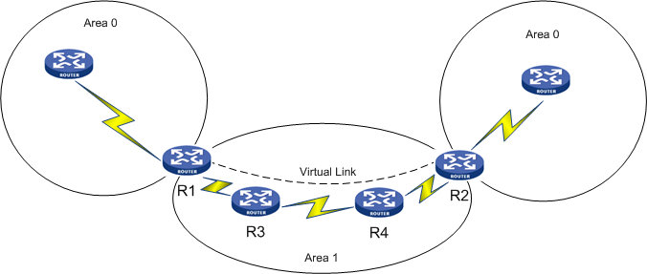

### Newly configured area is disconnected from area 0

For a scalable network, introducing new routers as per the requirement and making changes in the area design is not a difficult task. But for a cramped network design where all the resources have been used up, making any change in the network is a big task. If such a network design requires introducing new routers in an altogether different area, virtual link concept is the solution. Sometimes the lack of physical proximity results in non-backbone area routers stranded away from the backbone area. Though the distance cannot be cut down, the ospf design can definitely be modified to include the new area by creating a virtual link, as shown in .

Virtual link to non-backbone router

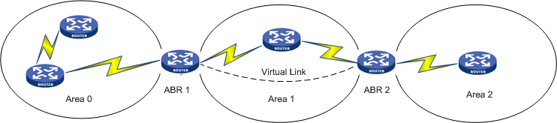

### Redundancy for area 0 routers

Sometimes the multiple link failures in area 0 may make the backbone area discontiguous affecting the ospf routing process. This could be avoided by creating a virtual link between the Area 0 ABRs via a transit area. So, even if the links of area 0 fails, it does not make the backbone area discontiguous, as shown in .

Virtual link between Area 0 ABRs

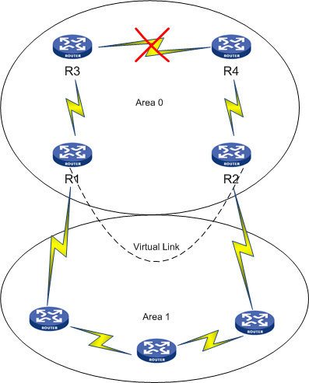

In , the failure of links between R3 and R4 makes area 0 discontiguous. But the virtual link configured between R1 and R2 still binds the area 0 routers together. This virtual link is configured via the *transit area* area 1.

### Problem 1: Incorrect virtual-link command

In this scenario, R4 is an ABR connecting area 1 and area 2. Since R4 is not directly connected to area 0, area 2 cannot participate in ospf routing. For area 2 to communicate with other areas in ospf domain, it must form a virtual-link with a backbone router. This virtual-link establishes a connection between area 2 and area 0, as shown in .

Router ID of R2: 2.2.2.2 and Router ID of R4: 4.4.4.4

Virtual link between area 2 and area 0

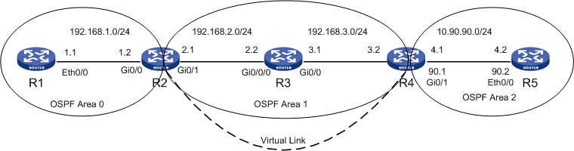

The configuration of virtual link is very simple. The vlink-peer command is followed by the Router ID of the device. The common mistake committed by network engineers is the inclusion of interface ip address in place of Router ID. As a result, virtual link does not come up.

#### Problem

Virtual link is not establishing between R2 and R4

Verify the ospf neighbor table using the command display ospf peer.

[R2]disp ospf peer

OSPF Process 1 with Router ID 2.2.2.2

Neighbor Brief Information

Area: 0.0.0.0

Router ID Address Pri Dead-Time Interface State

1.1.1.1 192.168.1.1 1 33 GE0/0 Full/BDR

Area: 0.0.0.1

Router ID Address Pri Dead-Time Interface State

3.3.3.3 192.168.2.2 1 34 GE0/1 Full/DR

No virtual link has been established between R2 and R4.

#### Troubleshooting

Check the ospf configuration on R2 and R4.

Router R4:

[R4]disp current-configuration | begin ospf

ospf 1

area 0.0.0.1

network 192.168.3.0 0.0.0.255

vlink-peer 192.168.2.1

area 0.0.0.2

network 10.90.90.0 0.0.0.255

Router R2:

[R2]disp current-configuration | begin ospf

ospf 1

area 0.0.0.0

network 192.168.1.0 0.0.0.255

area 0.0.0.1

network 192.168.2.0 0.0.0.255

vlink-peer 192.168.3.2

The configuration shows that vlink-peer command is followed by the interface ip. The vlink-peer command should be followed by the router-id.

#### Resolution

Correct the vlink-peer command configured for R2 and R4.

Router R4:

[R4]ospf 1

[R4-ospf-1]area 1

[R4-ospf-1-area-0.0.0.1]undo vlink-peer 192.168.2.1

[R4-ospf-1-area-0.0.0.1]vlink-peer 2.2.2.2

Router R2:

[R2]ospf 1

[R2-ospf-1]area 1

[R2-ospf-1-area-0.0.0.1]undo vlink-peer 192.168.3.2

[R2-ospf-1-area-0.0.0.1]vlink-peer 4.4.4.4

#### Result

Check the ospf virtual link status.

[R4]disp ospf peer

OSPF Process 1 with Router ID 4.4.4.4

Neighbor Brief Information

Area: 0.0.0.1

Router ID Address Pri Dead-Time Interface State

3.3.3.3 192.168.3.1 1 38 GE0/0 Full/BDR

Area: 0.0.0.2

Router ID Address Pri Dead-Time Interface State

5.5.5.5 10.90.90.2 1 37 GE0/1 Full/DR

Virtual link:

Router ID Address Pri Dead-Time Interface State

2.2.2.2 192.168.2.1 0 38 GE0/0 Full

R2 has formed successful virtual-link with R4.

### Problem 2: Wrong Router ID chosen by the router

In this scenario, although Router R4 has been configured with a loopback ip, the RID assumed by the router is the highest physical interface ip. As a result, R2 and R4 are not able to establish virtual link between them, as shown in .

Virtual link between R2 and R4

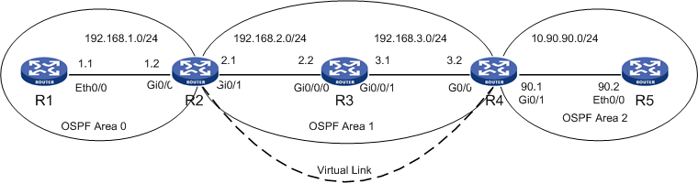

Configuration of Router ID is important in virtual-link configuration. If a Router ID is not globally configured on a device, then the router assumes the highest loopback ip as its RID. In absence of loopback ip, device assumes the highest physical interface ip as its RID. Once a router has chosen its RID from the interface IPs and if the engineer configures a new Router ID and wants the router to take up the new RID, then the engineer needs to either reboot the router or reload the ospf process to make the router accept the new Router ID configured.

In brief, if no loopback IP is configured and ospf process is running on all the routers, the router assumes the highest physical interface as its RID. Now when a new loopback ip is configured, Router does not change its RID to the loopback ip unless the device is rebooted or ospf process is reloaded.

#### Problem

Virtual link is not establishing between R2 and R4

Verify the ospf peer table of R2.

[R2]disp ospf peer

OSPF Process 1 with Router ID 2.2.2.2

Neighbor Brief Information

Area: 0.0.0.0

Router ID Address Pri Dead-Time Interface State

1.1.1.1 192.168.1.1 1 37 GE0/0 Full/DR

Area: 0.0.0.1

Router ID Address Pri Dead-Time Interface State

3.3.3.3 192.168.2.2 1 38 GE0/1 Full/DR

R2 is not establishing a vlink peer with R4.

#### Troubleshooting

Check the ospf vlink status.

[R2]disp ospf vlink

OSPF Process 1 with Router ID 2.2.2.2

Virtual Links

Virtual-link Neighbor-ID -> 4.4.4.4, Neighbor-State: Down

Interface: <Unknown>

Cost: 0 State: Down Type: Virtual

Transit Area: 0.0.0.1

Timers: Hello 10, Dead 40, Retransmit 5, Transmit Delay 1

The display ospf vlink command shows the neighbor status as down.

Check the ospf configuration of R2 and R4.

R4:

[R4]disp current-configuration | begin ospf

ospf 1

area 0.0.0.1

network 192.168.3.0 0.0.0.255

vlink-peer 2.2.2.2

area 0.0.0.2

network 10.90.90.0 0.0.0.255

R2:

ospf 1

area 0.0.0.0

network 192.168.1.0 0.0.0.255

area 0.0.0.1

network 192.168.2.0 0.0.0.255

vlink-peer 4.4.4.4

Router is properly configured for Virtual link.

Check the Router ID of both the routers. From the display osfp vlink command, it is clear that RID of router R2 is 2.2.2.2.

Now check the RID for R4.

[R4]disp ospf vlink

OSPF Process 1 with Router ID 192.168.3.2

Virtual Links

Virtual-link Neighbor-ID -> 2.2.2.2, Neighbor-State: Down

Interface: 192.168.3.2 (GigabitEthernet0/0)

Cost: 2 State: P-2-P Type: Virtual

Transit Area: 0.0.0.1

Timers: Hello 10, Dead 40, Retransmit 5, Transmit Delay 1

R4 shows that the RID is 192.168.3.2, whereas the vlink-peer command configured on R2 includes the RID of R4 as 4.4.4.4.

Check the interfaces configured for R4 to verify the loopback ip.

[R4]disp int brief

The brief information of interface(s) under route mode:

Link: ADM - administratively down; Stby - standby

Protocol: (s) - spoofing

Interface Link Protocol Main IP Description

Aux0 DOWN DOWN --

Cellular0/0 DOWN DOWN --

GE0/0 UP UP 192.168.3.2

GE0/1 UP UP 10.90.90.1

Loop0 UP UP(s) 4.4.4.4

NULL0 UP UP(s) --

S5/0 DOWN DOWN --

S5/1 DOWN DOWN --

S5/2 DOWN DOWN --

S5/3 DOWN DOWN --

Loopback ip is configured; still router assumes the highest physical interface as its Router ID.

#### Resolution

Globally configure the Router ID of R4 as 4.4.4.4 and reload the ospf process.

[R4]router

[R4]router id 4.4.4.4

[R4]return

<R4>reset ospf process

Warning : Reset OSPF process? [Y/N]:y

#### Result

Verify the vlink peer status on R4.

<R4>disp ospf peer

OSPF Process 1 with Router ID 4.4.4.4

Neighbor Brief Information

Area: 0.0.0.1

Router ID Address Pri Dead-Time Interface State

3.3.3.3 192.168.3.1 1 31 GE0/0 Full/DR

Area: 0.0.0.2

Router ID Address Pri Dead-Time Interface State

5.5.5.5 10.90.90.2 1 38 GE0/1 Full/DR

Virtual link:

Router ID Address Pri Dead-Time Interface State

2.2.2.2 192.168.2.1 0 37 GE0/0 Full

R4 has formed successful vlink peering with R2.

The OSPF vlink status could also be checked using the command display ospf vlink.

Router R4:

<R4>disp ospf vlink

OSPF Process 1 with Router ID 4.4.4.4

Virtual Links

Virtual-link Neighbor-ID -> 2.2.2.2, Neighbor-State: Full

Interface: 192.168.3.2 (GigabitEthernet0/0)

Cost: 2 State: P-2-P Type: Virtual

Transit Area: 0.0.0.1

Timers: Hello 10, Dead 40, Retransmit 5, Transmit Delay 1

Router R2:

[R2]disp ospf vlink

OSPF Process 1 with Router ID 2.2.2.2

Virtual Links

Virtual-link Neighbor-ID -> 4.4.4.4, Neighbor-State: Full

Interface: 192.168.2.1 (GigabitEthernet0/1)

Cost: 2 State: P-2-P Type: Virtual

Transit Area: 0.0.0.1

Timers: Hello 10, Dead 40, Retransmit 5, Transmit Delay 1

### Problem 3: Authentication enabled on Area 0

In a scenario where authentication is enabled, as shown in , on Area 0 any ABR peering with Area 0 must have authentication enabled with the same authentication-key configured. In failure to do so, peer relationship never comes up.

Authentication enabled

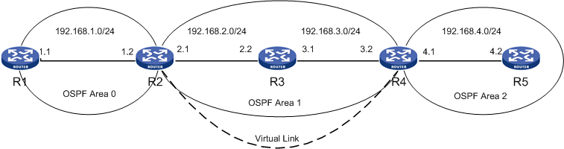

Area 0 is the Backbone area and hence an additional security is essential to safeguard the network from malpractices.

#### Problem

Virtual-Link is not established between R2 and R4

Verify the ospf peer status using the command display ospf peer.

<R2>disp ospf peer

OSPF Process 1 with Router ID 2.2.2.2

Neighbor Brief Information

Area: 0.0.0.0

Router ID Address Pri Dead-Time Interface State

1.1.1.1 192.168.1.1 1 37 GE0/0 Full/DR

Area: 0.0.0.1

Router ID Address Pri Dead-Time Interface State

3.3.3.3 192.168.2.2 1 39 GE0/1 Full/DR

No peering with R4 detected

#### Troubleshooting

Use debug command to check for any ospf events.

<R2>debugging ospf event

<R2>terminal debugging

OSPF 1 :OSPF received packet with mismatch authentication type :0 from interface Virtual Link.

The **debug ospf event** command states that R2 has received a packet with no authentication enabled on virtual link, which means that authentication is enabled on R2.

Check the OSPF configuration of R2 and R4.

Router R2:

<R2>display current-configuration | begin ospf

ospf 1

area 0.0.0.0

authentication-mode simple

network 192.168.1.0 0.0.0.255

area 0.0.0.1

network 192.168.2.0 0.0.0.255

vlink-peer 4.4.4.4

Router R4:

<R4>display current-configuration | begin ospf

ospf 1

area 0.0.0.1

network 192.168.3.0 0.0.0.255

vlink-peer 2.2.2.2

area 0.0.0.2

network 192.168.4.0 0.0.0.255

As seen in the ospf configuration on R2, Authentication is enabled for area 0. As a result, Router R4 is not able to form virtual link with R2.

#### Resolution

In this case where authentication is enabled on the backbone area router, create an area 0 on Router R4 and configure the authentication mode and authentication key the same as the backbone router.

The commands configured on R4 are as follows:

[R4]ospf 1

[R4-ospf-1]area 0

[R4-ospf-1-area-0.0.0.0]authentication-mode simple

[R4-ospf-1-area-0.0.0.0]quit

[R4-ospf-1]area 1

[R4-ospf-1-area-0.0.0.1]vlink-peer 2.2.2.2 simple hello

Also configure authentication on R4 for vlink peer.

[R2]ospf 1

[R2-ospf-1]area 1

[R2-ospf-1-area-0.0.0.1]vlink-peer 4.4.4.4 simple cisco

#### Result

Verify the virtual link peer status.

[R2]disp ospf peer

OSPF Process 1 with Router ID 2.2.2.2

Neighbor Brief Information

Area: 0.0.0.0

Router ID Address Pri Dead-Time Interface State

1.1.1.1 192.168.1.1 1 35 GE0/0 Full/DR

Area: 0.0.0.1

Router ID Address Pri Dead-Time Interface State

3.3.3.3 192.168.2.2 1 37 GE0/1 Full/DR

Virtual link:

Router ID Address Pri Dead-Time Interface State

4.4.4.4 192.168.3.2 0 30 GE0/1 Full

R2 has established successful vlink peering with R4.

### Problem 4: Vlink peer status stuck at INIT state

If an ACL is blocking the IP traffic, it may result in the virtual link being stuck at INIT state, as shown in .

Vlink-peer relationship stuck at INIT

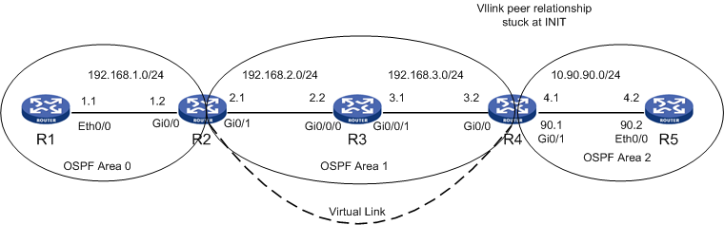

Chapter 1 covers the common issues regarding the OSPF neighbor relation getting stuck at INIT state. The same issue occurs on a virtual link configuration.

#### Problem

The vlink peer status stuck at INIT state

Verify the ospf peer table of R4 using the command display ospf peer.

[R4]disp ospf peer

OSPF Process 1 with Router ID 4.4.4.4

Neighbor Brief Information

Area: 0.0.0.1

Router ID Address Pri Dead-Time Interface State

3.3.3.3 192.168.3.1 1 31 GE0/0 Full/BDR

Area: 0.0.0.2

Router ID Address Pri Dead-Time Interface State

5.5.5.5 10.90.90.2 1 38 GE0/1 Full/DR

Virtual link:

Router ID Address Pri Dead-Time Interface State

2.2.2.2 192.168.2.1 0 30 GE0/0 Init

The virtual link peer status is stuck at INIT state.

#### Troubleshooting

Check the OSPF configurations on R2 and R4.

Router R4:

<R4>display current-configuration | begin ospf

ospf 1

area 0.0.0.1

network 192.168.3.0 0.0.0.255

vlink-peer 2.2.2.2

area 0.0.0.2

network 10.90.90.0 0.0.0.255

Router R2:

<R2>display current-configuration | begin ospf

ospf 1

area 0.0.0.0

network 192.168.1.0 0.0.0.255

area 0.0.0.1

network 192.168.2.0 0.0.0.255

vlink-peer 4.4.4.4

The OSPF configuration is correct. Check the interface configuration to verify the presence of ACL.

<R4> display current-configuration

:

:

interface GigabitEthernet0/0

port link-mode route

firewall packet-filter 3000 outbound

ip address 192.168.3.2 255.255.255.0

ospf network-type broadcast

The interface configuration shows an ACL configured on outbound traffic. Check the ACL configuration.

<R4> display current-configuration

:

:

acl number 3000

rule 50 permit ip destination 224.0.0.5 0

rule 51 permit ip destination 192.168.3.0 0.0.0.255

rule 100 deny ip

The ACL configured on R4 allows the multicast traffic on 224.0.0.5 and unicast on 192.168.3.0 network. As a result, R4 is able to form a successful peering with R3 on interface Gi 0/0. Since all other IP traffics are blocked, R4 is not able to form Neighbor relation with R2.

#### Resolution

Modify the ACL to allow ip traffic to the destination 192.168.2.0.

[R4]acl number 3000

[R4-acl-adv-3000]rule 52 permit ip destination 192.168.2.0 0.0.0.255

#### Result

Verify the ospf peer status.

[R4]disp ospf peer

OSPF Process 1 with Router ID 4.4.4.4

Neighbor Brief Information

Area: 0.0.0.1

Router ID Address Pri Dead-Time Interface State

3.3.3.3 192.168.3.1 1 30 GE0/0 Full/BDR

Area: 0.0.0.2

Router ID Address Pri Dead-Time Interface State

5.5.5.5 10.90.90.2 1 37 GE0/1 Full/DR

Virtual link:

Router ID Address Pri Dead-Time Interface State

2.2.2.2 192.168.2.1 0 39 GE0/0 Full

R4 has formed successful peering with R2.