BGP Troubleshooting Guide

Abstract

The main purpose of this guide is to illustrate various issues encountered while configuring BGP on HP routers. This troubleshooting guide discusses ways of analyzing a problem and the corrective measures to resolve the issue for both, ProVision and Comware. This guide assumes that readers are familiar with the OSI layer and IP routing protocols.

|  |  |
| --- | --- |
| Part number: 5998-4042 | HP_S_K_1C_SM |

© Copyright 2012 Hewlett-Packard Development Company, L.P.

No part of this documentation may be reproduced or transmitted in any form or by any means without prior written consent of Hewlett-Packard Development Company, L.P.

The information contained herein is subject to change without notice.

HEWLETT-PACKARD COMPANY MAKES NO WARRANTY OF ANY KIND WITH REGARD TO THIS MATERIAL, INCLUDING, BUT NOT LIMITED TO, THE IMPLIED WARRANTIES OF MERCHANTABILITY AND FITNESS FOR A PARTICULAR PURPOSE. Hewlett-Packard shall not be liable for errors contained herein or for incidental or consequential damages in connection with the furnishing, performance, or use of this material.

The only warranties for HP products and services are set forth in the express warranty statements accompanying such products and services. Nothing herein should be construed as constituting an additional warranty. HP shall not be liable for technical or editorial errors or omissions contained herein.

Contents

Contents

[1 BGP Neighbor Relation Establishment 3](#_Toc342570123)

[(ProVision) no BGP packets are being sent 3](#_Toc342570124)

[Troubleshooting 3](#_Toc342570125)

[Solution 4](#_Toc342570126)

[Verification 4](#_Toc342570127)

[Incorrect IP address configured on the interface 5](#_Toc342570128)

[Troubleshooting 5](#_Toc342570129)

[Solution 8](#_Toc342570130)

[Verification 8](#_Toc342570131)

[Incorrect neighbor IP configured under peer command 9](#_Toc342570132)

[Troubleshooting 9](#_Toc342570133)

[Solution 10](#_Toc342570134)

[Verification 11](#_Toc342570135)

[Incorrect AS number included under peer command 11](#_Toc342570136)

[Troubleshooting 12](#_Toc342570137)

[Solution 13](#_Toc342570138)

[Verification 13](#_Toc342570139)

[Loopback IP not configured for indirectly connected routers 14](#_Toc342570140)

[Troubleshooting 14](#_Toc342570141)

[Solution 17](#_Toc342570142)

[Verification 17](#_Toc342570143)

[Missing Command connect-interface or update-source 18](#_Toc342570144)

[Troubleshooting 18](#_Toc342570145)

[Solution 20](#_Toc342570146)

[Verification 20](#_Toc342570147)

[Missing Command ebgp-max-hop or ebgp-multihop 21](#_Toc342570148)

[Troubleshooting 22](#_Toc342570149)

[Solution 22](#_Toc342570150)

[Verification 22](#_Toc342570151)

[Connect-interface or update-source configured for directly connected peers 23](#_Toc342570152)

[Troubleshooting 23](#_Toc342570153)

[Solution 24](#_Toc342570154)

[Verification 25](#_Toc342570155)

[No route to reach loopback interface 25](#_Toc342570156)

[Troubleshooting 26](#_Toc342570157)

[Solution 29](#_Toc342570158)

[Verification 29](#_Toc342570159)

[Ignore or shutdown command configured on BGP peer 30](#_Toc342570160)

[Troubleshooting 30](#_Toc342570161)

[Solution 32](#_Toc342570162)

[Verification 32](#_Toc342570163)

[ACL Blocking the TCP/BGP Packets 32](#_Toc342570164)

[Troubleshooting 33](#_Toc342570165)

[Solution 36](#_Toc342570166)

[Verification 36](#_Toc342570167)

[Same Router-id configured on peers (Comware Only) 37](#_Toc342570168)

[Troubleshooting 37](#_Toc342570169)

[Solution 38](#_Toc342570170)

[Verification 38](#_Toc342570171)

[2 BGP Routing Issues 39](#_Toc342570172)

[BGP router not installing the routes in routing table 39](#_Toc342570173)

[Network command is not announcing the configured route 39](#_Toc342570174)

[Next-hop-local/next-hop-self command is missing 44](#_Toc342570175)

[Troubleshooting 45](#_Toc342570176)

[Solution 46](#_Toc342570177)

[Verification 47](#_Toc342570178)

[BGP router not advertising the routes 48](#_Toc342570179)

[Router is not receiving External-AS routes or routes that are more than one hop away. 48](#_Toc342570180)

[Problem 49](#_Toc342570181)

[Troubleshooting 49](#_Toc342570182)

[Solution 52](#_Toc342570183)

[Verification 52](#_Toc342570184)

[3 BGP Confederation issues (Comware Only) 54](#_Toc342570185)

[BGP Confederation peer relation not establishing: Incorrect peer IP configured 54](#_Toc342570186)

[Problem 54](#_Toc342570187)

[Troubleshooting 54](#_Toc342570188)

[Solution 55](#_Toc342570189)

[Verification 55](#_Toc342570190)

[Incorrect confederation peer-as configured 56](#_Toc342570191)

[Troubleshooting 56](#_Toc342570192)

[Solution 57](#_Toc342570193)

[Verification 57](#_Toc342570194)

[Missing confederation peer-as <AS number> command 57](#_Toc342570195)

[Troubleshooting 58](#_Toc342570196)

[Solution 59](#_Toc342570197)

[Verification 59](#_Toc342570198)

[4 BGP Route Aggregation issue 60](#_Toc342570199)

[Router receiving both detailed routes as well as summary route (Comware only) 60](#_Toc342570200)

[Problem 60](#_Toc342570201)

[Troubleshooting 60](#_Toc342570202)

[Solution 61](#_Toc342570203)

[A manually configured summary route is not being advertised (ProVision only) 63](#_Toc342570204)

[Problem 63](#_Toc342570205)

[Troubleshooting 63](#_Toc342570206)

[Solution 64](#_Toc342570207)

[Verification 65](#_Toc342570208)

# 1 BGP Neighbor Relation Establishment

Below listed are the common problems found in the BGP Neighbor relation establishment:

* (ProVision) no BGP packets are being sent
* Incorrect IP address configured on the interface
* Incorrect Neighbor IP configured under peer command
* Incorrect AS-number included under peer command
* Loopback ip not configured for indirectly connected routers
* Missing Command peer x.x.x.x connect-interface
* Missing Command peer x.x.x.x e-bgp maxhop <hops>
* Undesirable configuration of peer x.x.x.x connect-interface command for directly connected routers
* No route to reach loopback interface
* peer x.x.x.x ignore command configured under BGP configuration
* ACL blocking TCP/BGP packets
* Duplicate router-id

## (ProVision) no BGP packets are being sent

BGP appears to be configured correctly however neither router is sending any BGP packets, and BGP peering relationships are not being established.

### Troubleshooting

Use the show ip bgp summary command to determine if packets are being sent. The State of “idle” indicates no packets are being sent.

RT1(bgp)# show ip bgp summary

Peer Information

Remote Address Remote-AS Local-AS State Admin Status

--------------- --------- -------- ------------- ------------

20.1.1.2 2 1 Idle Start

To determine the actual status of the BGP protocol, use the show ip bgp general command.

RT1# show ip bgp general

BGP Configuration Information

Enable : No Local AS : 1

Local Distance : 200 Local Identifier : 1.1.1.0

Default Metric : Maximum Prefix : 4294967295

Always Compare MED : No Cluster-ID :

Miss MED As Worst : No Compare Router ID : No

Ignore AS-Path Length : No Open On Accept : No

Compare Origin Id : No Allow-AS in : 0

External Distance : 20 Internal Distance : 200

Log Neighbor Changes : No C-to-C Reflection : Yes

Log Prefix List :

Hold Time : 180 Keep Alive : 60

Restart Time : 120 Stalepath Time : 360

Non Stop Forwarding : Disabled

### Solution

On ProVision platforms, the routing protocol must be explicitly enabled. The default status is disabled. The BGP routing protocol must be manually enabled inside the BGP context.

RT1(config)# router bgp 1

RT1(bgp)# enable

RT1(bgp)# show ip bgp general

BGP Configuration Information

Enable : Yes Local AS : 1

Local Distance : 200 Local Identifier : 1.1.1.0

Default Metric : Maximum Prefix : 4294967295

Always Compare MED : No Cluster-ID :

Miss MED As Worst : No Compare Router ID : No

Ignore AS-Path Length : No Open On Accept : No

Compare Origin Id : No Allow-AS in : 0

External Distance : 20 Internal Distance : 200

Log Neighbor Changes : No C-to-C Reflection : Yes

Log Prefix List :

Hold Time : 180 Keep Alive : 60

Restart Time : 120 Stalepath Time : 360

Non Stop Forwarding : Disabled

### Verification

Use the show ip bgp summary command to verify the neighbor relationship.

R2(vlan-1)# show ip bgp summary

Peer Information

Remote Address Remote-AS Local-AS State Admin Status

--------------- --------- -------- ------------- ------------

20.1.1.1 6500 777 Established Start

## Incorrect IP address configured on the interface

An example of an incorrect IP address configured on the interface is shown in and .

Incorrect IP address

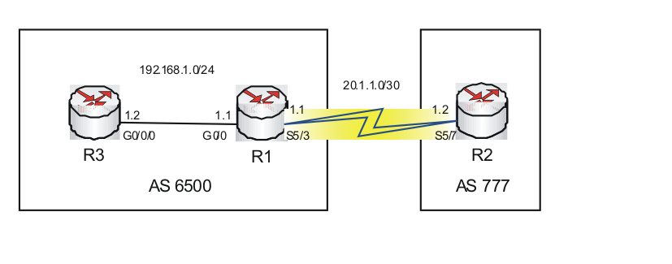

Incorrect IP address

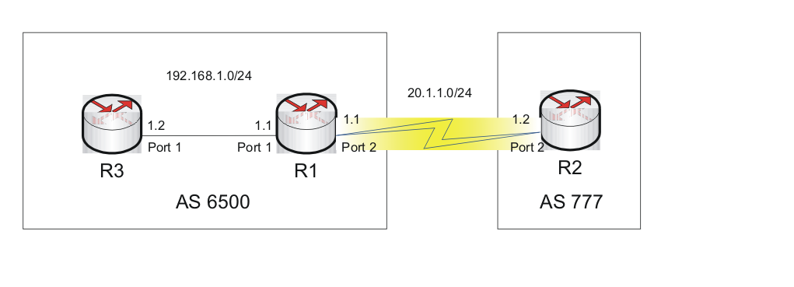

R1 is trying to establish a neighbor relationship with R2. R1 and R2 are directly connected routers belonging to different AS.

### Troubleshooting

Use the display bgp peerorshow ip bgp summary command to determine the BGP peer status.

Comware:

<R1>display bgp peer

BGP local router ID : 1.1.1.1

Local AS number : 6500

Total number of peers : 1 Peers in established state : 0

Peer AS MsgRcvd MsgSent OutQ PrefRcv Up/Down State

20.1.1.2 777 0 0 0 0 00:03:39 Active

ProVision:

R1(config)# show ip bgp summary

Peer Information

Remote Address Remote-AS Local-AS State Admin Status

--------------- --------- -------- ------------- ------------

20.1.1.2 777 6500 Connect Start

Check the ping reply.

Comware:

<R1>ping 20.1.1.2

PING 20.1.1.2: 56 data bytes, press CTRL\_C to break

Request time out

Request time out

Request time out

Request time out

Request time out

--- 20.1.1.2 ping statistics ---

5 packet(s) transmitted

0 packet(s) received

100.00% packet loss

ProVision:

R1(config)# ping 20.1.1.2

Request timed out.

R1 is not able to ping R2’s interface ip.

Check the interface status at both ends.

Router R1

Comware:

<R1>display int s 5/7

Serial5/7 current state: UP

Line protocol current state: UP

Description: Serial5/7 Interface

The Maximum Transmit Unit is 1500, Hold timer is 10(sec)

Internet Address is 20.1.1.1/24 Primary

Link layer protocol is PPP

ProVision:

R1(config)# show ip

Internet (IP) Service

IP Routing : Enabled

Default TTL : 64

Arp Age : 20

Domain Suffix :

DNS server :

| Proxy ARP

VLAN | IP Config IP Address Subnet Mask Std Local

-------------------- + ---------- --------------- --------------- ----------

DEFAULT\_VLAN | Manual 20.1.1.1 255.255.255.0 No No

Router R2

Comware:

[R2]display int s 5/3

Serial5/3 current state: UP

Line protocol current state: UP

Description: Serial5/3 Interface

The Maximum Transmit Unit is 1500, Hold timer is 10(sec)

Internet Address is 20.1.1.3/24 Primary

Link layer protocol is PPP

ProVision:

R2(bgp)# show ip

Internet (IP) Service

IP Routing : Enabled

Default TTL : 64

Arp Age : 20

Domain Suffix :

DNS server :

| Proxy ARP

VLAN | IP Config IP Address Subnet Mask Std Local

-------------------- + ---------- --------------- --------------- ----------

DEFAULT\_VLAN | Manual 20.1.1.3 255.255.255.0 No No

The IP address configured on R2 is not correct.

### Solution

Configure router R2 with correct Interface IP.

Comware:

[R2]int s 5/3

[R2-Serial5/3]ip add 20.1.1.2 24

ProVision:

R2(vlan-1)# no ip address

R2(vlan-1)# ip address 20.1.1.2/24

### Verification

Use the display bgp peer or show ip bgp summary command to verify the neighbor relationship.

Comware:

[R2]disp bgp peer

BGP local router ID : 2.2.2.2

Local AS number : 777

Total number of peers : 1 Peers in established state : 0

Peer AS MsgRcvd MsgSent OutQ PrefRcv Up/Down State

20.1.1.1 6500 0 0 0 0 00:11:01 Established

ProVision:

R2(vlan-1)# show ip bgp summary

Peer Information

Remote Address Remote-AS Local-AS State Admin Status

--------------- --------- -------- ------------- ------------

20.1.1.1 6500 777 Established Start

## Incorrect neighbor IP configured under peer command

An example of an incorrect neighbor IP address configured under peer command is shown in .

Incorrect neighbor IP address configured under peer command

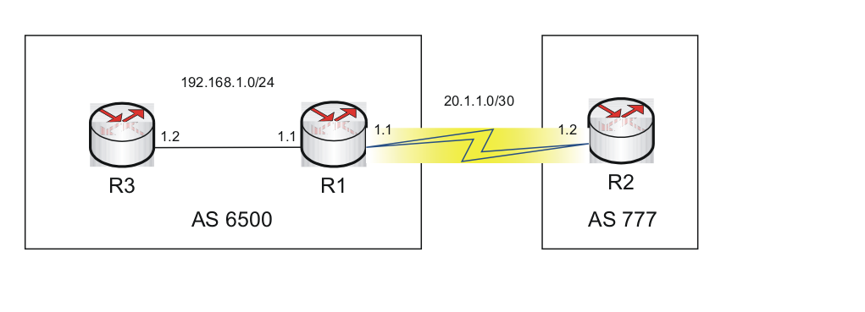

### Troubleshooting

Use the display bgp peerorshow ip bgp summary command to verify the peer status.

Comware:

[R1]disp bgp peer

BGP local router ID : 1.1.1.1

Local AS number : 6500

Total number of peers : 1 Peers in established state : 0

Peer AS MsgRcvd MsgSent OutQ PrefRcv Up/Down State

20.1.1.2 777 0 0 0 0 00:00:22 Active

ProVision:

R1(config)# show ip bgp summary

Peer Information

Remote Address Remote-AS Local-AS State Admin Status

--------------- --------- -------- ------------- ------------

20.1.1.2 777 6500 Active Start

BGP peer status is stuck in Active. Check the BGP configuration on both routers.

Router R1

Comware:

[R1]disp current-configuration | begin bgp

bgp 6500

undo synchronization

timer keepalive 6 hold 18

peer 20.1.1.2 as-number 777

ProVision:

R1(config)# show run

router bgp 6500

enable

neighbor 20.1.1.2 remote-as 777

exit

Router R2

Comware:  
[R2]disp current-configuration | begin bgp

bgp 777

undo synchronization

timer keepalive 5 hold 30

peer 20.1.1.3 as-number 6500

ProVision:

R2(config)# show run

router bgp 777

enable

neighbor 20.1.1.3 remote-as 6500

exit

The peer command is followed by the incorrect IP address on R2.

### Solution

Correct the peer command configured on R2.

Comware:

[R2]bgp 777

[R2-bgp]undo peer 20.1.1.3

[R2-bgp]peer 20.1.1.1 as-number 6500

ProVision:

R2(bgp)# router bgp 777

R2(bgp)# no neighbor 20.1.1.3

R2(bgp)# neighbor 20.1.1.1 remote-as 6500

### Verification

Verify the BGP peer relationship status.

Comware:

[R2]disp bgp peer

BGP local router ID : 2.2.2.2

Local AS number : 777

Total number of peers : 1 Peers in established state : 1

Peer AS MsgRcvd MsgSent OutQ PrefRcv Up/Down State

20.1.1.1 6500 3 3 0 0 00:00:10 Established

ProVision:

R1(config)# show ip bgp summary

Peer Information

Remote Address Remote-AS Local-AS State Admin Status

--------------- --------- -------- ------------- ------------

20.1.1.2 777 6500 Established Start

## Incorrect AS number included under peer command

An example of an incorrect AS number included under peer command is shown in .

Incorrect AS number included under peer command

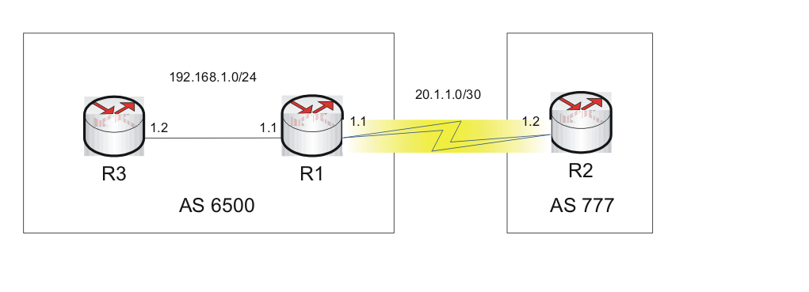

### Troubleshooting

Verify the BGP peer status using the command display bgp peerorshow ip bgp summary.

Comware:

<R1>disp bgp peer

BGP local router ID : 1.1.1.1

Local AS number : 6500

Total number of peers : 1 Peers in established state : 0

Peer AS MsgRcvd MsgSent OutQ PrefRcv Up/Down State

20.1.1.2 777 1 1 0 0 00:00:31 Active

ProVision:

R1(config)# show ip bgp summary

Peer Information

Remote Address Remote-AS Local-AS State Admin Status

--------------- --------- -------- ------------- ------------

20.1.1.2 777 6500 Active Start

Check the BGP configurations at both ends.

Router R1

Comware:

[R1]disp current-configuration | begin bgp

bgp 6500

undo synchronization

timer keepalive 6 hold 18

peer 20.1.1.2 as-number 777

ProVision:

R1(config)# show run

router bgp 6500

enable

neighbor 20.1.1.2 remote-as 777

exit

Router R2

Comware:

[R2]disp current-configuration | begin bgp

bgp 777

undo synchronization

timer keepalive 5 hold 30

peer 20.1.1.1 as-number 6502

ProVision:

R2(config)# show run

router bgp 777

enable

neighbor 20.1.1.1 remote-as 6502

exit

The as-number configured under BGP peer command on R2 is incorrect.

### Solution

Configure the Neighbor IP under correct AS

Comware:

[R2]bgp 777

[R2-bgp]undo peer 20.1.1.1

[R2-bgp]peer 20.1.1.1 as-number 6500

ProVision:

R2(bgp)# router bgp 777

R2(bgp)# no neighbor 20.1.1.1

R2(bgp)# neighbor 20.1.1.1 remote-as 6500

### Verification

Use display bgp peerorshow ip bgp summary command to verify the BGP peer status.

Comware:

[R2]disp bgp peer

BGP local router ID : 2.2.2.2

Local AS number : 777

Total number of peers : 1 Peers in established state : 1

Peer AS MsgRcvd MsgSent OutQ PrefRcv Up/Down State

20.1.1.1 6500 5 6 0 0 00:00:23 Established

ProVision:

R1(config)# show ip bgp summary

Peer Information

Remote Address Remote-AS Local-AS State Admin Status

--------------- --------- -------- ------------- ------------

20.1.1.2 777 6500 Established Start

## Loopback IP not configured for indirectly connected routers

An example of a loopback IP not configured for indirectly connected routers is shown in .

Loopback IP not configured for indirectly connected routers

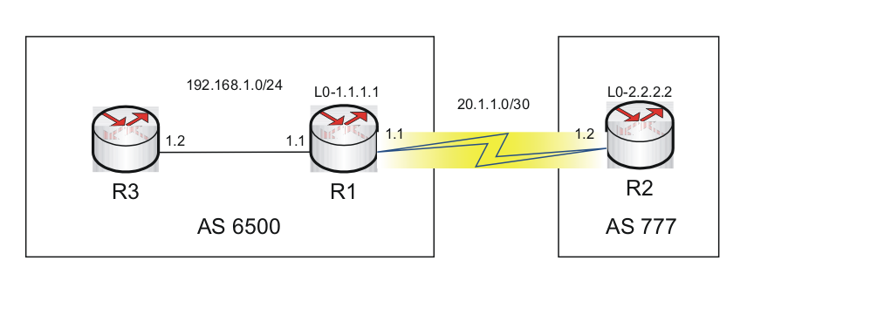

### Troubleshooting

Verify the BGP peer status using the command display bgp peerorshow ip bgp summary.

Comware:

[R1]disp bgp peer

BGP local router ID : 1.1.1.1

Local AS number : 6500

Total number of peers : 1 Peers in established state : 0

Peer AS MsgRcvd MsgSent OutQ PrefRcv Up/Down State

2.2.2.2 777 0 0 0 0 00:00:05 Idle

ProVision:

R1(lo-0)# show ip bgp summary

Peer Information

Remote Address Remote-AS Local-AS State Admin Status

--------------- --------- -------- ------------- ------------

2.2.2.2 777 6500 Idle Start

Comware:

[R2]disp bgp peer

BGP local router ID : 2.2.2.2

Local AS number : 777

Total number of peers : 1 Peers in established state : 0

Peer AS MsgRcvd MsgSent OutQ PrefRcv Up/Down State

1.1.1.1 6500 0 0 0 0 00:01:42 Active

ProVision:

R2(bgp)# show ip bgp summary

Peer Information

Remote Address Remote-AS Local-AS State Admin Status

--------------- --------- -------- ------------- ------------

1.1.1.1 6500 777 Connect Start

Ping the loopback IPs to verify connectivity.

Router R1

Comware:

[R1]ping 2.2.2.2

PING 2.2.2.2: 56 data bytes, press CTRL\_C to break

Reply from 2.2.2.2: bytes=56 Sequence=0 ttl=255 time=25 ms

Reply from 2.2.2.2: bytes=56 Sequence=1 ttl=255 time=26 ms

Reply from 2.2.2.2: bytes=56 Sequence=2 ttl=255 time=26 ms

Reply from 2.2.2.2: bytes=56 Sequence=3 ttl=255 time=26 ms

Reply from 2.2.2.2: bytes=56 Sequence=4 ttl=255 time=25 ms

--- 2.2.2.2 ping statistics ---

5 packet(s) transmitted

5 packet(s) received

0.00% packet loss

round-trip min/avg/max = 25/25/26 ms

ProVision:

R1(lo-0)# ping 2.2.2.2

2.2.2.2 is alive, time = 2 ms

Comware:

<R2>ping 1.1.1.1

PING 1.1.1.1: 56 data bytes, press CTRL\_C to break

Request time out

Request time out

Request time out

Request time out

Request time out

--- 1.1.1.1 ping statistics ---

5 packet(s) transmitted

0 packet(s) received

100.00% packet loss

ProVision:

R2(bgp)# ping 1.1.1.1

Request timed out.

Check the loopback interface of R1

Comware:

[R1]disp int lo 0

LoopBack0 current state: UP

Line protocol current state: UP (spoofing)

Description: LoopBack0 Interface

The Maximum Transmit Unit is 1536

Internet protocol processing : disabled

ProVision:

R1(lo-0)# show ip

Internet (IP) Service

IP Routing : Enabled

Default TTL : 64

Arp Age : 20

Domain Suffix :

DNS server :

| Proxy ARP

VLAN | IP Config IP Address Subnet Mask Std Local

-------------------- + ---------- --------------- --------------- ----------

DEFAULT\_VLAN | Manual 20.1.1.1 255.255.255.0 No No

The loopback interface is up but no ip has been configured.

|  |  |
| --- | --- |
|  | NOTE:  ProVision switch shows an absence of configuration on lo0. |

### Solution

Configure the loopback interface of R1.

Comware:

[R1]int lo 0

[R1-LoopBack0]ip add 1.1.1.1 32

ProVision:

R1(config)# int loop 0

R1(lo-0)# ip address 1.1.1.1

### Verification

Verify the BGP peer relationship status using the command display bgp peer.

Comware:

[R1]disp bgp peer

BGP local router ID : 1.1.1.1

Local AS number : 6500

Total number of peers : 1 Peers in established state : 1

Peer AS MsgRcvd MsgSent OutQ PrefRcv Up/Down State

2.2.2.2 777 2 2 0 0 00:00:26 Established

ProVision:

R1(lo-0)# show ip bgp summary

Peer Information

Remote Address Remote-AS Local-AS State Admin Status

--------------- --------- -------- ------------- ------------

2.2.2.2 777 6500 Established Start

## Missing Command connect-interface or update-source

An example of a missing command is shown in .

Missing command

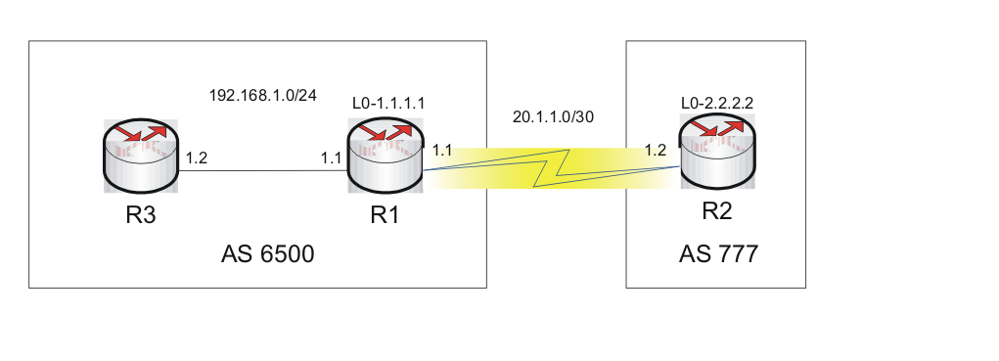

### Troubleshooting

Verify the BGP peer status using the command display bgp peer or show ip bgp summary.

Comware:

[R2]disp bgp peer

BGP local router ID : 2.2.2.2

Local AS number : 777

Total number of peers : 1 Peers in established state : 0

Peer AS MsgRcvd MsgSent OutQ PrefRcv Up/Down State

1.1.1.1 6500 0 0 0 0 00:00:11 Idle

ProVision:

R2(bgp)# show ip bgp summ

Peer Information

Remote Address Remote-AS Local-AS State Admin Status

--------------- --------- -------- ------------- ------------

1.1.1.1 6500 777 Active Start

Verify the BGP configurations on both routers.

Router R1

Comware:

[R1]disp current-configuration | begin bgp

bgp 6500

router-id 1.1.1.1

undo synchronization

peer 2.2.2.2 as-number 777

ProVision::

R1(lo-0)# show run

router bgp 6500

enable

neighbor 2.2.2.2 remote-as 777

exit

Router R2

Comware:

<R2>disp current-configuration | begin bgp

bgp 777

router-id 2.2.2.2

undo synchronization

peer 1.1.1.1 as-number 6500

ProVision::

R2(bgp)# show run

router bgp 777

enable

neighbor 1.1.1.1 remote-as 6500

exit

connect-interface or update-source command is missing from the BGP configurations on both routers. This command is mandatory when peering on loopback interfaces. This command forces BGP to use the loopback interface as the source address for outgoing BGP packets, rather than the native IP address of the outgoing interface.

### Solution

Include the command under the BGP configuration.

Router R1

Comware:

[R1]bgp 6500

[R1-bgp]peer 2.2.2.2 connect-interface lo 0

ProVision:

R1(bgp)# router bgp 6500

R1(bgp)# neighbor 2.2.2.2 update-source 1.1.1.1

Router R2

Comware:

[R2]bgp 777

[R2-bgp]peer 1.1.1.1 connect-interface lo 0

ProVision:

R2(config)# router bgp 777

R2(bgp)# neighbor 1.1.1.1 update-source 2.2.2.2

### Verification

Verify the BGP peer relationship status using the command display bgp peer or show ip bgp summary.

Comware:

[R2]disp bgp peer

BGP local router ID : 2.2.2.2

Local AS number : 777

Total number of peers : 1 Peers in established state : 1

Peer AS MsgRcvd MsgSent OutQ PrefRcv Up/Down State

1.1.1.1 6500 2 3 0 0 00:00:12 Established

ProVision:

R2(bgp)# show ip bgp summary

Peer Information

Remote Address Remote-AS Local-AS State Admin Status

--------------- --------- -------- ------------- ------------

1.1.1.1 6500 777 Established Start

|  |  |
| --- | --- |
|  | NOTE:  The "ebgp-max-hop" or “ebgp-multihop” command is not required when peering with the loopback ip address of a directly connected router. |

## Missing Command ebgp-max-hop or ebgp-multihop

An example of a missing command ebgp-max-hop or edgp-multihop is shown in .

Missing command ebgp-max-hop or edgp-multihop

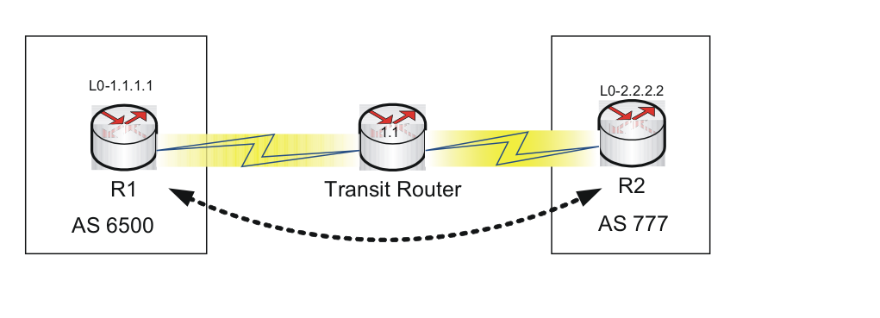

### Troubleshooting

Two indirectly connected EBGP neighbors do not form neighbor relation if the command peer x.x.x.x e-bgp maxhop <hops> or neighbor x.x.x.x ebgp-multihop <hops> is missing from the BGP configuration.

This command specifies the number of hops required to reach the neighbor router. If the number of hops configured in the BGP configuration is less than the actual hops needed to reach the router, a neighbor relationship cannot be established.

### Solution

Configure the command peer x.x.x.x ebgp-max-hop <hops> or neighbor x.x.x.x ebgp-multihop <number> with the proper hop counts.

### Verification

Verify the BGP peer relationship status using the command display bgp peer or show ip bgp summary.

Comware:

[R2]disp bgp peer

BGP local router ID : 2.2.2.2

Local AS number : 777

Total number of peers : 1 Peers in established state : 1

Peer AS MsgRcvd MsgSent OutQ PrefRcv Up/Down State

1.1.1.1 6500 2 3 0 0 00:00:12 Established

ProVision:

R2(bgp)# show ip bgp summary

Peer Information

Remote Address Remote-AS Local-AS State Admin Status

--------------- --------- -------- ------------- ------------

1.1.1.1 6500 777 Established Start

## Connect-interface or update-source configured for directly connected peers

An example of a “connect-interface” or “update-source” configured for directly connected peers is shown in .

“Connect-interface” or “update-source” configured for directly connected peers

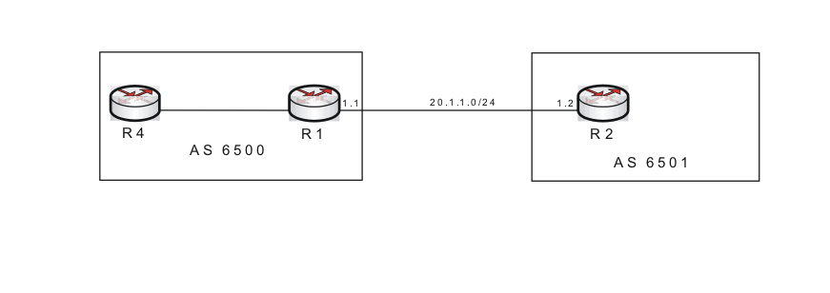

### Troubleshooting

Verify the BGP peer status using the command display bgp peer.

Comware:

[R2]display bgp peer

BGP local router ID : 2.2.2.2

Local AS number : 6501

Total number of peers : 1 Peers in established state : 0

Peer AS MsgRcvd MsgSent OutQ PrefRcv Up/Down State 20.1.1.1 6500 4 4 0 1 00:00:18 Active

ProVision:

R2(lo-0)# show ip bgp summary

Peer Information

Remote Address Remote-AS Local-AS State Admin Status

--------------- --------- -------- ------------- ------------

20.1.1.1 6500 6501 Connect Start

Verify the BGP configurations on both routers.

Router R1

Comware:

[R1]disp current-configuration | begin bgp

bgp 6500

peer 20.1.1.2 as-number 6501

ProVision:

R1(bgp)# show run

router bgp 6500

enable

neighbor 20.1.1.2 remote-as 6501

exit

Router R2

Comware:

[R2]disp current-configuration | begin bgp

bgp 6501

peer 20.1.1.1 as-number 6500

peer 20.1.1.1 connect-interface LoopBack0

ProVision::

R2(lo-0)# show run

router bgp 6501

enable

neighbor 20.1.1.1 remote-as 6500

neighbor 20.1.1.1 update-source 2.2.2.2

exit

### Solution

Remove the incorrect command from the BGP configuration on R2.

Comware:

[R2]bgp 6501

[R2-bgp]undo peer 20.1.1.1 connect-interface

ProVision:

R2(lo-0)# router bgp 6501

R2(bgp)# no neighbor 20.1.1.1 update-source

### Verification

Verify the BGP peer relationship status using the command display bgp peer or show ip bgp summary.

Comware::

[R2]disp bgp peer

BGP local router ID : 2.2.2.2

Local AS number : 6501

Total number of peers : 1 Peers in established state : 0

Peer AS MsgRcvd MsgSent OutQ PrefRcv Up/Down State 20.1.1.1 6500 4 4 0 1 00:00:18 Established

ProVision:

R2(bgp)# show ip bgp summary

Peer Information

Remote Address Remote-AS Local-AS State Admin Status

--------------- --------- -------- ------------- ------------

20.1.1.1 6500 6501 Established Start

## No route to reach loopback interface

An example of no route to reach loopback interface is shown in and .

No route to reach loopback interface

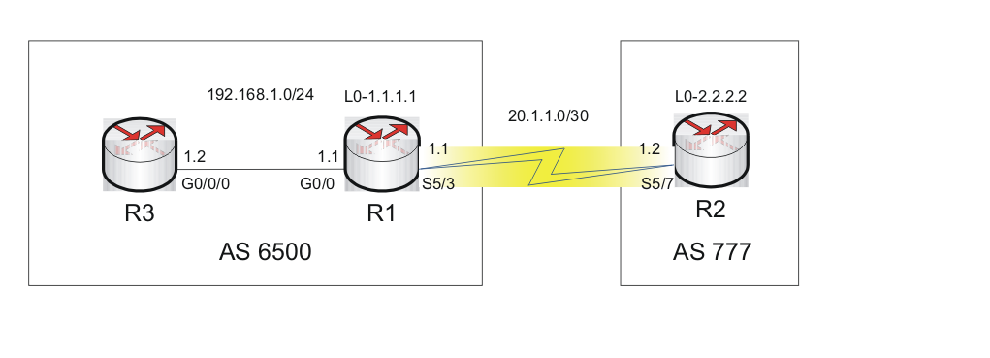

No route to reach loopback interface

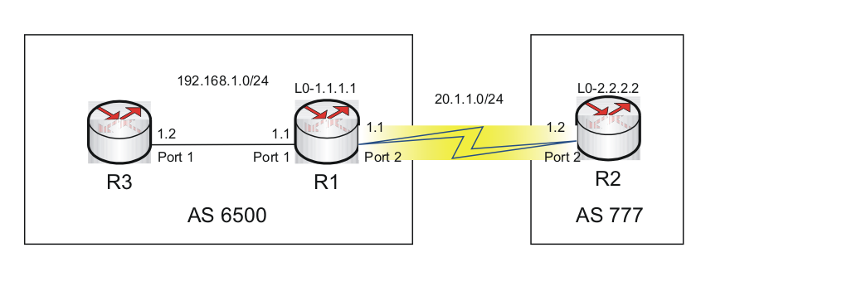

### Troubleshooting

Verify the BGP peer status using the command display bgp peer or show ip bgp summary.

Comware:

[R1]disp bgp peer

BGP local router ID : 192.168.1.1

Local AS number : 6500

Total number of peers : 1 Peers in established state : 0

Peer AS MsgRcvd MsgSent OutQ PrefRcv Up/Down State

2.2.2.2 777 0 0 0 0 00:00:25 Active

ProVision:

R1(bgp)# show ip bgp summary

Peer Information

Remote Address Remote-AS Local-AS State Admin Status

--------------- --------- -------- ------------- ------------

2.2.2.2 777 6500 Connect Start

Ping the loopback IPs to verify the connectivity.

Router R1

Comware:

R1]ping 2.2.2.2

PING 2.2.2.2: 56 data bytes, press CTRL\_C to break

Reply from 2.2.2.2: bytes=56 Sequence=0 ttl=255 time=25 ms

Reply from 2.2.2.2: bytes=56 Sequence=1 ttl=255 time=26 ms

Reply from 2.2.2.2: bytes=56 Sequence=2 ttl=255 time=26 ms

Reply from 2.2.2.2: bytes=56 Sequence=3 ttl=255 time=26 ms

Reply from 2.2.2.2: bytes=56 Sequence=4 ttl=255 time=25 ms

--- 2.2.2.2 ping statistics ---

5 packet(s) transmitted

5 packet(s) received

0.00% packet loss

round-trip min/avg/max = 25/25/26 ms

ProVision::

R1(bgp)# ping 2.2.2.2

2.2.2.2 is alive, time = 2 ms

Router R2

Comware:

[R2]ping 1.1.1.1

PING 1.1.1.1: 56 data bytes, press CTRL\_C to break

Request time out

Request time out

Request time out

Request time out

Request time out

--- 1.1.1.1 ping statistics ---

5 packet(s) transmitted

0 packet(s) received

100.00% packet loss

ProVision:

R2(config)# ping 1.1.1.1

The destination address is unreachable.

Check the routing table of R1 and R2.

Router R1

Comware:

[R1]disp ip routing-table

Routing Tables: Public

Destinations : 9 Routes : 9

Destination/Mask Proto Pre Cost NextHop Interface

1.1.1.1/32 Direct 0 0 127.0.0.1 InLoop0

2.2.2.2/32 Static 60 0 20.1.1.2 S5/7

20.1.1.0/24 Direct 0 0 20.1.1.1 S5/7

20.1.1.1/32 Direct 0 0 127.0.0.1 InLoop0

20.1.1.2/32 Direct 0 0 20.1.1.2 S5/7

127.0.0.0/8 Direct 0 0 127.0.0.1 InLoop0

127.0.0.1/32 Direct 0 0 127.0.0.1 InLoop0

192.168.1.0/24 Direct 0 0 192.168.1.1 GE0/0

192.168.1.1/32 Direct 0 0 127.0.0.1 InLoop0

ProVision:

R1(bgp)# show ip route

IP Route Entries

Destination Gateway VLAN Type Sub-Type Metric Dist.

------------------ --------------- ---- --------- ---------- ---------- -----

1.1.1.1/32 lo0 connected 1 0

2.2.2.2/32 20.1.1.2 1 static 1 1

20.1.1.0/24 DEFAULT\_VLAN 1 connected 1 0

127.0.0.0/8 reject static 0 0

127.0.0.1/32 lo0 connected 1 0

192.168.1.0/24 VLAN2 2 connected 1 0

192.168.2.0/24 192.168.1.2 2 bgp 0 200

R1 has a static route to R2’s loopback ip.

Router R2

Comware:

[R2]disp ip routing-table

Routing Tables: Public

Destinations : 6 Routes : 6

Destination/Mask Proto Pre Cost NextHop Interface

2.2.2.2/32 Direct 0 0 127.0.0.1 InLoop0

20.1.1.0/24 Direct 0 0 20.1.1.2 S5/3

20.1.1.1/32 Direct 0 0 20.1.1.1 S5/3

20.1.1.2/32 Direct 0 0 127.0.0.1 InLoop0

127.0.0.0/8 Direct 0 0 127.0.0.1 InLoop0

127.0.0.1/32 Direct 0 0 127.0.0.1 InLoop0

ProVision:

R2(config)# show ip route

IP Route Entries

Destination Gateway VLAN Type Sub-Type Metric Dist.

------------------ --------------- ---- --------- ---------- ---------- -----

2.2.2.2/32 lo0 connected 1 0

11.90.90.0/24 VLAN2 2 connected 1 0

20.1.1.0/24 DEFAULT\_VLAN 1 connected 1 0

127.0.0.0/8 reject static 0 0

127.0.0.1/32 lo0 connected 1 0

R2 does not have a route to R1’s loopback interface.

### Solution

Configure a static route on R2 to confirm the connectivity to the loopback network on R1.

Comware:

[R2]ip route-static 1.1.1.1 32 20.1.1.1

ProVision:

R2(config)# ip route 1.1.1.1 255.255.255.255 20.1.1.1

### Verification

Verify the BGP peer relationship status using the command display bgp peer.

Comware:

[R2]disp bgp peer

BGP local router ID : 20.1.1.2

Local AS number : 777

Total number of peers : 1 Peers in established state : 1

Peer AS MsgRcvd MsgSent OutQ PrefRcv Up/Down State

1.1.1.1 6500 2 2 0 0 00:00:08 Established

ProVision:

R2(config)# show ip bgp summary

Peer Information

Remote Address Remote-AS Local-AS State Admin Status

--------------- --------- -------- ------------- ------------

1.1.1.1 6500 777 Established Start

11.90.90.2 777 777 Established Start

## Ignore or shutdown command configured on BGP peer

An example of ignore or shutdown command configured on BGP peer is shown in .

Ignore or shutdown command configured on BGP peer 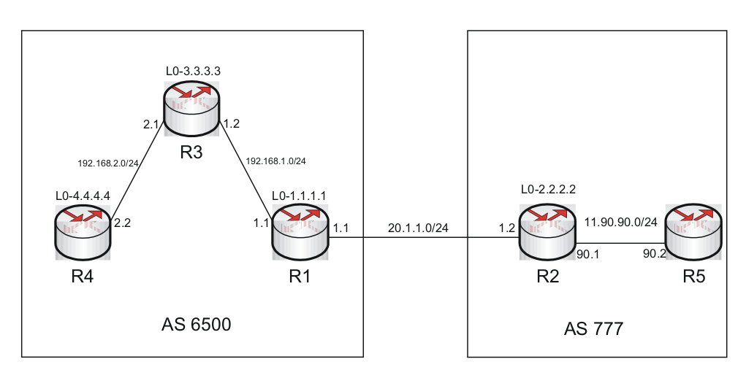

### Troubleshooting

Verify the BGP peer status using the command display bgp peer or show ip bgp summary.

Router R2

Comware:

[R2]disp bgp peer

BGP local router ID : 2.2.2.2

Local AS number : 777

Total number of peers : 2 Peers in established state : 1

Peer AS MsgRcvd MsgSent OutQ PrefRcv Up/Down State

1.1.1.1 6500 0 0 0 0 00:01:54 Idle(Admin)

11.90.90.2 777 48 43 0 0 00:47:32 Established

ProVision:

R2(bgp)# show ip bgp summary

Peer Information

Remote Address Remote-AS Local-AS State Admin Status

--------------- --------- -------- ------------- ------------

1.1.1.1 6500 777 Idle Stop

Router R1

Comware:

[R1]disp bgp peer

BGP local router ID : 1.1.1.1

Local AS number : 6500

Total number of peers : 1 Peers in established state : 0

Peer AS MsgRcvd MsgSent OutQ PrefRcv Up/Down State

2.2.2.2 777 0 5 0 0 00:02:46 Active

ProVision:

R1(bgp)# show ip bgp summary

Peer Information

Remote Address Remote-AS Local-AS State Admin Status

--------------- --------- -------- ------------- ------------

2.2.2.2 777 6500 Active Start

The display bgp peer or show ip bgp summary command on R2 shows that the peer status is idle(admin) or Stop. This means that peer relationship is administratively down. The ignore or shutdown command is a way to suspend BGP peering without deleting commands from the configuration.

Check the BGP configuration on R2.

Comware:

[R2]disp current-configuration | begin bgp

bgp 777

network 11.90.90.0 255.255.255.0

undo synchronization

peer 1.1.1.1 as-number 6500

peer 11.90.90.2 as-number 777

peer 1.1.1.1 ignore

peer 1.1.1.1 connect-interface LoopBack0

ProVision:

R2(bgp)# show run

router bgp 777

enable

network 2.2.2.2 255.255.255.255

network 11.90.90.0 255.255.255.0

neighbor 1.1.1.1 remote-as 6500

neighbor 1.1.1.1 shutdown

neighbor 1.1.1.1 update-source 2.2.2.2

neighbor 11.90.90.2 remote-as 777

neighbor 11.90.90.2 next-hop-self

exit

### Solution

Undo ignore or shutdown command.

Comware:

[R2]bgp 777

[R2-bgp]undo peer 1.1.1.1 ignore

### Verification

Verify the BGP peer relationship status using the command display bgp peer.

Comware:

[R2]disp bgp peer

BGP local router ID : 2.2.2.2

Local AS number : 777

Total number of peers : 2 Peers in established state : 2

Peer AS MsgRcvd MsgSent OutQ PrefRcv Up/Down State

1.1.1.1 6500 3 3 0 1 00:00:19 Established

11.90.90.2 777 48 43 0 0 00:47:32 Established

ProVision:

R2(bgp)# show ip bgp summary

Peer Information

Remote Address Remote-AS Local-AS State Admin Status

--------------- --------- -------- ------------- ------------

1.1.1.1 6500 777 Established Start

## ACL Blocking the TCP/BGP Packets

An example of ACL blocking the TCP/BGP packets is shown in .

ACL blocking the TCP/BGP packets

**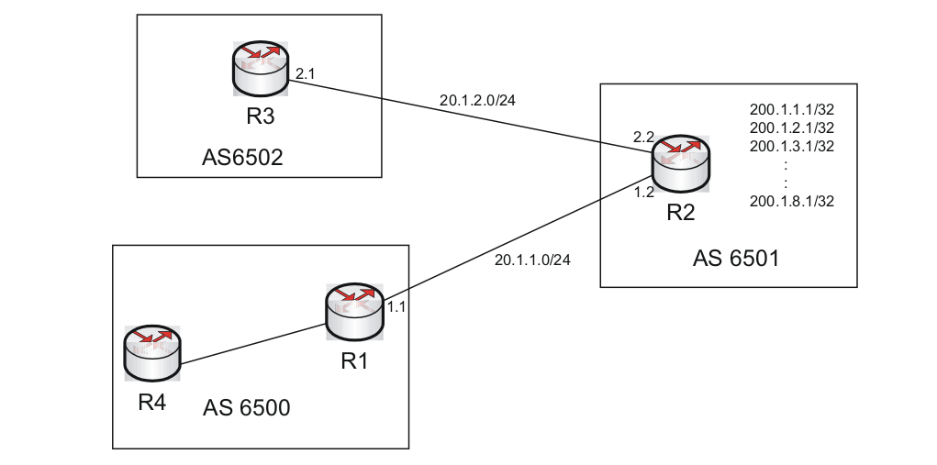**

### Troubleshooting

Use display bgp peer or show ip bgp summary command to determine the BGP peer status.

Comware:

<R3>display bgp peer

BGP local router ID : 4.4.4.4

Local AS number : 6502

Total number of peers : 1 Peers in established state : 1

Peer AS MsgRcvd MsgSent OutQ PrefRcv Up/Down State

20.1.2.2 6501 5 6 0 11 00:01:30 Active

ProVision:

R3(bgp)# show ip bgp summary

Peer Information

Remote Address Remote-AS Local-AS State Admin Status

--------------- --------- -------- ------------- ------------

20.1.2.2 6501 6502 Active Start

Verify the BGP configuration on both routers.

Router R3

Comware:

<R3>disp current-configuration | begin bgp

bgp 6502

undo synchronization

peer 20.1.2.2 as-number 6501

ProVision:

R3(bgp)# show run

router bgp 6502

enable

neighbor 20.1.2.2 remote-as 6501

exit

Router R2

Comware:

<R2>disp current-configuration | begin bgp

bgp 6501

undo synchronization

peer 20.1.2.1 as-number 6502

ProVision:

R2(bgp)# show run

router bgp 6501

enable

neighbor 20.1.1.1 remote-as 6500

neighbor 20.1.2.1 remote-as 6502

exit

step1: Check the ip address and subnet mask of the respective interfaces at both ends.

step2: Check the ping reply to the respective interfaces.

step3: Check the configuration on the interface. Is there any ACL configured?

Router R2

Comware:

<R2>disp current-configuration | begin interface

:

:

:

interface GigabitEthernet0/1

port link-mode route

ip address 20.1.2.2 255.255.255.0

ProVision:

vlan 2

name "VLAN2"

untagged 2

ip address 20.1.2.2 255.255.255.0

exit

Router R3

Comware:

<R3>disp current-configuration | begin interface

:

:

:

interface GigabitEthernet0/1

port link-mode route

firewall packet-filter 3000 outbound

ip address 20.1.2.1 255.255.255.0

ProVision:

vlan 2

name "VLAN2"

untagged 2

ip address 20.1.2.1 255.255.255.0

ip access-group "100" out

exit

Check the ACL configured on interface Gi 0/1 or Vlan 2 of R3.

Comware:

[R3]disp acl all

Advanced ACL 3000, named -none-, 1 rule,

ACL's step is 5

rule 10 deny tcp (70 time(s) matched)

ProVision:

R3(bgp)# show access-list 100

Access Control Lists

Name: 100

Type: Extended

Applied: Yes

SEQ Entry

-----------------------------------------------------------------------------

10 Action: deny

Src IP: 0.0.0.0 Mask: 255.255.255.255 Port(s):

Dst IP: 0.0.0.0 Mask: 255.255.255.255 Port(s):

Proto : TCP

TOS : - Precedence: -

The ACL on the R3-interface is blocking all the TCP packets preventing establishment of a neighbor relationship.

### Solution

Modify the ACL rule to allow TCP packets

Comware:

[R3]acl number 3000

[R3-acl-adv-3000]rule 5 permit tcp destination 20.1.2.2 0.0.0.255

ProVision:

R3(config)# ip access-list extended 100

R3(config-ext-nacl)# 5 permit tcp any host 20.1.2.2

### Verification

Use the display bgp peer or show ip bgp summary command to verify that neighbor relationship has been established.

Comware:

<R3>disp bgp peer

BGP local router ID : 4.4.4.4

Local AS number : 6502

Total number of peers : 1 Peers in established state : 1

Peer AS MsgRcvd MsgSent OutQ PrefRcv Up/Down State

20.1.2.2 6501 5 6 0 11 00:01:47 Established

ProVision:

R3(config-ext-nacl)# show ip bgp summary

Peer Information

Remote Address Remote-AS Local-AS State Admin Status

--------------- --------- -------- ------------- ------------

20.1.2.2 6501 6502 Established Start

## Same Router-id configured on peers (Comware Only)

An example of same router-id configured on peers is shown in .

same router-id configured on peers

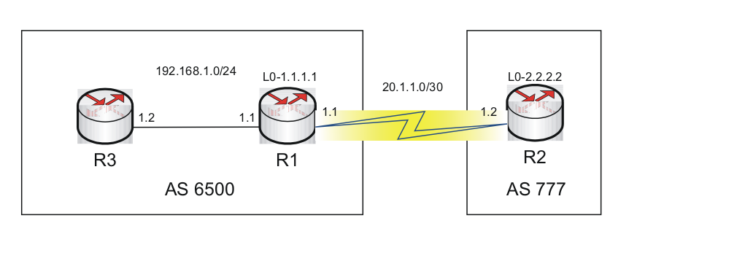

### Troubleshooting

Use display bgp peercommand to determine the BGP peer status.

Router R1:

<R1>disp bgp peer

BGP local router ID : 1.1.1.1

Local AS number : 6500

Total number of peers : 1 Peers in established state : 0

Peer AS MsgRcvd MsgSent OutQ PrefRcv Up/Down State

20.1.1.2 777 0 0 0 0 00:00:45 Active

Router R2

<R2>disp bgp peer

BGP local router ID : 1.1.1.1

Local AS number : 777

Total number of peers : 1 Peers in established state : 0

Peer AS MsgRcvd MsgSent OutQ PrefRcv Up/Down State

20.1.1.1 6500 0 0 0 0 00:00:05 Idle

Check the BGP configuration.

Router R1

[R1]disp current-configuration | begin bgp

bgp 6500

router-id 1.1.1.1

undo synchronization

timer keepalive 6 hold 18

peer 20.1.1.2 as-number 777

Router R2

[R2]disp current-configuration | begin bgp

bgp 777

router-id 1.1.1.1

undo synchronization

timer keepalive 5 hold 30

peer 20.1.1.1 as-number 6500

### Solution

Correct the router-id on R2

[R2]bgp 777

[R2-bgp]router-id 2.2.2.2

### Verification

Verify the BGP peer relationship status using the command display bgp peer.

[R2]disp bgp peer

BGP local router ID : 2.2.2.2

Local AS number : 777

Total number of peers : Peers in established state : 1

Peer AS MsgRcvd MsgSent OutQ PrefRcv Up/Down State

20.1.1.1 6500 4 4 0 0 00:00:13 Established

|  |  |
| --- | --- |
|  | NOTE:  ProVision devices allow establishment of a peer relationship when the router-ids are the same. Two ProVision devices can form a peer relationship with each other, where a Comware and ProVision device can not form a peer relationship, since the Comware device terminates the connection. |

# 2 BGP Routing Issues

BGP Routing issues can be divided into two categories:

* BGP router not installing the routes in routing table
* BGP router not advertising the routes

## BGP router not installing the routes in routing table

Below listed are some of the reasons:

* network command is not announcing the configured route
* Next-hop-local/next-hop-self command is missing

### Network command is not announcing the configured route

An example of network command is not announcing the configured route is shown in .

Network command is not announcing the configured route

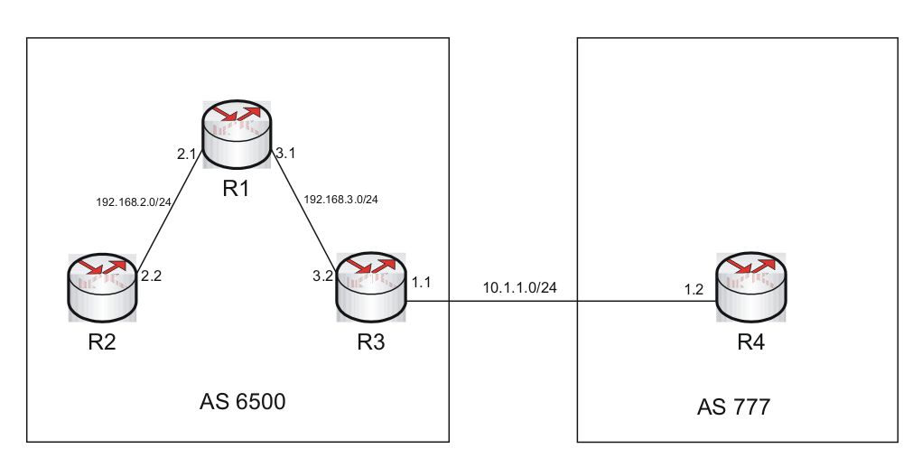

#### Problem

R3 is not receiving the routes from R2 and vice versa

Comware:

<R3>ping 192.168.2.2

PING 192.168.2.2: 56 data bytes, press CTRL\_C to break

Request time out

Request time out

Request time out

Request time out

Request time out

--- 192.168.2.2 ping statistics ---

5 packet(s) transmitted

0 packet(s) received

100.00% packet loss

ProVision:

R3(bgp)# ping 192.168.2.2

The destination address is unreachable.

Ping command executed from R3 to R2 is unsuccessful.

#### Troubleshooting

Check the routing table of R3.

Comware:

[R3]display ip routing-table

Routing Tables: Public

Destinations : 7 Routes : 7

Destination/Mask Proto Pre Cost NextHop Interface

127.0.0.0/8 Direct 0 0 127.0.0.1 InLoop0

127.0.0.1/32 Direct 0 0 127.0.0.1 InLoop0

192.168.3.0/24 Direct 0 0 192.168.3.2 GE0/1

192.168.3.2/32 Direct 0 0 127.0.0.1 InLoop0

ProVision:

R3(bgp)# show ip route

IP Route Entries

Destination Gateway VLAN Type Sub-Type Metric Dist.

------------------ --------------- ---- --------- ---------- ---------- -----

20.1.2.0/24 VLAN2 2 connected 1 0

127.0.0.0/8 reject static 0 0

127.0.0.1/32 lo0 connected 1 0

192.168.3.0/24 VLAN2 2 connected 1 0

The routing table of R3 does not contain the routes to the network 192.168.2.0/24.

Check the BGP routing table to verify the same.

Comware:

[R3]display bgp routing-table

Total Number of Routes: 3

BGP Local router ID is 3.3.3.3

Status codes: \* - valid, > - best, d - damped,

h - history, i - internal, s - suppressed, S - Stale

Origin : i - IGP, e - EGP, ? - incomplete

Network NextHop MED LocPrf PrefVal Path/Ogn

\*> 10.1.1.0/24 0.0.0.0 0 0 i

\* 10.1.1.2 0 0 777i

\*> 192.168.3.0 0.0.0.0 0 0 i

ProVision:

R3(bgp)# show ip bgp

Local AS : 6500 Local Router-id : 10.228.0.15

BGP Table Version : 5

Status codes: \* - valid, > - best, i - internal, e - external, s - stale

Origin codes: i - IGP, e - EGP, ? - incomplete

Network Nexthop Metric LocalPref Weight AsPath

------------------ --------------- ---------- ---------- ------ ---------

i 192.168.3.0/24 192.168.3.1 0 100 0 i

Check the ip routing table of R1.

Comware:

[R1]display ip routing-table

Routing Tables: Public

Destinations : 8 Routes : 8

Destination/Mask Proto Pre Cost NextHop Interface

1.1.1.1/32 Direct 0 0 127.0.0.1 InLoop0

10.1.1.0/24 BGP 255 0 192.168.3.2 GE0/1

127.0.0.0/8 Direct 0 0 127.0.0.1 InLoop0

127.0.0.1/32 Direct 0 0 127.0.0.1 InLoop0

192.168.2.0/24 Direct 0 0 192.168.2.1 GE0/0

192.168.2.1/32 Direct 0 0 127.0.0.1 InLoop0

192.168.3.0/24 Direct 0 0 192.168.3.1 GE0/1

192.168.3.1/32 Direct 0 0 127.0.0.1 InLoop0

ProVision:

R1(bgp)# show ip route

IP Route Entries

Destination Gateway VLAN Type Sub-Type Metric Dist.

------------------ --------------- ---- --------- ---------- ---------- -----

2.2.2.2/32 lo0 connected 1 0

127.0.0.0/8 reject static 0 0

127.0.0.1/32 lo0 connected 1 0

192.168.2.0/24 DEFAULT\_VLAN 1 connected 1 0

192.168.3.0/24 VLAN2 2 connected 1 0

The IP routing table of R1 shows an entry for 192.168.2.0/24 network. R1 is directly connected to that network, hence IP routing table entry has an entry for direct route.

Since iBGP is being used as the internal routing protocol among the routers in AS 6500 , the directly connected networks must be advertised using BGP.

Based on the information above, it appears that R1 is not advertising the network 192.168.3.0/24 via BGP. Check whether the BGP network advertised using network is the correct network.

Comware:

[R1]display bgp network

BGP Local Router ID is 1.1.1.1.

Local AS Number is 6500.

Network Mask Route-policy Short-cut

192.168.0.0 255.255.0.0

ProVision:

R1(bgp)# show run

router bgp 6500

enable

network 192.168.0.0 255.255.0.0

neighbor 192.168.2.2 remote-as 6500

neighbor 192.168.3.2 remote-as 6500

exit

The output above shows that the network configured for advertising is 192.168.0.0/16.

Unlike OSPF, BGP advertises a route only if the network command also has a matching route that has been installed in the global IP routing table.

In the above scenario, network command is followed by 192.168.0.0/16 subnet address. Though 192.168.0.0/16 is a supernet address and would include 192.168.2.0 subnet under it, this command does not advertise the 192.168.2.0/24 network. There is no route in the global routing table that is an exact match for 192.168.2.0/24. This rule prevents advertising of a BGP route if the router is not actually able to route the packet for that specific route.

#### Solution

Remove the previously configured network command and configure the correct network command with the correct subnet mask under R1

Comware:

[R1]bgp 6500

[R1-bgp]undo network 192.168.0.0

[R1-bgp]network 192.168.2.0 24

[R1-bgp]network 192.168.3.0 24

ProVision:

R1(bgp)# router bgp 6500

R1(bgp)# no network 192.168.0.0 255.255.0.0

R1(bgp)# network 192.168.2.0 255.255.255.0

R1(bgp)# network 192.168.3.0 255.255.255.0

Since routes for 192.168.2.0/24 and 192.168.3.0/24 exist in the routing table of R1 as directly connected routes, R1 begins advertising those routes to both of its peers.

#### Verification

Verify the BGP routing table of R1.

Comware:

[R1]display bgp routing-table

Total Number of Routes: 5

BGP Local router ID is 1.1.1.1

Status codes: \* - valid, ^ - VPN best, > - best, d - damped,

h - history, i - internal, s - suppressed, S - Stale

Origin : i - IGP, e - EGP, ? - incomplete

Network NextHop MED LocPrf PrefVal Path/Ogn

\* >i 10.1.1.0/24 192.168.3.2 0 100 0 i

\* > 192.168.2.0 0.0.0.0 0 0 i

\* i 192.168.2.2 0 100 0 i

\* > 192.168.3.0 0.0.0.0 0 0 i

\* i 192.168.3.2 0 100 0 i

ProVision:

R1(bgp)# show ip bgp

Local AS : 6500 Local Router-id : 10.228.0.14

BGP Table Version : 0

Status codes: \* - valid, > - best, i - internal, e - external, s - stale

Origin codes: i - IGP, e - EGP, ? - incomplete

Network Nexthop Metric LocalPref Weight AsPath

------------------ --------------- ---------- ---------- ------ ---------

\*> 192.168.2.0/24 0 32768 i

\*> 192.168.3.0/24 0 32768 i

The BGP routing table of R1 now shows that it is announcing routes 192.168.2.0 and 192.168.3.0 since they are marked as “best” routes.

Now, ping R2 from R3.

Comware:

<R3>ping 192.168.2.2

PING 192.168.2.2: 56 data bytes, press CTRL\_C to break

Reply from 192.168.2.2: bytes=56 Sequence=1 ttl=254 time=1 ms

Reply from 192.168.2.2: bytes=56 Sequence=2 ttl=254 time=1 ms

Reply from 192.168.2.2: bytes=56 Sequence=3 ttl=254 time=1 ms

Reply from 192.168.2.2: bytes=56 Sequence=4 ttl=254 time=1 ms

Reply from 192.168.2.2: bytes=56 Sequence=5 ttl=254 time=1 ms

--- 192.168.2.2 ping statistics ---

5 packet(s) transmitted

5 packet(s) received

0.00% packet loss

round-trip min/avg/max = 1/1/1 ms

R3 is receiving a successful ping reply.

ProVision:

R3(bgp)# ping 192.168.2.2

192.168.2.2 is alive, time = 4 ms

## Next-hop-local/next-hop-self command is missing

An example of next-hop-local/next-hop-self command is missing is shown in .

Next-hop-local/next-hop-self command is missing



Router R5 is an IBGP neighbor of R2 whereas R2 and R1 are EBGP neighbors. R5 is trying to ping network in AS 6500. Routes from AS 6500 appear in the BGP routing table, however they are not installed into the router’s global IP routing table.

### Troubleshooting

Verify the BGP routing table of R5.

Comware:

<R5>disp bgp routing-table

Total Number of Routes: 3

BGP Local router ID is 5.5.5.5

Status codes: \* - valid, ^ - VPN best, > - best, d - damped,

h - history, i - internal, s - suppressed, S - Stale

Origin : i - IGP, e - EGP, ? - incomplete

Network NextHop MED LocPrf PrefVal Path/Ogn

\* i 11.90.90.0/24 11.90.90.1 0 100 0 i

i 192.168.1.0 1.1.1.1 0 100 0 6500i

i 192.168.2.0 1.1.1.1 2 100 0 6500?

ProVision:

R5(bgp)# show ip bgp

Local AS : 777 Local Router-id : 11.90.90.2

BGP Table Version : 4

Status codes: \* - valid, > - best, i - internal, e - external, s - stale

Origin codes: i - IGP, e - EGP, ? - incomplete

Network Nexthop Metric LocalPref Weight AsPath

------------------ --------------- ---------- ---------- ------ ---------

\*> 11.90.90.0/24 0 32768 i

\* i 11.90.90.0/24 11.90.90.1 0 100 0 i

i 192.168.1.0/24 1.1.1.1 0 100 0 6500 i

i 192.168.2.0/24 1.1.1.1 0 100 0 6500 i

R5 is receiving the external-as routes from AS 6500. However, they are not being installed in the routing table. When AS 777 receives the routes, the NEXT\_HOP attribute is set to the outgoing interface of R1 (1.1.1.1). By default the NEXT\_HOP attribute is preserved inside an AS. However, routes to 192.168.1.0/24 and 192.168.2.0/24 cannot be installed into the global routing table, since there is no route to 1.1.1.1 in the global routing table already.

Comware:

[R5]ping 192.168.1.1

PING 192.168.1.1: 56 data bytes, press CTRL\_C to break

Request time out

Request time out

Request time out

Request time out

Request time out

--- 192.168.1.1 ping statistics ---

5 packet(s) transmitted

0 packet(s) received

100.00% packet loss

ProVision:

R5(bgp)# ping 192.168.1.1

The destination address is unreachable.

### Solution

Add the command peer x.x.x.x next-hop-local orneighbor x.x.x.x next-hop-self under the BGP configuration of R2. This changes the next-hop for external-as routes to R2 for all the IBGP neighbors in AS 777. Since a route to R2 exists in AS 777, the route is installed in the global routing table.

Comware:

[R2]bgp 777

[R2-bgp]peer 11.90.90.2 next-hop-local

ProVision:

R2(bgp)# router bgp 777

R2(bgp)# neighbor 11.90.90.2 next-hop-self

### Verification

Verify the BGP routing table of R5

Comware:

[R5]disp bgp routing-table

Total Number of Routes: 3

BGP Local router ID is 5.5.5.5

Status codes: \* - valid, ^ - VPN best, > - best, d - damped,

h - history, i - internal, s - suppressed, S - Stale

Origin : i - IGP, e - EGP, ? - incomplete Network NextHop MED LocPrf PrefVal Path/Ogn

\* i 11.90.90.0/24 11.90.90.1 0 100 0 i

\* >i 192.168.1.0 11.90.90.1 0 100 0 6500i

\* >i 192.168.2.0 11.90.90.1 2 100 0 6500?

ProVision:

R5(bgp)# show ip bgp

Local AS : 777 Local Router-id : 11.90.90.2

BGP Table Version : 5

Status codes: \* - valid, > - best, i - internal, e - external, s - stale

Origin codes: i - IGP, e - EGP, ? - incomplete

Network Nexthop Metric LocalPref Weight AsPath

------------------ --------------- ---------- ---------- ------ ---------

\* i 11.90.90.0/24 11.90.90.1 0 100 0 i

\*>i 192.168.1.0/24 11.90.90.1 0 100 0 6500 i

\*>i 192.168.2.0/24 11.90.90.1 0 100 0 6500 i

R5 is now receiving the external-as routes with the next hop as 11.90.90.1 which is R2’s interface ip.

Comware:

[R5]ping 192.168.1.1

PING 192.168.1.1: 56 data bytes, press CTRL\_C to break

Reply from 192.168.1.1: bytes=56 Sequence=0 ttl=254 time=1 ms

Reply from 192.168.1.1: bytes=56 Sequence=1 ttl=254 time=1 ms

Reply from 192.168.1.1: bytes=56 Sequence=2 ttl=254 time=1 ms

Reply from 192.168.1.1: bytes=56 Sequence=3 ttl=254 time=1 ms

Reply from 192.168.1.1: bytes=56 Sequence=4 ttl=254 time=1 ms

--- 192.168.1.1 ping statistics ---

5 packet(s) transmitted

5 packet(s) received

0.00% packet loss

round-trip min/avg/max = 1/1/1 ms

ProVision:

R5(bgp)# ping 192.168.1.1

192.168.1.1 is alive, time = 3 ms

R5 is able to successfully ping the network in AS 6500.

As an alternative solution, the IGP in AS777 could be configured to have a route to R1 (1.1.1.1). This could be achieved by use of static routes or by injecting the route to 1.1.1.1 into your IGP. However, the solution presented above (next-hop-self, next-hop-local) is generally preferable.

## BGP router not advertising the routes

The most common reason for this is, the Router is not configured as Route Reflector for IBGP neighbors.

## Router is not receiving External-AS routes or routes that are more than one hop away.

An example of router is not receiving external-AS routes, is shown in .

router is not receiving external-AS routes



### Problem

R4 is not able to reach the network 11.90.90.0/24 in AS 777.

### Troubleshooting

Check the IP routing table of R4

Comware:

[R4]disp ip routing-table

Routing Tables: Public

Destinations : 5 Routes : 5

Destination/Mask Proto Pre Cost NextHop Interface

127.0.0.0/8 Direct 0 0 127.0.0.1 InLoop0

127.0.0.1/32 Direct 0 0 127.0.0.1 InLoop0

192.168.1.0/24 BGP 255 0 192.168.2.1 GE0/1

192.168.2.0/24 Direct 0 0 192.168.2.2 GE0/1

192.168.2.2/32 Direct 0 0 127.0.0.1 InLoop0

ProVision:

R4(bgp)# show ip route

IP Route Entries

Destination Gateway VLAN Type Sub-Type Metric Dist.

------------------ --------------- ---- --------- ---------- ---------- -----

4.4.4.4/32 lo0 connected 1 0

127.0.0.0/8 reject static 0 0

127.0.0.1/32 lo0 connected 1 0

192.168.1.0/24 192.168.2.1 1 bgp 0 200

192.168.2.0/24 DEFAULT\_VLAN 1 connected 1 0

Verify the BGP routing table of R4 to check whether R4 is receiving the External-as routes.

Comware:

[R4]disp bgp routing-table

Total Number of Routes: 3

BGP Local router ID is 192.168.2.2

Status codes: \* - valid, ^ - VPN best, > - best, d - damped,

h - history, i - internal, s - suppressed, S - Stale

Origin : i - IGP, e - EGP, ? - incomplete

Network NextHop MED LocPrf PrefVal Path/Ogn

\* >i 192.168.1.0 192.168.2.1 0 100 0 i

\* > 192.168.2.0 0.0.0.0 0 0 i

\* i 192.168.2.1 0 100 0 i

ProVision:

R4(bgp)# show ip bgp

Local AS : 6500 Local Router-id : 192.168.2.2

BGP Table Version : 2

Status codes: \* - valid, > - best, i - internal, e - external, s - stale

Origin codes: i - IGP, e - EGP, ? - incomplete

Network Nexthop Metric LocalPref Weight AsPath

------------------ --------------- ---------- ---------- ------ ---------

\*>i 192.168.1.0/24 192.168.2.1 0 100 0 i

i 192.168.2.0/24 192.168.2.1 0 100 0 i

R4 is not receiving any external-as routes.

Check the routing table of R3 to verify whether it is receiving any external AS routes.

Comware:

[R3]disp bgp routing-table

Total Number of Routes: 5

BGP Local router ID is 3.3.3.3

Status codes: \* - valid, ^ - VPN best, > - best, d - damped,

h - history, i - internal, s - suppressed, S - Stale

Origin : i - IGP, e - EGP, ? - incomplete Network NextHop MED LocPrf PrefVal Path/Ogn

\* >i 11.90.90.0/24 192.168.1.1 0 100 0 777i

\* > 192.168.1.0 0.0.0.0 0 0 i

\* i 192.168.1.1 0 100 0 i

\* > 192.168.2.0 0.0.0.0 0 0 i

\* i 192.168.2.2 0 100 0 i

ProVision:

R3(bgp)# show ip bgp

Local AS : 6500 Local Router-id : 192.168.2.1

BGP Table Version : 4

Status codes: \* - valid, > - best, i - internal, e - external, s - stale

Origin codes: i - IGP, e - EGP, ? - incomplete

Network Nexthop Metric LocalPref Weight AsPath

------------------ --------------- ---------- ---------- ------ ---------

\* i 11.90.90.0/24 20.1.1.2 0 100 0 777 i

\* i 192.168.1.0/24 192.168.1.1 0 100 0 i

\*> 192.168.2.0/24 0 32768 i

R3 is receiving the external-as routes. But R4 is not receiving the same routes.

Check the BGP configuration on R3.

Comware:

[R3]disp current-configuration | begin bgp

bgp 6500

network 192.168.1.0

network 192.168.2.0

undo synchronization

peer 192.168.1.1 as-number 6500

peer 192.168.2.2 as-number 6500

ProVision:

R3(bgp)# show run

router bgp 6500

enable

network 192.168.1.0 255.255.255.0

network 192.168.2.0 255.255.255.0

neighbor 192.168.1.1 remote-as 6500

neighbor 192.168.2.2 remote-as 6500

exit

R3 is an IBGP neighbor of R1. Even though R3 receives all the external-as routes from R1, it does not advertise those routes to R4. IBGP rules state that IBGP routes that are learned from another peer are not propagated.

To advertise these external-as routes to other IBGP neighbors in AS 6500, configure R3 as Route reflector for all routers in the AS. A route reflector acts as a hub for IBGP peers, allowing them to exchange routes directly with each other.

### Solution

Configure R3 as Route reflector for R4 and R1.

Comware:

[R3]bgp 6500

[R3-bgp]peer 192.168.2.2 reflect-client

[R3-bgp]peer 192.168.1.1 reflect-client

ProVision:

R3(bgp)# router bgp 6500

R3(bgp)# neighbor 192.168.1.1 route-reflector-client

R3(bgp)# neighbor 192.168.2.2 route-reflector-client

### Verification

Verify whether R4 is receiving the external-as routes.

Comware:

[R4]disp bgp routing-table

Total Number of Routes: 4

BGP Local router ID is 192.168.2.2

Status codes: \* - valid, ^ - VPN best, > - best, d - damped,

h - history, i - internal, s - suppressed, S - Stale

Origin : i - IGP, e - EGP, ? - incomplete

Network NextHop MED LocPrf PrefVal Path/Ogn

\* >i 11.90.90.0/24 192.168.1.1 0 100 0 777i

\* >i 192.168.1.0 192.168.2.1 0 100 0 i

\* > 192.168.2.0 0.0.0.0 0 0 i

\* i 192.168.2.1 0 100 0 i

ProVision:

R4(bgp)# show ip bgp

Local AS : 6500 Local Router-id : 192.168.2.2

BGP Table Version : 4

Status codes: \* - valid, > - best, i - internal, e - external, s - stale

Origin codes: i - IGP, e - EGP, ? - incomplete

Network Nexthop Metric LocalPref Weight AsPath

------------------ --------------- ---------- ---------- ------ ---------

\*>i 11.90.90.0/24 192.168.1.1 0 100 0 777 i

\*>i 192.168.1.0/24 192.168.2.1 0 100 0 i

i 192.168.2.0/24 192.168.2.1 0 100 0 i

R4 is now receiving external-as routes

# 3 BGP Confederation issues (Comware Only)

|  |  |
| --- | --- |
|  | NOTE:  ProVision devices do not support BGP confederations. |

The common configuration mistakes which occur in BGP confederation setup are:

* Incorrect confederation peer ip
* Incorrect confederation peer-as
* Missing confederation peer-as <AS Number> command

## BGP Confederation peer relation not establishing: Incorrect peer IP configured

An example of BGP confederation peer relation not establishing: Incorrect peer IP configured is shown in .

BGP confederation per relation not establishing: Incorrect peer IP configured

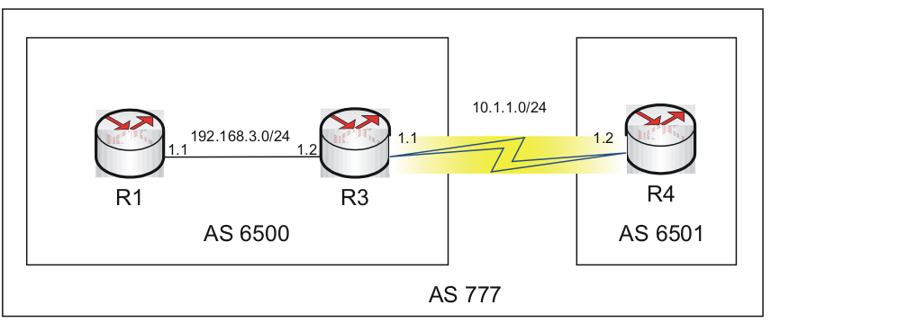

### Problem

R3 is not forming peer relation with R4. Incorrect peer ip configured.

### Troubleshooting

Verify the peer relation between R3 and R4 using the command display bgp peer.

[R3]display bgp peer

BGP local router ID : 3.3.3.3

Local AS number : 6500

Total number of peers : 2 Peers in established state : 1

Peer AS MsgRcvd MsgSent OutQ PrefRcv Up/Down State

192.168.3.1 6500 86 85 0 2 01:29:27 Established

10.1.1.3 6501 0 0 0 0 01:29:39 Active

The peer relationship is stuck in active state.

Check the BGP configuration on both the routers to verify the correctness in the configuration of the devices.

Router R3

[R3]display current-configuration | begin bgp

bgp 6500

confederation id 777

confederation peer-as 6501

network 10.1.1.0 255.255.255.0

network 192.168.3.0

undo synchronization

peer 10.1.1.3 as-number 6501

peer 192.168.3.1 as-number 6500

Router R4

[R4]display current-configuration | begin bgp

bgp 6501

confederation id 777

confederation peer-as 6500

network 10.1.1.0 255.255.255.0

undo synchronization

peer 10.1.1.1 as-number 6500

The peer command on R3 shows an incorrect IP configured.

### Solution

Input the correct peer ip under R3.

[R3]bgp 6500

[R3-bgp]undo peer 10.1.1.3

[R3-bgp]peer 10.1.1.2 as-number 6501

### Verification

Check the BGP peer status using the command display bgp peer.

<R3>display bgp peer

BGP local router ID : 3.3.3.3

Local AS number : 6500

Total number of peers : 2 Peers in established state : 2

Peer AS MsgRcvd MsgSent OutQ PrefRcv Up/Down State

192.168.3.1 6500 154 153 0 2 02:44:27 Established

10.1.1.2 6501 34 39 0 1 00:35:14 Established

## Incorrect confederation peer-as configured

An example of incorrect confederation peer-as configured is shown in .

Incorrect confederation peer-as configured

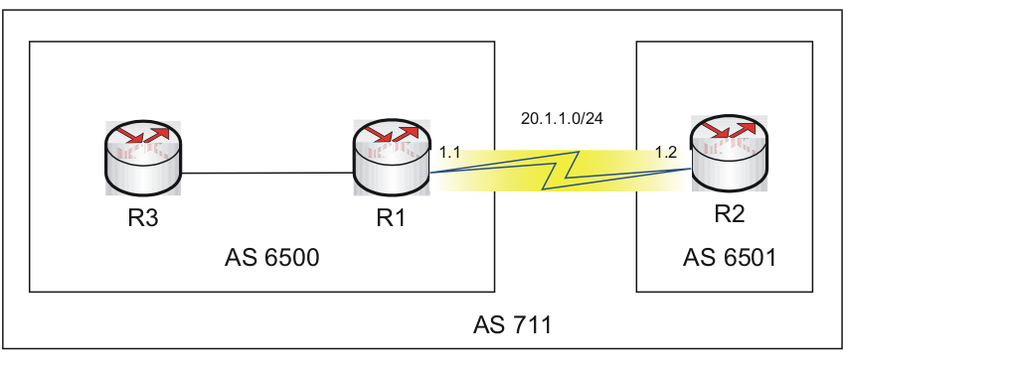

### Troubleshooting

Verify the bgp peer status using the command display bgp peer.

[R2]disp bgp peer

BGP local router ID : 2.2.2.2

Local AS number : 6501

Total number of peers : 1 Peers in established state : 0

Peer AS MsgRcvd MsgSent OutQ PrefRcv Up/Down State 20.1.1.1 6500 0 1 0 0 00:00:38 Active

Check the bgp configurations on both the routers.

Router R1

[R1]disp current-configuration | begin bgp

bgp 6500

confederation id 711

confederation peer-as 6501

network 10.1.1.0 255.255.255.0

network 20.1.1.0 255.255.255.0

undo synchronization

peer 20.1.1.2 as-number 6501

Router R2

[R2]disp current-configuration | begin bgp

bgp 6501

confederation id 711

confederation peer-as 6502

network 20.1.1.0 255.255.255.0

undo synchronization

peer 20.1.1.1 as-number 6500

The confederation peer-as configured is incorrect.

### Solution

Correct the confederation AS configured.

[R2]bgp 6501

[R2-bgp]undo confederation peer-as 6502

[R2-bgp]confederation peer-as 6500

### Verification

Verify the BGP peer status.

[R2]disp bgp peer

BGP local router ID : 2.2.2.2

Local AS number : 6501

Total number of peers : 1 Peers in established state : 1

Peer AS MsgRcvd MsgSent OutQ PrefRcv Up/Down State 20.1.1.1 6500 6 5 0 3 00:01:01 Established

## Missing confederation peer-as <AS number> command

An example of missing confederation peer-as <AS numbers> command is shown in .

Missing confederation peer-as <AS numbers> command



### Troubleshooting

Verify the bgp peer status using the command display bgp peer.

[R1]display bgp peer

BGP local router ID : 1.1.1.1

Local AS number : 6500

Total number of peers : 1 Peers in established state : 0

Peer AS MsgRcvd MsgSent OutQ PrefRcv Up/Down State

20.1.1.2 6501 0 0 0 0 00:00:26 Idle

Check the BGP configuration on both routers.

Router R1

[R1]disp current-configuration | begin bgp

bgp 6500

confederation id 711

network 10.1.1.0 255.255.255.0

network 20.1.1.0 255.255.255.0

undo synchronization

peer 20.1.1.2 as-number 6501

confederation peer-as <as no.> command missing under BGP configuration for R1

Router R2

[R2]disp current-configuration | begin bgp

bgp 6501

confederation id 711

confederation peer-as 6500

network 20.1.1.0 255.255.255.0

undo synchronization

peer 20.1.1.1 as-number 6500

### Solution

Configure the confederation AS number for router R2.

[R1]bgp 6500

[R1-bgp]confederation peer-as 6501

### Verification

R1 has formed successful peering with R2.

[R1]disp bgp peer

BGP local router ID : 1.1.1.1

Local AS number : 6500

Total number of peers : 1 Peers in established state : 1

Peer AS MsgRcvd MsgSent OutQ PrefRcv Up/Down State

20.1.1.2 6501 6 5 0 4 00:00:40 Established

# 4 BGP Route Aggregation issue

The most common problems found in the route aggregation in BGP are:

* Router receiving both detailed routes as well as summary route (Comware)
* No option to send a summary route (ProVision)
* Router not receiving summary route: route-policy blocking summary route

## Router receiving both detailed routes as well as summary route (Comware only)

An example of a router receiving both detailed routes as well as summary route is shown in .

router receiving both detailed routes as well as summary route

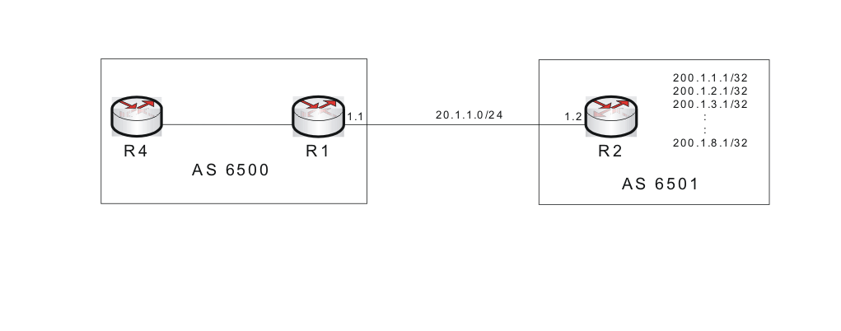

Router R2 is advertising the following routes: 200.1.1.1/32, 200.1.2.1/32, 200.1.3.1/32, 200.1.4.1/32, 200.1.5.1/32, 200.1.6.1/32, 200.1.7.1/32 and 200.1.8.1/32.

These routes are being summarized at R2 before advertising to EBGP neighbor R1.

### Problem

R1 is receiving both Summarized routes and detailed routes.

### Troubleshooting

Check the BGP routing table of R1.

[R1]disp bgp routing-table

Total Number of Routes: 11

BGP Local router ID is 1.1.1.1

Status codes: \* - valid, ^ - VPN best, > - best, d - damped,

h - history, i - internal, s - suppressed, S - Stale

Origin : i - IGP, e - EGP, ? - incomplete Network NextHop MED LocPrf PrefVal Path/Ogn

\* > 20.1.1.0/24 0.0.0.0 0 0 i

\* 20.1.1.2 0 0 6501i

\* > 200.1.0.0/16 20.1.1.2 0 0 6501i

\* > 200.1.1.1/32 20.1.1.2 0 0 6501i

\* > 200.1.2.1/32 20.1.1.2 0 0 6501i

\* > 200.1.3.1/32 20.1.1.2 0 0 6501i

\* > 200.1.4.1/32 20.1.1.2 0 0 6501i

\* > 200.1.5.1/32 20.1.1.2 0 0 6501i

\* > 200.1.6.1/32 20.1.1.2 0 0 6501i

\* > 200.1.7.1/32 20.1.1.2 0 0 6501i

\* > 200.1.8.1/32 20.1.1.2 0 0 6501i

Check the BGP configuration on R2.

<R2> display current-configuration | begin bgp

bgp 6501

aggregate 200.1.0.0 255.255.0.0

network 20.1.1.0 255.255.255.0

network 200.1.1.1 255.255.255.255

network 200.1.2.1 255.255.255.255

network 200.1.3.1 255.255.255.255

network 200.1.4.1 255.255.255.255

network 200.1.5.1 255.255.255.255

network 200.1.6.1 255.255.255.255

network 200.1.7.1 255.255.255.255

network 200.1.8.1 255.255.255.255

undo synchronization

peer 20.1.1.1 as-number 6500

The **aggregate** command configured on R2 is not followed by **detail-suppress**. As a result all the detailed routes get advertised along with the summary route.

### Solution

There are two ways to curb this issue.

1. Include **detail-suppress** keyword in the **aggregate** command
2. Use IP prefix to filter out the detailed routes.

Both the solutions are described here.

#### Solution1

Include the keyword detail-suppress in the aggregate command.

[R2]bgp 6500

[R2-bgp]aggregate 200.1.0.0 16 detail-suppressed

#### Verification for Solution 1

R1 is receiving only the summarized routes.

[R1]disp bgp routing-table

Total Number of Routes: 3

BGP Local router ID is 1.1.1.1

Status codes: \* - valid, ^ - VPN best, > - best, d - damped,

h - history, i - internal, s - suppressed, S - Stale

Origin : i - IGP, e - EGP, ? - incomplete Network NextHop MED LocPrf PrefVal Path/Ogn

\* > 20.1.1.0/24 0.0.0.0 0 0 i

\* 20.1.1.2 0 0 6501i

\* > 200.1.0.0/16 20.1.1.2 0 0 6501i

#### Solution2

Use IP prefix to filter out the detailed routes on R2.

[R2]ip ip-prefix block\_multiply index 10 deny 200.1.1.1 32

[R2]ip ip-prefix block\_multiply index 11 deny 200.1.2.1 32

[R2]ip ip-prefix block\_multiply index 12 deny 200.1.3.1 32

[R2]ip ip-prefix block\_multiply index 13 deny 200.1.4.1 32

[R2]ip ip-prefix block\_multiply index 14 deny 200.1.5.1 32

[R2]ip ip-prefix block\_multiply index 15 deny 200.1.6.1 32

[R2]ip ip-prefix block\_multiply index 16 deny 200.1.7.1 32

[R2]ip ip-prefix block\_multiply index 17 deny 200.1.8.1 32

[R2]ip ip-prefix block\_multiply index 50 permit 0.0.0.0 0 less-equal 32

[R2]bgp 6501

[R2-bgp]peer 20.1.1.1 ip-prefix block\_multiply export

#### Verification for Solution 2

R1 is receiving only the summary routes.

<R1>disp bgp routing-table

Total Number of Routes: 3

BGP Local router ID is 1.1.1.1

Status codes: \* - valid, ^ - VPN best, > - best, d - damped,

h - history, i - internal, s - suppressed, S - Stale

Origin : i - IGP, e - EGP, ? - incomplete Network NextHop MED LocPrf PrefVal Path/Ogn

\* > 20.1.1.0/24 0.0.0.0 0 0 i

\* 20.1.1.2 0 0 6501i

\* > 200.1.0.0/16 20.1.1.2 0 0 6501i

## A manually configured summary route is not being advertised (ProVision only)

An example of a manually configured summary route is not being advertised is shown in .

manually configured summary route is not being advertised

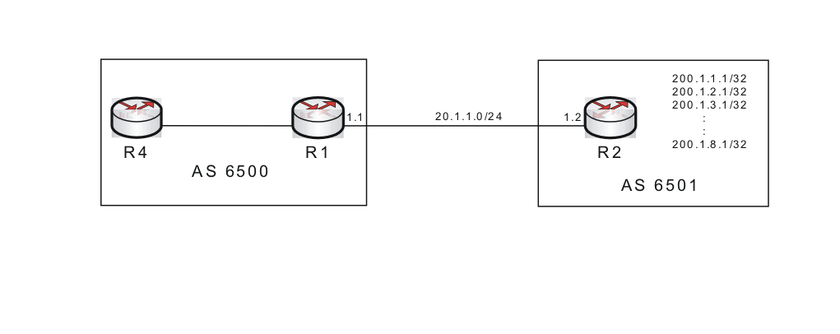

The following routes exist in AS 6501: 200.1.1.1/32, 200.1.2.1/32, 200.1.3.1/32, 200.1.4.1/32, 200.1.5.1/32, 200.1.6.1/32, 200.1.7.1/32 and 200.1.8.1/32.

R2 should announce only the route 200.1.0.0/16 to R1, but ProVision devices do not offer the aggregate option.

### Problem

R1 is receiving the detailed routes. The desired behavior is for R1 to only receive the single summary route. The route 200.1.0.0/16 is configured to be advertised from R2, however R1 is not receiving the route.

### Troubleshooting

R2 is configured like this:

router bgp 6501

enable

network 200.1.0.0 255.255.0.0

network 200.1.1.1 255.255.255.255

network 200.1.2.1 255.255.255.255

network 200.1.3.1 255.255.255.255

network 200.1.4.1 255.255.255.255

network 200.1.5.1 255.255.255.255

network 200.1.6.1 255.255.255.255

network 200.1.7.1 255.255.255.255

network 200.1.8.1 255.255.255.255

neighbor 20.1.1.1 remote-as 6500

exit

R1’s BGP routing table:

R1(bgp)# show ip bgp

Local AS : 6500 Local Router-id : 10.228.0.11

BGP Table Version : 8

Status codes: \* - valid, > - best, i - internal, e - external, s - stale

Origin codes: i - IGP, e - EGP, ? - incomplete

Network Nexthop Metric LocalPref Weight AsPath

------------------ --------------- ---------- ---------- ------ ---------

\*>e 200.1.1.1/32 20.1.1.2 0 0 6501 i

\*>e 200.1.2.1/32 20.1.1.2 0 0 6501 i

\*>e 200.1.3.1/32 20.1.1.2 0 0 6501 i

\*>e 200.1.4.1/32 20.1.1.2 0 0 6501 i

\*>e 200.1.5.1/32 20.1.1.2 0 0 6501 i

\*>e 200.1.6.1/32 20.1.1.2 0 0 6501 i

\*>e 200.1.7.1/32 20.1.1.2 0 0 6501 i

\*>e 200.1.8.1/32 20.1.1.2 0 0 6501 i

R1 is not receiving the summary route.

### Solution

The network command only announces the specified route, if that route exists in the routers global routing table. The routing table of R2 looks like this:

R2(config)# show ip route

IP Route Entries

Destination Gateway VLAN Type Sub-Type Metric Dist.

------------------ --------------- ---- --------- ---------- ---------- -----

20.1.1.0/24 DEFAULT\_VLAN 1 connected 1 0

127.0.0.0/8 reject static 0 0

127.0.0.1/32 lo0 connected 1 0

200.1.1.1/32 lo0 connected 1 0

200.1.2.1/32 lo1 connected 1 0

200.1.3.1/32 lo2 connected 1 0

200.1.4.1/32 lo3 connected 1 0

200.1.5.1/32 lo4 connected 1 0

200.1.6.1/32 lo5 connected 1 0

200.1.7.1/32 lo6 connected 1 0

200.1.8.1/32 lo7 connected 1 0

As expected, the detailed routes are announced, however since the summary route 200.1.0.0/16 does not exist in the routing table that route is not announced.

The desired behavior is to not announce the detailed routes, and to only announce the summary route. This can be accomplished by eliminating the network statements for the detailed routes and adding a “spoofed” route for the summary route.

The configuration would look like this:

router bgp 6501

enable

network 200.1.0.0 255.255.0.0

neighbor 20.1.1.1 remote-as 6500

exit

ip route 200.1.0.0/16 blackhole

By adding the blackhole route, R2 is now able to announce the summary route. Traffic is not actually being blackholed, since the more specific routes still exist in the routing table of R2.

|  |  |
| --- | --- |
|  | NOTE:  Unlike when using the aggregate command, the summary route is always announced regardless of the existence of any of the detailed routes. |

### Verification

R1(bgp)# show ip bgp

Local AS : 6500 Local Router-id : 10.228.0.11

BGP Table Version : 17

Status codes: \* - valid, > - best, i - internal, e - external, s - stale

Origin codes: i - IGP, e - EGP, ? - incomplete

Network Nexthop Metric LocalPref Weight AsPath

------------------ --------------- ---------- ---------- ------ ---------

\*>e 200.1.0.0/16 20.1.1.2 0 0 6501 ?